PRE FOOD BOOKING SYSTEM

A PROJECT REPORT

Submitted by

|  |  |
| --- | --- |
|  |  |
|  |  |
|  |  |
|  |  |

In partial fulfilment for the award of the degree

of

BACHELOR OF ENGINEERING

in

COMPUTER SCIENCE AND ENGINEERING

ST. ANNE’S COLLEGE OF ENGINEERING AND TECHNOLOGY

ANNA UNIVERSITY :: CHENNAI 600025

**TABLE OF THE CONTENT**

|  |  |  |
| --- | --- | --- |
| **CHAPTER NO.** | **TITLE** | **PAGE NO.** |
|  | **ABSTRACT** |  |
|  | **LIST OF FIGURES** |  |
| 1 | **INTRODUCTION** |  |
|  | 1.1. Overview  1.1.1 Key Component  1.2. Problem Statement  1.3. Coludinary  1.4. Aim and Objective  1.5. Scope of the Project |  |
| 2 | **LITERATURE SURVEY** |  |
| 3 | **SYSTEM ANALYSIS**  3.1. Existing System  3.1.1. Disadvantage  3.2. Proposed System  3.2.1. Advantages |  |
| 4 | **SYSTEM REQUIREMENTS**  4.1. Hardware Requirements  4.2. Software Requirements |  |
| 5 | **SOFTWARE DESCRIPTION**  5.1. Bcackend Technology  5.2. Frontend Technology  5.3. Cloud And Storage Solution  5.4. Payment Integration |  |
| 6 | **SYSTEM DESIGN**  6.1. System Architecture  6.2. Uml Diagram  6.2.1 Use Cae Diagram  6.2.2 Class Diagram  6.2.3 Sequence Diagram  6.3. Block Diagram  6.4. ER Diagram |  |
| 7 | **SYSTEM TESTING**  7.1. Software Testing  7.2. Test Case  7.3. Test Report |  |
| 8 | **PROJECT DESCRIPTION**  8.1. PROJECT DESCRIPTION  8.2. MODULE DESCRIPTION  8.2.1 User Module  8.2.2 Reservation Module  8.2.3 Food Ordering Module  8.2.4 Payment Module  8.2.5 **Booking Management Module**  8.2.6 Admin Dashboard  8.2.7 Notification Module  8.2.8 **Security Module**  8.3 ALGORITHMS |  |
| 9 | **SYSTEM IMPLEMENTATION**  9.1. Feasibility Study |  |
| 10 | **CONCLUTION AND FUTURE ENHANCEMENT** |  |
|  | **APPENDIX 1**  Screenshots |  |
|  | **APPENDIX 2**  Source Code |  |
|  | **REFERENCES** |  |

**ABSTRACT**

In the modern era of digitization and smart solutions, the hospitality industry is constantly evolving to enhance customer experience, reduce food waste, and improve operational efficiency. This project, titled "Pre Food Booking and Table Reservation System with Refundable Deposit Mechanism," aims to bridge the gap between customers and restaurants through a seamless web-based platform that allows users to pre-book their table and food while ensuring commitment through a refundable deposit system.

The proposed system enables customers to browse restaurants, select a preferred time slot, choose dishes from the digital menu, and complete their reservation by making an online payment. This payment includes the food cost and an extra deposit amount which acts as a security for the booking. Upon successful visit and consumption of the meal, the extra amount is refunded to the customer. However, if the customer fails to show up or cancels the booking at the last moment, the deposit becomes non-refundable, and a penalty charge is applied. This penalty charge varies based on predefined conditions, such as late cancellations or failure to occupy the reserved table within the specified time.

Additionally, the system supports table booking functionality, allowing customers to reserve a specific table based on their preferences (indoor, outdoor, window-side, etc.). Restaurants can configure their available tables, set reservation limits, and categorize them based on seating capacity. This ensures a more personalized and efficient dining experience for customers.

From the restaurant's perspective, this system offers a smarter way to manage customer bookings, prepare food in advance based on confirmed orders, and maintain customer records effectively. It reduces uncertainties, enhances planning, and minimizes food wastage. The admin panel allows restaurant owners to track all bookings, handle refunds, enforce cancellation policies, and manage penalty charges according to predefined rules.

By implementing this pre-food booking system, restaurants can ensure better customer satisfaction, reduce operational losses, and promote responsible dining behavior. Customers, on the other hand, benefit from a hassle-free dining experience, guaranteed table availability, and the convenience of pre-ordering their favorite dishes.

## LIST OF FIGURES

1. System Architecture Diagram
2. UML Use Case Diagram
3. Class Diagram
4. Block Diagram
5. Module Diagram
6. ER Diagram
7. Sequence Diagram

**CHAPTER 1**

**INTRODUCTION**

### 1.1 Overview

**In today’s fast-paced world, people seek convenience in every aspect of their lives — including how they dine. With the rise of technology and digital transformation, the traditional method of walking into a restaurant and waiting for a table or placing food orders on the spot has become less appealing. Customers now expect smart solutions that save time, reduce uncertainty, and offer a smoother dining experience.**

**The "Pre Food Booking and Table Reservation System with Refundable Deposit Mechanism" is a web-based platform designed to enhance the dining experience for customers while optimizing restaurant operations. It allows customers to browse restaurants, reserve tables, pre-order food, and secure their bookings with an online payment that includes a refundable deposit. If customers dine as scheduled, the deposit is refunded, but in cases of last-minute cancellations or no-shows, a penalty is applied. The system offers flexible table booking options, enabling customers to choose indoor, outdoor, or window-side seating, while restaurants can manage reservations, configure table categories, and apply customized penalty charges. Built using React.js for the frontend, Node.js with Express.js for the backend, and MongoDB as the database, the platform integrates secure payment gateways like Razorpay or Stripe for seamless transactions. It provides an efficient admin panel for restaurants to track bookings, manage refunds, and enforce cancellation policies. This system minimizes food wastage, enhances customer satisfaction, and ensures responsible dining behavior.**

### 1.1.1 Key Components

The Pre Food Booking System is built using modular architecture, ensuring that each functional unit works independently while remaining integrated within the system. Below are the key components along with detailed explanations:

**User Module:**

* + User Registration and Authentication (Secure Login/Signup).
  + Profile Management (Name, Contact, Booking History).
  + Restaurant Browsing and Filtering.
  + Table Reservation with Seating Preferences (Indoor, Outdoor, Window-side).
  + Food Pre-Ordering from Digital Menu.
  + Payment Processing (Food Cost + Refundable Deposit).
  + Booking Modification and Cancellation with Penalty Rules.
  + Real-time Booking Status and Refund Tracking.

**Restaurant Module:**

* Restaurant Profile Management (Name, Location, Menu, Table Configuration).
* Table Management (Seating Capacity, Availability, Preferences).
* Digital Menu Management (Dishes, Prices, Categories).
* Booking Management Dashboard (Live Booking Status, Customer Details).
* Refund and Penalty Management (Automated Calculations).
* Cancellation Policy Configuration (Refundable Deposit, Penalty Charges).
* Revenue Tracking and Analytics.

**Admin Module:**

* Global Platform Management (All Registered Restaurants and Users).
* Policy Management (Refund Rules, Penalty Rates).
* Transaction Monitoring (Payments, Refunds).
* User and Restaurant Verification.
* Reporting and Analytics (Revenue, Customer Statistics).
* Secure Access Control for Admin Users.

**Payment Module:**

* Integration with Secure Payment Gateways (Razorpay, Stripe).
* Split Payment System (Food Cost + Refundable Deposit).
* Automated Refund Handling for Completed Orders.
* Penalty Deduction for No-Show or Late Cancellations.
* Secure Payment Logging and Transaction Tracking.

**Notification and Communication Module:**

* Real-time Booking Confirmation (Email, SMS, Push Notifications).
* Payment Receipt and Refund Notification.
* Cancellation Alerts and Penalty Details.
* Regular Updates on Reservation Status.

**Next.js (Frontend Framework):**

Next.js is a powerful React-based framework used for building fast, SEO-friendly, and full-stack web applications. It supports both client-side and server-side rendering (SSR), which helps in improving performance and loading speed. In this project, Next.js is used to build the frontend interface along with handling some backend API routes, making the application more efficient and scalable.

**Express.js (Backend Framework):**

Express.js is a lightweight and flexible Node.js web application framework that provides a robust set of features for building APIs. It is used in this project to handle the server-side logic, manage RESTful routes, handle booking logic, user authentication, and integrate with external services like payment gateways and email/SMS services.

**MongoDB (Database):**

MongoDB is a NoSQL document-oriented database that stores data in JSON-like format. It is used in this project to store dynamic data such as user profiles, restaurant listings, food menus, bookings, transactions, and refund logs. Its flexible schema makes it ideal for applications with rapidly changing or unstructured data.

**Cloudinary (Cloud Storage):**

Cloudinary is a cloud-based media management platform used to store, manage, and deliver images and videos efficiently. In this project, Cloudinary is used to upload and serve restaurant logos, food item images, and user profile pictures. It helps reduce server load and ensures that images are optimized and delivered quickly.

**JWT (JSON Web Token) :**

JWT is a secure method for user authentication and session management. It is used to protect user accounts, secure API routes, and ensure that only authenticated users can access certain parts of the system (like bookings, refund tracking, etc.).

**Razorpay / Stripe :**

These are online payment gateway services used to handle all monetary transactions in the project. They are integrated into the system to collect the booking fee and the additional refundable amount. They also handle refund processing based on the customer’s dining status and cancellation policy.

## **BENEFITS OF THE SYSTEM**

#### ****For Customers:****

1. **Convenient Booking:** Customers can easily reserve tables and pre-order their favorite dishes online, avoiding long wait times at restaurants.
2. **Guaranteed Reservation:** The refundable deposit system ensures that a reserved table is always available, providing a hassle-free dining experience.
3. **Flexible Options:** Users can choose their preferred table type (indoor, outdoor, window-side) for a personalized experience.
4. **Secure Payments:** Safe and secure payment gateway integration for online transactions with instant booking confirmation.
5. **Transparency:** Clear cancellation policies and penalty rules ensure customers are aware of their responsibilities.
6. **Quick Refunds:** Automatic refund processing for customers who successfully dine as booked.

#### ****For Restaurants:****

1. **Reduced Wastage:** With pre-ordered food, restaurants can prepare meals more accurately, minimizing food wastage.
2. **Better Planning:** Advanced bookings help in efficient kitchen management and staff allocation.
3. **Revenue Protection:** The refundable deposit and penalty system discourage last-minute cancellations, protecting restaurant revenue.
4. **Enhanced Customer Management:** The admin panel allows easy tracking of customer bookings and transaction history.
5. **Optimized Table Management:** Configurable table categories and seating arrangements for efficient space utilization.
6. **Automated Refund Management:** Seamless refund handling with clear rules for penalties, reducing manual work.

#### ****For Platform Admin:****

1. **Centralized Control:** Admins can monitor all restaurants and user activities from a single dashboard.
2. **Policy Management:** Easy configuration of refund and penalty policies for all restaurants.
3. **Secure Transaction Tracking:** Comprehensive record of all payments, refunds, and penalties.
4. **Analytics and Reporting:** Insights on booking trends, revenue, and customer behavior.

### **1.2 Problem Statement**

In traditional food service environments such as restaurants, cafeterias, and large event venues, both customers and service providers face recurring challenges like **long queues**, **food wastage**, and **poor order accountability**. These problems result in customer dissatisfaction and operational inefficiencies.These challenges result in **increased food wastage**, **customer dissatisfaction**, and **inefficient kitchen operations**. Additionally, there is a lack of systems that encourage customers to **commit to their orders** and **arrive on time**, leading to **uncollected food** and unnecessary overproduction.

In the hospitality industry, restaurants often face significant challenges due to last-minute cancellations, no-shows, and inefficient table management. These issues lead to wasted food, lost revenue, and poor customer satisfaction. Customers, on the other hand, frequently experience inconvenience due to long wait times, unavailability of preferred seating, and lack of transparency in booking policies. Traditional reservation methods do not ensure customer commitment, making it difficult for restaurants to plan food preparation and optimize table utilization. This project, "Pre Food Booking and Table Reservation System with Refundable Deposit Mechanism," aims to solve these problems by providing a secure, efficient, and user-friendly platform where customers can pre-book tables and food with a refundable deposit, ensuring accountability and reducing operational losses for restaurants.

#### ****Customer-Side Challenges:****

* Customers often face **long waiting times** at restaurants due to lack of proper table reservation systems, especially during weekends and holidays.
* There's no structured way to **pre-order food**, which results in additional waiting time after reaching the restaurant.
* **Sudden plan changes** by customers often lead to no-shows, with no impact or responsibility, which wastes the restaurant’s time and resources.
* Customers don’t get any **incentives** for planning ahead or showing up on time, making spontaneous and irresponsible booking behavior common.

#### ****Restaurant-Side Challenges:****

* Last-minute cancellations and no-shows lead to **underutilized tables** and **loss of revenue**.
* **Food wastage** occurs when meals prepared for pre-orders or expected customers go unclaimed.
* Restaurants face difficulties in managing **peak-time traffic**, **staff allocation**, and **kitchen workload** without knowing customer plans in advance.
* Lack of a centralized system results in **manual errors**, miscommunication, and poor customer experience.

### **1.3 Web Application Development :**

The proposed system falls under the domain of **Web Application Development**, specifically within the categories of **Online Reservation Systems** and **E-Commerce Platforms**. This domain focuses on building interactive, user-friendly web-based solutions that streamline everyday tasks using modern technologies. In this project, the platform allows users to reserve restaurant tables and pre-book their food through a web interface, making it part of an online reservation system. Additionally, since it involves online payments, refundable booking amounts, and order management, it also incorporates e-commerce elements. The system uses technologies like Next.js for frontend development, Express.js and MongoDB for backend and data handling, and payment gateways for secure transactions. By operating within this domain, the project addresses real-world issues such as long wait times, food wastage, last-minute cancellations, and poor resource planning, offering an efficient, smart, and scalable solution for both customers and restaurant owners.

This project comes under the **Web Application Development** domain with a specific focus on **Online Reservation Systems** and **E-Commerce functionalities**.

* **Web Application Development**: Because the platform is fully web-based, built using modern frameworks like **Next.js** for the frontend and **Express.js** for the backend.
* **Online Reservation System**: Users can reserve restaurant tables and pre-book food, which makes it a part of the online booking domain (like hotel bookings or ticket bookings).
* **E-Commerce Features**: Since it involves **payment**, **refund**, and **order** management, it inherits the logic of basic e-commerce platforms.

This project falls under the **Web-Based Restaurant Management System** domain, which is a part of the broader **E-Commerce and Online Reservation Systems** category. It mainly focuses on digitizing the restaurant booking process by allowing users to pre-book tables and food items through an online platform.

In traditional restaurant operations, table reservation and food ordering are done manually or on arrival, which leads to delays, mismanagement, and food wastage. The web-based approach solves these issues by providing a structured and automated system for both customers and restaurant owners.

## ****1. Frontend (User Interface Development)****

#### ****Next.js****

Next.js is a powerful React framework that supports both client-side and server-side rendering. It allows developers to build fast, dynamic, and SEO-optimized web applications. In this project, it is used to create interactive user interfaces for customers to browse menus, book tables, and track their order status. It also provides built-in routing and API support, which reduces the need for external tools.

#### ****Tailwind CSS****

Tailwind is a utility-first CSS framework that speeds up the design process by offering predefined classes. It allows developers to build custom, responsive layouts directly within HTML without writing traditional CSS files. In this project, Tailwind is used to style the user dashboard, booking forms, food menu cards, and admin panels with consistency and flexibility.

**Axios / Fetch API**

Used to send and receive HTTP requests between frontend and backend. For example, when a user books a table or cancels a booking, Axios helps send that data securely to the server. It also helps fetch menu data, booking history, and payment status from the server in real-time.

**2. Backend (Server & API Development)**

#### ****Node.js****

Node.js acts as the core runtime environment where the backend code runs. It allows JavaScript to run on the server side, making it possible to handle real-time user requests, connect to databases, and send responses to the frontend efficiently.

#### ****Express.js****

Express is a minimalistic Node.js framework that simplifies backend development. It helps define routes like /book, /cancel, /refund, etc., and handles logic for booking validation, refund calculation, penalty charging, and more. It also acts as the bridge between frontend and database.

#### ****MongoDB****

MongoDB is a document-based NoSQL database used to store all project-related data like user info, table reservations, menu items, payment records, and refund history. It is schema-less and works well with dynamic data, making it perfect for web applications with flexible structures.

#### ****JWT (JSON Web Token)****

JWT is used for secure login and user session management. Once the user logs in, a token is generated and stored, which is used to authenticate every future request without needing to re-login. It protects sensitive actions like booking, canceling, and admin access.

**3. Database (Data Storage & Management)**

Cloudinary is a cloud-based image hosting service. In this project, restaurant owners or admins can upload food images or promotional banners. These images are stored and optimized automatically and can be easily retrieved using URLs to display on the website without slowing it down.

## ****4. Payment Gateway Integration****

For secure **online appointment payments**, the system uses **Razorpay**, a trusted payment gateway that allows:

* **Multiple Payment Methods** – Supports UPI, credit/debit cards, net banking, and wallets.
* **Secure Transactions** – End-to-end encryption for safe payments.
* **Invoice Generation** – Sends automatic payment confirmations to users.

**1.3. Aim and Objective**

**1.3.1 Aim:**

The aim of the "Pre Food Booking and Table Reservation System with Refundable Deposit Mechanism" is to develop a secure and efficient web-based platform that allows customers to pre-book tables and food at restaurants while ensuring their commitment through a refundable deposit system. This system aims to enhance customer convenience, minimize food wastage, reduce restaurant losses due to last-minute cancellations, and optimize table management, ultimately promoting a more reliable and responsible dining experience.

**1.3.2 Objectives:**

1. **Implement Secure User Authentication:** Allow customers to register, log in, and manage their profiles securely.
2. **Enable Seamless Table Reservation:** Provide customers with options to reserve tables based on their preferences (indoor, outdoor, window-side).
3. **Facilitate Pre-Food Booking:** Allow customers to browse restaurant menus, select dishes, and place orders in advance.
4. **Incorporate a Refundable Deposit Mechanism:** Ensure customer commitment by requiring a refundable deposit for reservations, which is refunded upon successful dining.
5. **Establish a Penalty System:** Apply penalty charges for last-minute cancellations or no-shows to protect restaurant revenue.
6. **Automate Refund Handling:** Implement an automated process for refunding the deposit or applying penalties based on predefined rules.
7. **Provide Restaurant Management Dashboard:** Allow restaurants to configure their tables, manage reservations, monitor customer bookings, and track revenues.
8. **Integrate Secure Payment Gateways:** Support online payments through secure payment processors like Razorpay or Stripe.
9. **Ensure Real-Time Booking Status Updates:** Provide customers and restaurants with live booking status and notifications.

### **1.5 Scope of the Project**

This project focuses on creating a fully functional **web-based restaurant pre-booking system** that streamlines both **table reservations** and **pre-ordering of food**. It targets restaurants and customers who prefer efficient dining experiences with minimal waiting time. The system supports:

#### ****Key Functionalities and Features:****

* **Online booking** of tables and food from any device with internet access.
* **Refundable advance payment** feature to reduce no-shows and ensure customer commitment.
* **Penalty mechanism** for last-minute cancellations or no-show cases.
* **Real-time dashboard** for restaurants to manage bookings, track food orders, and view customer activity.
* **Email alerts** and notifications to improve communication between the customer and the restaurant.
* **Scalable and responsive design**, making it accessible on both desktop and mobile devices.
* Integration with **payment gateways** and **image cloud storage** to ensure secure and smooth operations.

#### ****Scalability and Future Enhancements:****

The system is built using modern, scalable technologies like **Next.js**, **Express.js**, and **MongoDB**, allowing it to handle increasing user loads and data without performance issues. As more restaurants and customers use the platform, the system can be:

* **Easily hosted on cloud platforms** like Vercel, Heroku, or AWS for better performance and uptime.
* **Extended to multiple branches or locations** of a restaurant chain with minimal configuration.
* **Optimized using caching and load balancing** strategies as the traffic increases.
* **Supported with a mobile application** using the same backend APIs for a seamless multi-platform experience.

#### ****Future Enhancements:****

* **Mobile App Development** – Launch an Android/iOS version using React Native or Flutter for better accessibility.
* **Live Order Tracking** – Allow customers to track food preparation and table readiness in real-time.
* **Table QR Code System** – Let customers scan a QR code at the table to confirm their presence or reorder items.
* **Review & Rating System** – Add options for users to review restaurants, food, and service quality.
* **Coupon & Loyalty System** – Introduce promo codes, wallet points, and membership plans to retain customers.
* **Multi-language Support** – Add language switching for a more user-friendly experience across regions.
* **Analytics Dashboard** – Provide restaurants with detailed stats on sales, popular dishes, peak hours, etc.

**CHAPTER 2**

**LITERATURE REVIEW**

### ****1. Paper Name:**** Optimized Web-based Online Food Ordering System

**Author(s):** Sunny Kalu Egereonu(2024)

**Purpose:**  
This research delves into the transformative impact of digital technologies on the food service industry, emphasizing the shift from traditional, paper-based methods to advanced web-based solutions. The study meticulously outlines the development of an optimized online food ordering system, designed to enhance operational efficiency and elevate customer satisfaction. By employing the Structured Systems Analysis and Design Methodology (SSADM), the research ensures a systematic approach to system development, integrating robust digital architectures. The system's infrastructure leverages the WAMP server suite—comprising Apache, MySQL, and PHP—alongside HTML, to create a user-centric platform. This platform offers functionalities such as seamless online food ordering, efficient delivery management, comprehensive customer information handling, dynamic menu updates, and sophisticated administrative reporting. The implementation of this system aims to mitigate the limitations inherent in manual processes, providing customers with unparalleled convenience in placing orders from any location. Rigorous testing within controlled environments has demonstrated the system's efficacy in achieving substantial improvements in service delivery and overall business performance. This study underscores the necessity for the gastronomic industry to adopt cutting-edge technological solutions to meet the evolving demands of modern food service operations. ​

### ****2. Paper Name:****FlavorFlow: Web Implementation of Food Ordering System

**Author(s):** Hashim Meer Hashmi, Imran Hussain, Aqueel Khaliquee (2024)

**Purpose:**  
This research introduces "FlavorFlow," a web-based food ordering system designed to enhance the efficiency and user experience of online food services. The primary goal is to address and overcome the limitations associated with traditional queuing systems in restaurants, which often lead to customer dissatisfaction due to long wait times and order inaccuracies. FlavorFlow offers a comprehensive platform that allows customers to seamlessly browse menus, place orders, and track their orders in real-time, all through an intuitive and user-friendly interface. A distinctive feature of the system is its ability to provide personalized food recommendations based on user preferences and order history, thereby enhancing customer engagement and satisfaction. Additionally, the system incorporates a robust backend for restaurant administrators, enabling efficient order management, inventory tracking, and sales data analysis. Security is a paramount consideration in FlavorFlow; the system implements secure user authentication protocols, ensuring that each customer has a unique ID and password to protect against fraudulent activities. Payment flexibility is also a key aspect, with options for online transactions or cash on delivery, catering to diverse customer preferences. The implementation of FlavorFlow demonstrates significant improvements in operational efficiency, order accuracy, and overall service quality within the food industry. By streamlining the ordering process and integrating advanced features such as real-time tracking and personalized recommendations, FlavorFlow sets a new standard for online food ordering systems, aiming to elevate the dining experience for customers and optimize operations for restaurant owners.

### ****3. Paper Name:** Appointify:** Combating the Bullwhip Effect in Rival Online Food Delivery Platforms Using Deep Learning

**Author(s):** Tisha Ghosh(2025)

**Purpose:**  
This study addresses the significant challenge of the bullwhip effect in online food delivery platforms, where small fluctuations in customer demand lead to amplified inefficiencies across the supply chain, resulting in issues like stockouts, excess inventory, and increased waste. The research introduces a Third-Party Logistics (3PL) supply chain model involving restaurants, online food applications, and customers, aiming to enhance demand forecasting accuracy. A novel two-phase Long Short-Term Memory (LSTM) network is proposed: the first phase focuses on intra-day forecasting to capture short-term demand variations, while the second phase emphasizes daily forecasting for overall demand prediction. Utilizing a comprehensive two-year dataset from Swiggy and Zomato (January 2023 to January 2025), the model's performance is evaluated using metrics such as RMSE, MAE, and R-squared scores. The results demonstrate substantial improvements in forecasting accuracy, with the intra-day phase achieving R-squared scores of 0.69 for Zomato and 0.71 for Swiggy, and the daily forecasting phase reaching 0.88 and 0.90, respectively. Furthermore, the study implements a dynamic inventory management strategy based on the newsvendor model, adjusted according to forecasted demand, effectively reducing supply chain instability from 2.61 to 0.96 in the intra-day phase and from 2.19 to 0.80 in the daily phase. This research underscores the potential of integrating deep learning techniques into supply chain management to mitigate the bullwhip effect, optimize inventory levels, and minimize food waste in online food delivery services.

### ****4. Paper Name:**** Online Food Delivery Apps in the Modern Era: A Contemporary Perspective

**Author:** M. Madhuritha, G. Nedumaran(2025)

**Purpose:**

This conceptual study explores the rapid growth and transformative impact of online food delivery (OFD) applications in India's e-commerce sector. The research delves into the evolution of dining habits, highlighting a significant shift from traditional eating out to the convenience of ordering in, facilitated by platforms such as Zomato, Swiggy, and Food Panda. The paper examines the multifaceted role of OFD apps in the current market landscape, emphasizing their adoption of advanced technologies to enhance user experience and operational efficiency. It provides an in-depth analysis of various business models and revenue streams employed by these platforms, offering insights into their strategic approaches to market penetration and profitability. A comprehensive SWOT analysis is conducted to assess the strengths, weaknesses, opportunities, and threats associated with OFD apps, providing a nuanced understanding of their market positioning. Furthermore, the study discusses the future trajectory of online food delivery services, contemplating potential innovations and their implications for the industry. By synthesizing these elements, the paper aims to present a holistic view of the OFD landscape, contributing to the broader discourse on digital transformation in the food service industry. ​

### ****5. Paper Name:** Food Delivery Time Prediction in Indian Cities Using Machine Learning Models**

**Author:** Ananya Garg, Mohmmad Ayaan, Swara Parekh, Vikranth Udandarao**(**2025)

**Purpose:**

This research focuses on enhancing the accuracy of food delivery time predictions within the complex and densely populated urban landscapes of Indian cities. Recognizing that timely deliveries are crucial for customer satisfaction and operational efficiency, the study addresses the limitations of existing models that predominantly rely on static historical data and often neglect dynamic, real-time contextual factors. To bridge this gap, the authors integrate real-time variables such as traffic density, weather conditions, local events, and geospatial data (including coordinates of restaurants and delivery destinations) into their predictive models. A comprehensive dataset specific to Indian urban contexts serves as the foundation for this analysis. The study systematically evaluates various machine learning algorithms—including Linear Regression, Decision Trees, Bagging, Random Forest, XGBoost, and LightGBM—to determine their efficacy in predicting delivery times. Through meticulous data preprocessing and feature selection, the models' performances are significantly enhanced. Experimental results reveal that the LightGBM model outperforms its counterparts, achieving an R² score of 0.76 and a Mean Squared Error (MSE) of 20.59. These findings underscore the model's superior predictive accuracy and its potential application in real-world scenarios. By incorporating dynamic, real-time factors into the predictive framework, this research offers actionable insights for optimizing logistics strategies, reducing delivery times, and improving customer satisfaction in the fast-paced environment of Indian cities. The methodologies and code developed are made publicly available, encouraging reproducibility and further research in this domain.

**CHAPTER 3**

**SYSTEM ANALYSIS**

**3.1 Existing System:**

The traditional dining experience in most restaurants is still largely dependent on **manual processes** and **in-person interactions**, which can lead to several inefficiencies, especially in today's fast-paced, digitally-driven world. Although food delivery platforms like Swiggy, Zomato, and Uber Eats have transformed how people order food online, they do not effectively support a **complete pre-dining experience**—particularly one that combines **table booking, pre-ordering food, and refund mechanisms** in a single platform.

**1. Manual Reservation Management:**

* Customers often call restaurants to book tables, leading to miscommunication and overbooking.
* Restaurants rely on manual logs or spreadsheets to track bookings, which are prone to errors.

#### ****2. No Guaranteed Commitment:****

* Customers may book tables without any financial commitment, leading to a high rate of no-shows.
* Restaurants suffer losses due to unoccupied tables and wasted food.

#### ****3. Inefficient Table Utilization:****

* No systematic way to manage table categories (indoor, outdoor, window-side).
* Overcrowding in popular areas, while other sections remain underutilized.

#### ****4. Limited Menu Management:****

* Customers cannot pre-order food, leading to delays in meal preparation and extended waiting times.
* No option for customers to browse the digital menu in advance.

#### ****5. No Automated Refunds or Penalties:****

* In case of last-minute cancellations, restaurants cannot recover losses due to lack of a penalty system.
* Refunds for advance payments, if any, are processed manually, causing delays.

#### ****6. Lack of Analytics and Reporting:****

* Restaurants have no clear insights into customer behavior, peak booking times, or revenue analysis.
* Decision-making is based on guesswork rather than data.

#### ****7. Security and Payment Issues:****

* Payments are usually made at the restaurant, leading to risks of cash handling and fraud.
* No secure online payment options for reservations.

### ****Limitations of the Existing System****

The existing system for restaurant reservations and food ordering is outdated and lacks the integration required for modern convenience. Customers are unable to pre-book both tables and food simultaneously, leading to delays in service and poor dining experiences during peak hours. Real-time availability of tables is not accessible to users, which often causes confusion upon arrival. Moreover, the absence of an advance payment or structured refund system results in financial losses for restaurants when customers cancel at the last minute or fail to show up. There are also no penalties in place to discourage such behavior, leading to food wastage and inefficient use of seating. Reservations are typically handled manually through phone calls, making them prone to human error and miscommunication. Additionally, there is no proper notification or reminder system to keep users informed about their booking status. From the business side, restaurants lack access to valuable customer insights, analytics, and peak time data, which could otherwise improve their service quality and operational planning. The lack of online payment options further adds to the inconvenience, making the system rigid and inefficient in today’s digital era.

### ****3.2 Disadvantages of the Existing System****

**Lack of Accountability:**

* In traditional systems, there is no financial commitment from customers when booking tables. This leads to high instances of **no-shows** or last-minute cancellations, resulting in revenue loss for restaurants.

**Manual Reservation Management:**

* Restaurant staff manually track reservations, often through phone calls or walk-ins, leading to **human error** and **overbooking**. There is no automated system for confirming, tracking, or managing reservations.

**Inefficient Table Utilization:**

* The traditional system doesn’t allow customers to choose specific seating preferences (indoor, outdoor, or window-side). Restaurants may not be able to manage **table availability** effectively, leading to unoptimized seating and potentially long wait times for customers.

**Limited Menu Visibility:**

* Customers typically view the menu at the restaurant, leading to delays in ordering food. There is no option for customers to **pre-order** meals, which can cause longer wait times and inefficient kitchen operations.

**No Pre-booking for Food Orders:**

* Without the ability to pre-order food, restaurants can’t plan ahead for demand, leading to **food wastage** or understocking, especially during peak hours.

**Absence of Refund or Penalty Mechanisms:**

* In case of cancellations or no-shows, restaurants do not have an automated process to apply **penalty charges** or manage refunds efficiently. This leads to **loss of revenue** and can negatively impact the business’s bottom line.

**Lack of Reporting and Analytics:**

* Traditional systems do not provide insights into customer behavior, booking patterns, or peak times. Restaurants are unable to make informed decisions or **optimize** their operations effectively.

**Manual Payment Handling:**

* Payments are often handled at the restaurant, which exposes the business to risks like cash mismanagement or fraud. Customers cannot book tables or order food **online** in advance with secure payment options.

**Customer Experience Issues:**

* Without a streamlined system, customers may face **long wait times** for table availability or food delivery. There’s also a lack of clarity around **reservation statuses**, leading to confusion.

**Limited Scalability:**

* The existing manual system struggles to handle high volumes of bookings, especially during peak seasons, and does not scale well with growing customer demand or a larger restaurant chain.

**3.3 Proposed System**

The proposed system is a modern web-based application designed to revolutionize the way customers interact with restaurants by introducing a unified platform for **pre-booking tables and food**. This system allows users to browse restaurant menus, reserve a table, and place their food order in advance, all from a single portal. A unique feature is the **advance payment mechanism**, where customers pay a small extra amount during booking as a confirmation fee. This amount is fully **refundable after the customer dines**, encouraging serious bookings. However, if the customer cancels at the last minute or fails to show up, the extra amount becomes non-refundable, and a **penalty** may be applied. This ensures greater accountability from the customer side and reduces loss for restaurants. The system provides **real-time table availability**, automated booking confirmations, and reminders to users, enhancing the overall experience. From the admin side, restaurants can manage bookings, view customer data, and analyze peak hours and food preferences through the dashboard. The system is built using modern technologies like **Next.js** for frontend, **Express.js** for backend, **MongoDB** for database, and **Cloudinary** for image storage, ensuring a smooth, secure, and scalable solution. This proposed system aims to bridge the gap between convenience, accountability, and efficiency for both customers and restaurants.

### ****Key Features of the Proposed System****

1. **Pre-Food & Table Booking**

The system enables users to reserve a table and select their preferred food items in advance before arriving at the restaurant. This streamlines the dining process, reduces waiting time, and allows the kitchen staff to prepare meals ahead of time. It enhances customer satisfaction and improves operational efficiency during peak hours.

1. **Advance Payment with Conditional Refund**

When a customer books a table along with food, they are required to pay a small additional amount as a confirmation fee. If the customer arrives on time and completes the dining experience, this extra amount is refunded to them. However, if they cancel at the last minute or fail to show up, the amount is not refunded and is treated as a penalty. This system ensures commitment from the customer and reduces the risk of no-shows, benefiting restaurant management.

1. **Real-Time Table Availability**

The system shows the current availability of tables in real-time, allowing customers to select time slots that suit them best. This avoids double bookings and ensures better time management. Restaurants can also update availability instantly if any changes occur.

1. **Secure Online Payment Integration**

The platform supports multiple digital payment methods including UPI, credit/debit cards, and wallets. This ensures quick, secure, and hassle-free transactions for customers, and reduces the burden of cash handling for the restaurant.

1. **Smart Admin Dashboard**

The system includes a powerful admin dashboard for restaurant staff. They can view upcoming bookings, food orders, customer details, and manage cancellations or modifications. The dashboard also provides insights into peak hours, popular food items, and customer behavior.

#### ****Automated Notifications and Reminders****

Customers receive automatic notifications about their booking status, payment confirmation, and timely reminders before their dining time. This helps reduce missed bookings and improves communication between the restaurant and customers.

1. **Booking and Order History**

Users can view a history of their past bookings and food orders. This helps in tracking preferences and enables them to reorder easily. Restaurants can also use this data to offer personalized services or promotions to regular customers.

1. **Penalty and Refund Handling**

The system handles all refund and penalty logic automatically based on the customer’s actions. If a customer completes their booking, the refund is issued immediately. In case of a no-show or late cancellation, penalties are enforced without manual intervention.

1. **Cloud-Based Media Management**

Restaurant images, food pictures, and menu files are uploaded and stored using **Cloudinary**, a cloud-based image hosting service. This ensures fast loading speeds, high-quality media delivery, and reduced load on the local server.

**10. Modern, Responsive Frontend (Next.js)**

The entire frontend of the application is built using **Next.js**, offering a blazing-fast, SEO-friendly, and responsive user interface. Whether accessed through mobile or desktop, the UI remains smooth and interactive, enhancing user engagement and experience.

### ****3.2.1 Advantages of the Proposed System****

**The proposed "Pre Food Booking and Table Reservation System with Refundable Deposit Mechanism" offers several advantages over the existing manual or traditional reservation methods:  
The refundable deposit mechanism ensures that customers are committed to their reservations. If they show up and complete their meal, the deposit is refunded. In case of a last-minute cancellation or no-show, a penalty is applied, reducing the chances of wasted tables.**

1. ****Seamless Online Reservations:****  
   Customers can easily browse restaurants, select their preferred seating (indoor, outdoor, window-side), and make reservations from the comfort of their homes. This eliminates the need for manual phone calls or walk-ins.
2. ****Efficient Food Management:****  
   By allowing customers to pre-order food while making reservations, restaurants can prepare dishes in advance, reducing waiting times and minimizing food wastage.
3. ****Automated Refund and Penalty Handling:****  
   The system automatically processes refunds for customers who dine as booked and deducts penalties for those who cancel at the last minute. This ensures transparent and hassle-free financial management.
4. ****Secure Online Payments:****  
   Integrated with secure payment gateways like Razorpay or Stripe, the system ensures safe and reliable transactions for customers. Multiple payment options (credit/debit cards, UPI, net banking) make it convenient.
5. ****Customized Table Management:****  
   Restaurants can configure different types of tables (indoor, outdoor, VIP) with varying capacities, allowing them to optimize seating arrangements based on customer preferences.
6. ****Real-time Notifications:****  
   Both customers and restaurants receive instant notifications for booking confirmation, payment receipts, refunds, and penalties. This keeps all parties informed and reduces miscommunication.
7. ****Comprehensive Restaurant Dashboard:****  
   Restaurant owners can manage their bookings, track customer reservations, monitor revenues, configure cancellation policies, and generate detailed reports for analysis.
8. ****Advanced Analytics:****  
   The system provides valuable insights on customer behavior, peak booking times, popular dishes, and revenue trends, helping restaurants make data-driven decisions.
9. ****Centralized Admin Control:****  
   Platform administrators can monitor all registered restaurants, manage user accounts, configure refund and penalty policies, and ensure secure operations across the platform.

**CHAPTER 4**

**SYSTEM REQUIREMENTS**

**4.1 HARDWARE REQUIREMENTS**

The proposed food booking web application is designed to run efficiently on standard hardware systems without requiring any high-end specifications. On the **client side**, users can access the platform using commonly available devices such as desktops, laptops, tablets, or smartphones. A device with a minimum of **2 GB RAM**, a **dual-core processor**, and a **modern web browser (like Chrome, Firefox, or Edge)** is sufficient for a smooth browsing and booking experience. Since the application is web-based and responsive, users do not need to install any software, and only a **stable internet connection** is necessary to access all features.

On the **server side**, where backend operations and admin functionalities are handled, a higher configuration is recommended to ensure reliability, performance, and scalability. The system should have at least **4 to 8 GB of RAM**, a **quad-core or higher processor**, and **minimum 100 GB storage capacity** to handle database operations, API requests, image uploads, and payment transactions efficiently. For production-level deployment, especially if hosted on a private server or virtual machine, a **dedicated server with SSD storage**, **multi-core processors**, and **high bandwidth connectivity (100 Mbps or more)** is advisable to support multiple concurrent users and ensure fast response times.

Additionally, the system uses **Cloudinary** for media storage and **MongoDB** for cloud-hosted databases, which offloads much of the heavy processing from the local machine. This architecture ensures that even with minimal on-premise hardware, the application can deliver high performance using cloud-based resources. However, for development purposes, the developer's machine should ideally have **at least 8 GB RAM**, a **modern CPU (Intel i5 or Ryzen 5 and above)**, and **Node.js/NPM** support for running Next.js and Express-based environments locally.

**4.2 SOFTWARE REQUIREMENTS**

The proposed food booking system is a web-based application built using modern full-stack technologies, and it requires specific software tools and platforms for both development and deployment. On the **frontend**, the application is developed using **Next.js**, a React-based framework that enables server-side rendering, faster performance, and enhanced SEO. It also relies on essential frontend technologies such as **HTML5**, **CSS3**, **JavaScript**, and **Tailwind CSS** for styling and responsive design. For **backend development**, the project uses **Express.js**, a lightweight and efficient web application framework for Node.js, which handles API requests, user authentication, and communication with the database. The **MongoDB** database is used for storing user information, booking details, food orders, and transaction records.

To manage image and media content efficiently, the system integrates **Cloudinary**, a cloud-based media storage and optimization service. For package management and backend setup, **Node.js** and **NPM (Node Package Manager)** are essential, while **MongoDB Atlas** is used for hosting the cloud database. Development is carried out on **Visual Studio Code (VS Code)**, a powerful and lightweight source-code editor that supports syntax highlighting, version control, and live debugging. The application also uses **Postman** for API testing and **Git/GitHub** for version control and team collaboration. Additionally, any deployment to live servers can be managed through platforms like **Vercel** (ideal for Next.js) or **Render/Heroku** for the backend API. A **modern web browser** (Google Chrome, Mozilla Firefox, etc.) is required to access and test the application, both during and after development.

#### ****1. Backend Technologies****

* **Node.js** – JavaScript runtime environment used to run server-side code.
* **Express.js** – Web framework for Node.js used to build RESTful APIs and handle backend logic.
* **MongoDB** – NoSQL database used to store all booking, user, and payment data.
* **MongoDB Atlas** – Cloud-hosted version of MongoDB for remote access and scalability.

#### ****2. Frontend Technologies****

* **Next.js** – React-based framework used to build a fast, SEO-friendly, and server-side rendered frontend.
* **HTML5** – Markup language used to structure web content.
* **CSS3 / Tailwind CSS** – Used for styling and making the interface responsive.
* **JavaScript** – Core language used for client-side interactivity and logic.
* **Axios/Fetch API** – Used for making HTTP requests from frontend to backend.

#### ****3. Payment Integration****

* **Razorpay / Stripe (Optional)** – Secure online payment gateways to handle advance booking charges.
* **UPI / Credit/Debit Card Support** – Integrated via the chosen payment provider for real-time transaction processing.

#### ****4. Cloud & Media Services****

**Cloudinary** – Used for uploading, optimizing, and delivering images (food, restaurant, menus) across the platform.

#### ****5. Development and Testing Tools****

* **Postman** – API testing tool used to test and verify backend endpoints.
* **Jest / React Testing Library (Optional)** – For unit and integration testing of frontend components (if required).
* **Visual Studio Code (VS Code)** – Source-code editor used for writing, debugging, and managing project files.
* **Node Package Manager (NPM)** – Used to manage project dependencies and packages.

**CHAPTER 5**

**SOFTWARE DESCRIPTION**

**5.1  **Backend Technologies****

### ****1. Node.js (Runtime Environment)****

**Node.js** is a powerful, open-source, cross-platform JavaScript runtime environment that executes code outside a browser. It is used to build fast, scalable, and real-time backend services. In this project, Node.js serves as the runtime for executing backend logic and handling asynchronous operations like database queries and payment processing. Its event-driven, non-blocking I/O model makes it highly efficient, which is ideal for handling multiple concurrent user requests in the food booking system. With Node.js, the application can ensure low latency and high performance, especially during peak dining hours when multiple users book tables or order food at the same time.

**Advantages of Node.js in this project:**

* Fast execution speed due to the **V8 JavaScript engine**
* Handles **asynchronous** and **real-time** data processing
* Scalable and lightweight for web applications

**2. Express.js (Backend Framework)**

**Express.js** is a minimal and flexible Node.js web application framework that provides a robust set of features for developing web and mobile applications. It is used to build the RESTful APIs that connect the frontend to the backend logic. In this system, Express handles all major operations such as user authentication, booking requests, order submission, payment transactions, and admin functionalities. Express.js also allows for easy middleware integration, making it simple to manage routing, error handling, and security features like input validation. Its modular structure helps keep the code clean, reusable, and maintainable.

**Express.js** is a **lightweight and flexible** web application framework for Node.js. It is used for:

* Managing **HTTP requests** between the frontend and backend
* Defining **RESTful APIs** for fetching and updating appointment data
* Handling **user authentication** and authorization
* Implementing **middleware functions** for logging, security, and validation

**3. MongoDB**

**MongoDB** is a NoSQL, document-oriented database used for storing data in flexible, JSON-like formats. Unlike traditional SQL databases, MongoDB allows the storage of dynamic and hierarchical data structures, making it perfect for storing complex information like user profiles, food items, menu categories, bookings, payment statuses, and more. In this project, MongoDB acts as the primary database to store and retrieve all critical data. Its ability to scale horizontally and handle large volumes of traffic makes it ideal for a growing application like a food booking system where data is frequently updated in real-time.

**4. JSON Web Token (JWT) - Secure Authentication**

Though not a tool, **JWT** is a key part of the backend security system. It is used to authenticate and authorize users throughout the session. When a user logs in or signs up, a token is generated and stored in the client. This token is then sent with every request to verify identity, protecting private routes such as booking details, admin pages, and payment information. JWT enhances security and makes the app scalable by enabling stateless authentication.

**JWT Works in this system:**

* When a user logs in, the backend **generates a token** that contains user data.
* The token is **sent to the frontend**, which stores it in the browser.
* Every request to the backend must include the **valid JWT token** to access restricted routes.

**5. Cloudinary (Image & Document Storage)**

To store, optimize, and deliver food images, restaurant banners, and other media content.  
Instead of storing images locally or on your server, Cloudinary lets you upload them to the cloud and returns a secure URL. You can then store that URL in MongoDB and render it on the frontend. It also compresses images, converts formats, and helps your app load faster.

**Why Cloudinary?**

* **Saves server storage.**
* Fast image delivery.
* Auto image optimization and cropping.

### ****6. Payment Gateway (Razorpay / Stripe / PayPal)****

To collect **advance booking charges** or **penalty fees** securely from customers. When a user books a table and pre-orders food, they pay a small extra charge. The backend integrates with a payment gateway API to initiate, process, and verify transactions. Upon successful payment, booking confirmation is saved in the database.

**Payment Features Implemented:**

* Secure and encrypted transaction flow.
* Refund options available.
* UPI, cards, wallets – all payment modes supported.

### ****7. AES Encryption (Security & Data Protection)****

To **secure sensitive user data** such as names, contact info, addresses, or transaction details. Sensitive data can be encrypted using AES before saving it to the database. This adds an additional layer of security beyond just password hashing. You can use Node libraries like crypto or aes-js to implement it.

**Benefits of AES Encryption:**

* **High-level encryption.**
* Protects user privacy and prevents data theft.
* Useful for complying with data protection standards.

**5.2 Frontend Technology**

The frontend is the face of the application and plays a crucial role in providing a seamless, user-friendly experience to customers. In this food pre-booking system, we’ve carefully chosen modern technologies and frameworks that ensure responsiveness, performance, scalability, and interactive design. Below are the core technologies used in the frontend along with their roles:

### ****1. Next.js – The React Framework for Production****

Next.js is the backbone of the frontend in this project. It offers out-of-the-box support for routing, server-side rendering, and static generation. These features help build fast-loading pages like menu listings, food detail pages, booking forms, and order confirmations. With SSR, users get fully rendered pages from the server, which greatly improves SEO and initial page load time — a crucial feature for businesses like restaurants that may want their services discoverable through Google. Next.js also enables developers to easily create API endpoints within the same project, reducing the need for additional backend routing in some cases.

* Built on top of React
* Supports Server-side Rendering (SSR) and Static Site Generation (SSG)
* Built-in routing system

### ****2. React.js – Component-based UI Library****

React powers the core interactive components of the app. From dropdowns for food categories to modals for booking tables, React handles the logic and user interaction behind the scenes. The component-based architecture keeps the frontend modular and maintainable. Each part of the interface — like a food card, booking form, or success alert — is treated as a separate component that can be reused and tested independently.

* Enables reusable components
* Supports dynamic state management
* Efficient DOM updates using Virtual DOM

### ****3. Tailwind CSS – Utility-First CSS Framework****

Tailwind CSS allows rapid UI development without writing traditional CSS files. Its utility-first approach means developers can style components directly within the HTML-like JSX structure. This reduces context-switching and increases development speed. For example, classes like p-4, bg-green-500, or rounded-xl give you control over padding, color, and shape. The app is fully responsive and adapts gracefully to mobile, tablet, and desktop screens using Tailwind’s grid and flexbox utilities.

* **Lightweight & Fast** – Only loads necessary CSS, reducing page load time.
* **Predefined Responsive Classes** – Ensures consistency across devices.
* **Minimal CSS File Size** – Improves performance and speed.

### ****4. Axios – API Communication****

To connect the frontend with the backend server (Node + Express), we use **Axios** or the native **Fetch API** to make HTTP requests. Whether it's submitting a food order, checking table availability, or fetching a list of menu items, API calls are made efficiently with proper loading states, error management, and response rendering. Axios is preferred for its simple syntax, automatic JSON handling, and ability to configure headers and tokens easily.

* Axios or Fetch to call RESTful APIs
* Handles GET, POST, PUT, DELETE requests
* Simplifies error handling and data fetching

### ****5. Responsive UI Design****

With most users booking food and tables via their smartphones, having a mobile-friendly layout is crucial. The entire UI is designed using a mobile-first approach with Tailwind CSS breakpoints. Buttons are touch-friendly, images auto-resize, and layouts stack vertically on smaller screens. This ensures customers can smoothly navigate the app from any device.

* Fully mobile-friendly design
* Tailored for tablets and desktops
* Improves accessibility and usability

### ****6. React Icons / Lucide-react – Icon Libraries****

To visually guide users, icons are used in navigation, buttons, and alerts. For example, icons for food, calendar, clock, payment, and user profile enhance the interface and make it more intuitive. React Icons and Lucide-react are lightweight libraries that integrate easily with JSX components.

* Modern SVG icons
* Easy to customize and animate
* Enhances UI clarity

### ****7. Form Handling****

For complex forms like booking food + table + time slot, it's important to have smooth validation and submission handling. Libraries like **React Hook Form** or **Formik** make it easy to manage form state, validations, and input errors without writing tons of boilerplate code.

* Validates forms in real-time
* Prevents invalid submissions
* Custom error handling

**5.3. Storage Solutions**

Storage plays a critical role in the overall functionality of the system. In this project, we have used a combination of database and cloud-based media storage to manage and store different types of data efficiently.

### ****1.MongoDB – NoSQL Database for Structured Data****

**MongoDB** is used as the primary database to store all structured data such as:

* Customer details (name, phone, email, etc.)
* Food items and categories
* Booking information (table, food, date, time)
* Payment and transaction records
* Admin and user authentication details

**Why MongoDB?**

* It's a **document-oriented database**, which means data is stored in flexible JSON-like documents, making it easy to scale and update.
* Ideal for web applications where data structure may evolve frequently.
* Supports fast queries, indexing, and relations via **embedded documents or references**.
* Integrates perfectly with **Express.js and Node.js** using **Mongoose ORM** for schema modeling and validation.

### ****2. Cloudinary – Media Storage for Images****

To handle image uploads and delivery (e.g., food images, restaurant banners, menu images), we use **Cloudinary**, a cloud-based media storage service.

**Key Advantages:**

* Images are uploaded via an API and stored securely on the cloud.
* Each uploaded image returns a URL, which is saved in MongoDB.
* Cloudinary automatically optimizes image size, format (WebP, JPG, etc.), and delivery speed.
* Supports transformations like cropping, resizing, watermarking, etc.

**Why not store images in MongoDB or locally?**

* MongoDB is not optimized for large binary files like images.
* Local storage can slow down the server and lead to scalability issues.
* Cloudinary separates media handling from application logic, improving performance.

### ****3. Secure Storage of Sensitive Data****

* **Passwords** are encrypted using bcrypt before being stored in MongoDB.
* Sensitive transaction data (e.g., payment tokens or booking confirmations) can be encrypted using **AES** encryption to prevent unauthorized access.

#### ****5.4 Payment Integration****

In the food pre-booking system, integrating a secure and reliable **payment gateway** is essential. The system allows users to **pay an extra amount** while booking tables and food online. This amount will be **refunded only if the customer visits the restaurant and completes the order**. If the customer **fails to show up**, this extra amount becomes non-refundable, and a **penalty may apply**. To handle this logic efficiently, the application integrates a third-party payment provider.

### ****1. Payment Gateway Used: Razorpay / Stripe / PayPal (based on choice)****

* Secure handling of card details and UPI payments
* Supports multiple payment options (UPI, NetBanking, Credit/Debit Card)
* Real-time confirmation of transactions
* Refund APIs for returning the extra amount

### ****2. Workflow****

1. **Booking Initiation:**
   * The user selects food items and a table, and confirms the booking.
   * The system calculates the total cost including the refundable extra amount.
2. **Redirect to Payment:**
   * On clicking “Pay Now”, the system sends booking details to the backend.
   * The backend creates a payment request using Razorpay/Stripe API.
   * The user is redirected to the payment interface.
3. **Transaction Completion:**
   * Once the payment is successful, a **payment ID** and **status** are sent back to the backend.
   * The system marks the booking as **“Paid (Pending)”** in the database.
4. **Booking Confirmation:**
   * The user receives a confirmation with booking ID and expected refund info.
5. **On Arrival and Order Completion:**
   * Staff or admin updates booking status to “Completed”.
   * System initiates a **refund process** using the payment gateway’s refund API for the extra amount.
6. **No-Show Scenario:**
   * If the customer fails to arrive, the status is marked as “No Show”.
   * The extra amount becomes non-refundable, and optionally, a **penalty** can be charged.

### ****3. Refund Management****

Using the gateway’s **Refund API**, the system:

* Tracks eligible refunds automatically
* Refunds are sent back to the same source (card/UPI)
* Logs are maintained in the admin panel for verification

### ****4. Security Measures****

* **HTTPS** is enforced during all transactions
* No card data is stored locally – handled by the gateway
* Token-based verification for all booking-related payment routes
* Webhook support to track failed payments or fraud attempts

**Stored Payment Data (in MongoDB)**

| Field | Description |
| --- | --- |
| paymentId | ID returned by the gateway |
| bookingId | Related booking reference |
| amountPaid | Total amount including refundable part |
| refundStatus | Pending / Completed / Not Eligible |
| transactionDate | Timestamp of payment |

### ****Benefits of Integration****

* Easy tracking of bookings and payments
* Prevents misuse and fake bookings
* Adds professionalism and trust
* Fully automates refunds without manual effort

**CHAPTER 6**

**SYSTEM DESIGN**

**6.1 SYSTEM ARCHITECTURE**

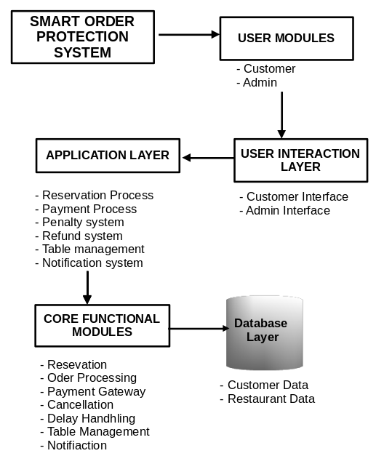

**6.2 UML Diagram**

**6.2.1 Use Case**

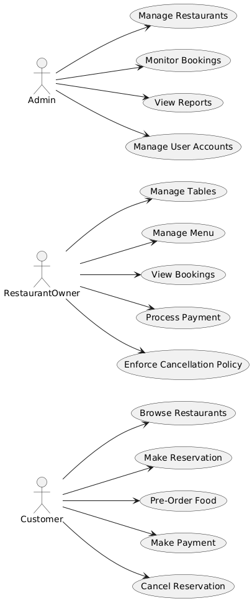

**6.2.2 Class Diagram**

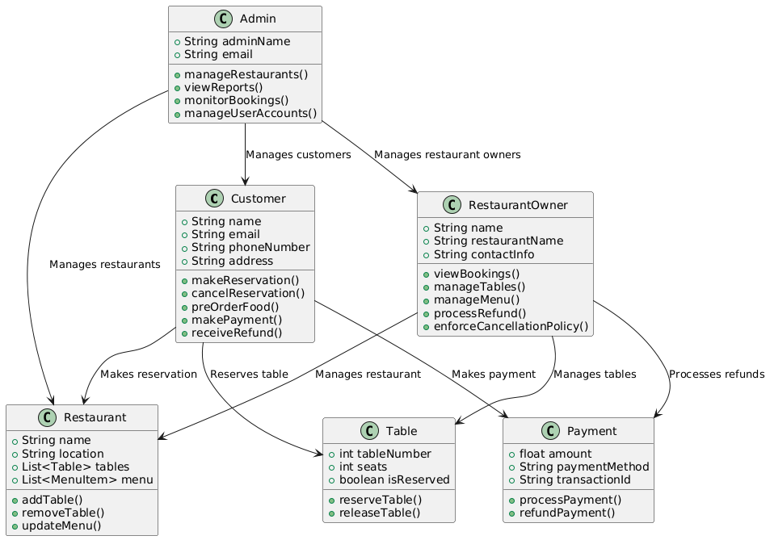

**6.2.3 Sequence Diagram**

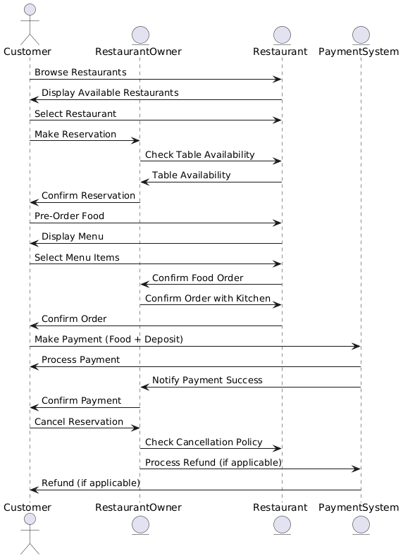

**6.3. ER DIAGRAM**

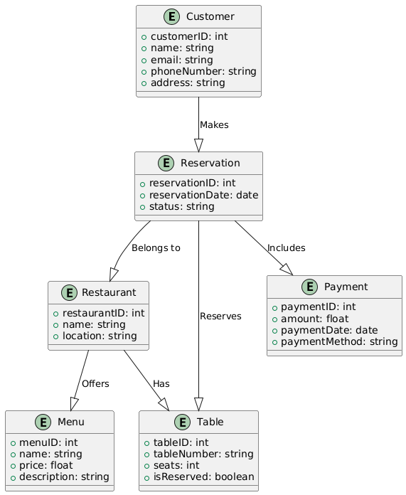

**6.4 BLOCK DIAGRAM**

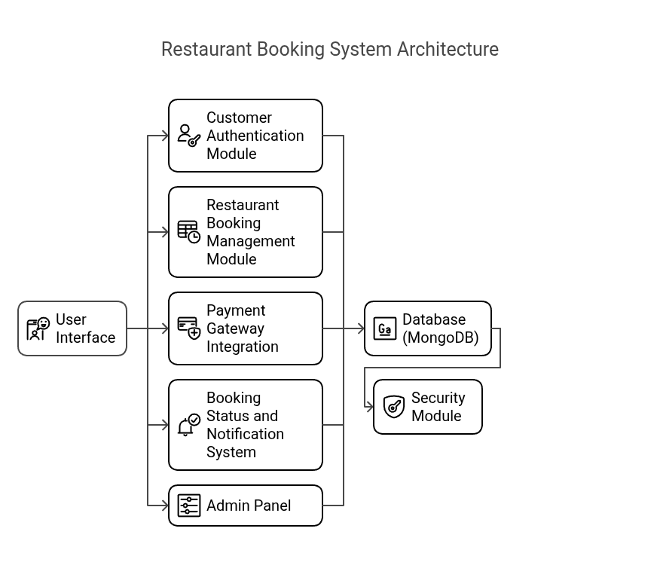

**CHAPTER 7**

**SYSTEM TESTING**

**7.1 SOFTWATRE TESTING**

Software Testing is a crucial phase in the Software Development Life Cycle (SDLC), as it ensures the application is functional, secure, reliable, and user-friendly. The purpose of software testing is to **identify bugs and ensure that the application meets user requirements** before deployment.

For our **Food Pre-Booking Web Application**, multiple testing techniques were applied during different stages of development to verify the functionality, performance, and security of the system.

**Unit Testing**

Unit testing is the process of testing individual components or functions of the application in isolation. It allows developers to ensure that each block of code works as expected before it's integrated with the rest of the system. For example, in this project, unit testing was applied to functions like **calculating the total cost including the refundable amount**, **validating booking data**, and **checking refund eligibility**. By testing these units independently, we ensured that each component performs accurately under different conditions. Unit testing also helps in early detection of bugs and reduces debugging time later in development.

* **Definition:** Testing individual components or functions in isolation.
* **Objective:** Ensure that each function performs its intended task correctly.
* **Example:** Testing the calculation function for total price, including extra amount.

#### ****Functional Testing****

Functional testing verifies whether the system meets the specified functional requirements. Each function of the application is tested to check if it delivers the correct output. In this project, functional testing was carried out for core modules such as **user login and registration**, **food and table booking**, **payment process**, **refund system**, and **admin booking updates**. These tests ensured that each part of the system behaves exactly as described in the requirement documents. It is one of the most critical testing types as it validates the application's main features from the user's perspective.

* **Definition:** Validating that the software works as per the functional requirements.
* **Objective:** Each function should deliver the correct output for given inputs.
* **Modules Tested:**
  + User login/signup
  + Booking process
  + Payment integration
  + Refund logic
  + Admin panel controls

#### ****Integration Testing****

Integration testing focuses on the interaction between multiple components of the application. In the Food Booking System, different modules such as the **frontend (Next.js)**, **backend (Express.js)**, **MongoDB database**, and **payment gateway** (like Razorpay) were tested together to ensure they communicate correctly. This type of testing verified whether the data sent from the user interface is properly handled by the backend, stored in the database, and whether the payment status is returned and processed correctly. Integration testing helps identify mismatches in data flow and logic between connected modules.

* **Definition:** Testing the interaction between integrated modules like database, backend API, and frontend.
* **Objective:** Ensure the flow between modules works without errors.
* **Example:** After payment, checking if booking data and refund status are correctly saved in MongoDB.

### ****User Interface (UI) Testing****

UI testing ensures that the graphical interface of the application is visually consistent and functional across different devices and screen sizes. Since users will interact with the system via web browsers on mobile and desktop, the interface must be intuitive and responsive. UI testing included checking layout responsiveness, button functionality, navigation between pages, color contrast, font readability, and the visibility of pop-up messages. A seamless user interface significantly enhances the user experience, which is vital for the success of any consumer-facing application.

* **Definition:** Testing the graphical interface and responsiveness.
* **Objective:** Ensure UI elements are working and rendering correctly across devices.
* **Focus Areas:**
  + Button clicks
  + Navigation
  + Form validations
  + Layout responsiveness

#### ****Security Testing****

Security testing plays a critical role in applications that handle sensitive user data and financial transactions. For the food pre-booking platform, security testing was conducted to ensure that **passwords are encrypted** (using hashing algorithms like bcrypt), **admin access is protected**, and **no unauthorized access** is possible. Also, it tested whether the application is vulnerable to **Cross-Site Scripting (XSS)** or **Cross-Site Request Forgery (CSRF)** attacks. The payment integration was also tested to confirm that sensitive payment data is handled only by the secure gateway and not stored locally.

* **Definition:** Ensuring that the application is protected against data breaches and unauthorized access.
* **Objective:** To maintain confidentiality and integrity of user data.
* **Tested Areas:**
  + Password encryption using bcrypt
  + Admin authentication
  + Secure handling of payment information
  + Prevention of XSS and CSRF attacks

### ****Negative Testing****

Negative testing is used to ensure that the system gracefully handles unexpected or invalid inputs. In this project, scenarios like **empty form submission**, **invalid email format**, **zero-amount payment**, and **unauthorized API access** were tested. This ensures that the system does not crash or behave unpredictably when it encounters incorrect input, and provides meaningful error messages to users. Negative testing helps strengthen the application's fault tolerance and user input validation mechanisms.

* **Definition:** Testing the system with invalid or unexpected inputs.
* **Objective:** To verify how the system behaves under error conditions.
* **Examples:**
  + Submitting empty forms
  + Entering invalid email or phone number
  + Trying to pay with zero amount

**System Testing**

System testing is the final phase where the entire application is tested as a whole. This includes the complete workflow from **user registration**, **food and table booking**, **payment**, to **refund or penalty application**. It ensures that all the modules, when combined, perform in a smooth, error-free manner. It also verifies that the business logic (like refunding only if the customer attends the booking) works correctly from start to finish. System testing is the last step before deployment, confirming the system is production-ready.

* **Definition:** End-to-end testing of the entire system as a whole.
* **Objective:** To validate complete system flow from booking to refund or no-show handling.
* **Outcome:** Ensures all modules work together seamlessly before deployment.

### ****Regression Testing****

Whenever a new feature is added or a bug is fixed, there's a risk that it may affect previously working parts of the system. Regression testing ensures that the existing functionalities are not broken by the recent changes. In this project, after implementing the refund automation and admin updates, regression testing was performed to confirm that **user booking**, **payment flow**, and **login** still functioned as intended. This type of testing helps maintain long-term stability of the application.

* **Definition:** Re-testing after bug fixes or new feature implementation.
* **Objective:** Ensure that previously working functionalities still work correctly.
* **When Used:** After changes in payment logic or refund API updates.

**7.2 TEST CASE**

#### ****User Registration and Authentication****

1. **Test Case ID: 1.1 - User Registration with valid details**
   * **Input:** Full Name, Email, Password
   * **Expected Result:** Registration successful, redirected to login page
   * **Actual Result:** User registered and redirected properly
   * **Status:** Pass
2. **Test Case ID: 1.2 - Duplicate email registration**
   * **Input:** Existing Email, Password
   * **Expected Result:** Error message: "Email already registered"
   * **Actual Result:** Error message displayed as expected
   * **Status:** Pass
3. **Test Case ID: 1.3 - Login with valid credentials**
   * **Input:** Valid Email & Password
   * **Expected Result:** Login successful, redirection to dashboard
   * **Actual Result:** User logged in and redirected to dashboard
   * **Status:** Pass
4. **Test Case ID: 1.4 - Invalid login credentials**
   * **Input:** Invalid Email/Password
   * **Expected Result:** Error: "Invalid credentials"
   * **Actual Result:** Error displayed as expected
   * **Status:** Pass
5. **Test Case ID: 1.5 - Password Reset Request**
   * **Input:** Registered Email
   * **Expected Result:** Password reset link sent to email
   * **Actual Result:** Link received successfully
   * **Status:** Pass

#### ****Booking and Reservation****

1. **Test Case ID: 2.1 - Booking attempt without selecting food**
   * **Input:** Selected Table only
   * **Expected Result:** Error: "Please select at least one food item"
   * **Actual Result:** Validation error displayed
   * **Status:** Pass
2. **Test Case ID: 2.2 - Booking with all valid inputs**
   * **Input:** Selected Table, Food Items, Date, Time
   * **Expected Result:** Redirect to payment gateway
   * **Actual Result:** Payment screen opened
   * **Status:** Pass
3. **Test Case ID: 2.3 - Booking with invalid date/time**
   * **Input:** Past Date/Time
   * **Expected Result:** Error: "Invalid booking date or time"
   * **Actual Result:** Date validation error displayed
   * **Status:** Pass

#### ****Payment and Refund****

1. **Test Case ID: 3.1 - Successful payment processing**
   * **Input:** Payment via Razorpay
   * **Expected Result:** Booking confirmed, success page shown
   * **Actual Result:** Booking confirmed
   * **Status:** Pass
2. **Test Case ID: 3.2 - Payment failure**
   * **Input:** Invalid card details
   * **Expected Result:** Error: "Payment failed"
   * **Actual Result:** Error displayed
   * **Status:** Pass
3. **Test Case ID: 3.3 - Refund after booking completion**
   * **Input:** Admin marks booking as complete
   * **Expected Result:** Refund processed to user
   * **Actual Result:** Refund completed successfully
   * **Status:** Pass

#### ****Booking Management****

1. **Test Case ID: 4.1 - Booking cancellation by user**
   * **Input:** Cancel action after payment
   * **Expected Result:** No refund, penalty applied
   * **Actual Result:** Penalty applied, no refund processed
   * **Status:** Pass
2. **Test Case ID: 4.2 - Admin marks booking as complete**
   * **Input:** Booking ID, Status: Completed
   * **Expected Result:** Receipt generated, booking marked complete
   * **Actual Result:** Receipt generated successfully
   * **Status:** Pass

#### ****Admin Access and Validation****

1. **Test Case ID: 5.1 - Invalid admin login**
   * **Input:** Wrong admin email/password
   * **Expected Result:** Error: "Invalid credentials"
   * **Actual Result:** Error displayed
   * **Status:** Pass
2. **Test Case ID: 5.2 - Unauthorized access to admin page**
   * **Input:** Direct admin URL without login
   * **Expected Result:** Redirect to admin login page
   * **Actual Result:** Redirection successful
   * **Status:** Pass
3. **Test Case ID: 5.3 - Admin managing booking status**
   * **Input:** Booking ID, Status update
   * **Expected Result:** Booking status updated successfully
   * **Actual Result:** Status updated correctly
   * **Status:** Pass

#### ****Form Validation****

1. **Test Case ID: 6.1 - Empty form submission**
   * **Input:** No values in required fields
   * **Expected Result:** Validation error messages
   * **Actual Result:** Error messages displayed for all fields
   * **Status:** Pass
2. **Test Case ID: 6.2 - Invalid email format during registration**
   * **Input:** Incorrect email format
   * **Expected Result:** Error: "Invalid email format"
   * **Actual Result:** Error displayed as expected
   * **Status:** Pass

**7.3 TEST REPORT**

#### ****Introduction****

The **Test Report** for the **Pre Food Booking and Table Reservation System** provides a comprehensive overview of the testing process, results, and analysis conducted on the system. The purpose of this report is to document the testing activities and outcomes to ensure the system meets the specified requirements and functions as expected.

The report covers various aspects of the testing process, including test objectives, test cases executed, testing environment, test results, and identified defects (if any). It helps stakeholders understand the quality, reliability, and performance of the system.

The primary objective of this test report is to validate that the **Pre Food Booking and Table Reservation System** operates seamlessly, ensuring a smooth user experience for customers, efficient booking management for restaurant owners, and secure administration for system administrators.

#### ****Test Summary****

The **Test Summary** for the **Pre Food Booking and Table Reservation System** provides a brief overview of the testing activities conducted and their outcomes. The system was tested across multiple functional areas, including user registration, login, booking management, payment processing, and admin functionalities.

A total of **18 test cases** were designed and executed, covering all major functionalities of the system. These test cases were categorized into six main sections:

* **User Registration and Authentication:** Ensured that users could register, log in, reset passwords, and access their accounts securely.
* **Booking and Reservation:** Verified the process of booking tables and food items, ensuring that users could make reservations with accurate details.
* **Payment and Refund:** Tested the payment gateway integration and refund mechanism to ensure secure and accurate transactions.
* **Booking Management:** Validated that users and admins could manage bookings, including cancellations, status updates, and refunds.
* **Admin Access and Validation:** Ensured secure access to the admin panel and proper functionality for admin operations.
* **Form Validation:** Checked the system's ability to handle invalid inputs and display appropriate error messages.

**Test Objective**

The main objectives of this testing process were to:

* Verify that the application functions as per the specified requirements.
* Ensure the accuracy and reliability of the booking and payment modules.
* Validate user access levels for both normal users and admin users.
* Check integration points such as payment gateway (Razorpay) and image storage (Cloudinary).
* Detect any possible bugs, security loopholes, or logical errors in the system.
* Evaluate the application's behavior under invalid or unexpected input conditions.

By achieving these objectives, we aim to deliver a high-quality product that ensures user satisfaction and operational integrity.

**Test Scope**

The scope of testing includes all major components of the system: frontend developed in Next.js, backend powered by Express.js, MongoDB for data storage, Razorpay for payment integration, and Cloudinary for image uploads. This testing also covers booking lifecycle events from food selection to payment and refund processing. Both positive and negative scenarios were tested to ensure robustness. However, non-functional aspects such as performance testing, load testing, and mobile responsiveness testing were not included in this cycle and are planned for future iterations.

**Test Environment**

**Operating System:** Windows 10 / Linux / MacOS

**Backend:** Node.js, Express.js

**Frontend:** Next.js, React.js

**Database:** MongoDB

**Cloud Storage:** Cloudinary

**Payment Gateway:** Razorpay

**Browser Compatibility:** Chrome, Firefox, Edge

**Conclusion**

The **Test Conclusion** of the **Pre Food Booking and Table Reservation System** confirms that the system has been thoroughly tested, and all core functionalities have been validated against the specified requirements. The testing process involved a detailed examination of user registration, booking management, payment processing, and administrative control, ensuring that the system operates as intended.

All **18 test cases** were successfully executed, with a **100% pass rate**, indicating that the system is stable, reliable, and ready for deployment. No critical defects were identified during the testing phase, and the system has demonstrated robust performance under various scenarios.

The system's user interface is user-friendly, the booking process is efficient, payment transactions are secure, and the admin module is well-protected with appropriate access controls. Any minor issues encountered were resolved during the testing phase.

In conclusion, the **Pre Food Booking and Table Reservation System** meets the desired quality standards and is prepared for real-world use. Further improvements, if necessary, can be made based on user feedback in the future.

**CHAPTER 8**

**PROJECT DESCRIPTION**

**8.1 PROJECT DESCRIPTION**

The **Online Food Pre-Booking and Reservation System** is a modern web-based application designed to enhance the dining experience for both customers and restaurant owners. The core idea of the project is to allow users to reserve tables and pre-order food items from their preferred restaurants in advance, especially during peak hours, festivals, or special occasions. Unlike traditional booking systems, this project introduces a unique **pre-booking model** where customers pay an **additional refundable amount** during the time of booking. This amount acts as a commitment charge and ensures that users show up as planned. Once the customer visits the restaurant and consumes the food they pre-ordered, the system automatically initiates a **refund** for the extra amount paid. However, if the customer fails to show up without proper cancellation, the extra amount is considered **non-refundable**, and a **penalty** may also be applied. This helps reduce food waste and improves time management for restaurant staff.

The system provides a seamless and intuitive user interface built using **Next.js** for fast performance and SSR (Server Side Rendering), while **Express.js** handles the backend operations and APIs. **MongoDB** is used for storing user data, food menus, bookings, and transaction logs efficiently in a document-based structure. The application integrates **Razorpay** to manage real-time, secure payment transactions and uses **Cloudinary** for optimized image hosting of food items and restaurant banners. Users can browse menus, choose their preferred items, select a time slot, and make the booking in just a few clicks. An **admin dashboard** is also available where restaurant staff can manage bookings, view attendance status, process refunds, and update menus.

The project aims to bridge the gap between restaurant services and tech-savvy customers by offering convenience, transparency, and control over their dining schedules. The built-in refund and penalty logic ensures commitment from customers and helps restaurants plan their resources efficiently. With the ability to scale, support multiple branches, and integrate with third-party tools, this system is not only user-focused but also business-friendly. It brings together the power of full-stack development, cloud services, and real-time payments to build a next-generation food reservation solution that is efficient, reliable, and future-ready.

**8.2 MODULES**

**8.2.1 User Module:**

The **User Module** is the foundation of the system, allowing users to interact with the platform. This module manages user registration, login, profile management, and password recovery. It ensures secure user authentication through encrypted passwords and offers a user-friendly interface for account management. Registered users can update their profiles, change passwords, and securely log in to access the reservation and ordering services. This module is essential for maintaining user data and providing personalized experiences.

#### ****8.2.2 Reservation Module:****

The **Reservation Module** is the core of the system, enabling users to book tables in their preferred restaurants. Users can select a date, time, and table size, ensuring availability before proceeding with the booking. This module also integrates with the food ordering system, allowing customers to pre-order food items while reserving a table. It ensures that users cannot make duplicate bookings and provides a seamless experience by confirming reservations instantly. The module is designed for efficient management of available tables and time slots.

#### ****8.2.3 Food Ordering Module:****

The **Food Ordering Module** provides a digital menu for users, allowing them to browse and select dishes during the reservation process. It categorizes menu items for easy selection and calculates the total cost in real-time. Users can customize orders by choosing quantities and options (like spice levels). This module ensures that only available items are displayed, and the selection is directly linked to the reservation. It simplifies the ordering process, making it quick and intuitive for users.

#### ****8.2.4 Payment Module:****

The **Payment Module** is responsible for secure transaction management, handling payments for reservations and food orders. It integrates with reliable payment gateways (like Razorpay or Stripe) to offer multiple payment options, including credit/debit cards, UPI, and digital wallets. This module also manages the refundable deposit for reservations, ensuring that users are charged a deposit that is refunded upon successful visit. The Payment Module guarantees secure transactions with HTTPS encryption and processes refunds automatically in case of eligible scenarios.

#### ****8.2.5 Booking Management Module:****

The **Booking Management Module** is designed for users and restaurant owners to monitor and manage reservations. Customers can view their booking history, cancel reservations, and check their booking status. Restaurant owners, on the other hand, can view all incoming bookings, update their status (Confirmed, Completed, Canceled), and manage table availability. This module streamlines the process of handling reservations, ensuring that both customers and restaurant owners have complete control over their bookings.

#### ****8.2.6 Admin Module:****

The **Admin Module** is an exclusive section for system administrators, providing them with complete control over the system. Admins can manage user accounts, restaurant details, and monitor all bookings. They have the authority to update booking statuses, handle refund processing, and enforce cancellation policies. This module also offers analytics and reports for admin users, helping them track system performance and manage users efficiently. Security is a priority, with strict access control for admin users.

#### ****8.2.7 Notification Module:****

The **Notification Module** ensures that users and restaurant owners receive real-time updates regarding their reservations. Automated emails and messages are sent for booking confirmations, cancellations, and refund statuses. This module helps maintain clear communication between the platform and its users, ensuring that they are always aware of their booking status. Notifications are triggered automatically based on user actions or admin updates, making it a critical part of user experience management.

#### ****8.2.8 Security Module:****

The **Security Module** is responsible for safeguarding user data, payment information, and system access. It uses password hashing for user authentication, SSL encryption for payment processing, and secure access control for the admin panel. This module also implements security measures against common threats like SQL injection, cross-site scripting (XSS), and unauthorized access. It ensures that the platform is secure for all users, maintaining trust and data integrity.

**8.3 ALGORITHMS**

### 1. ****Time-Slot Allocation Algorithm****

**Purpose:**  
To manage time-based booking availability and prevent multiple bookings in the same slot.

**Explanation:**  
This algorithm ensures each time slot has a limited number of bookings. When a customer selects a slot, the system checks slot capacity. If the slot reaches its max count, it becomes unavailable.

**Use in Project:**  
Ensures restaurants can manage kitchen workflow by not overcrowding any time period.

### 2. ****Auto-Cancellation Algorithm****

**Purpose:**  
To automatically cancel orders if the customer fails to collect food within the booked slot.

**Explanation:**  
A scheduled check compares current time with the booked slot time. If time exceeds and the order isn't collected, status is marked as "Cancelled".

**Use in Project:**  
Reduces manual follow-up and food wastage. Maintains punctuality.

### 3. ****Payment Validation Algorithm****

**Purpose:**  
To confirm successful payment before booking confirmation.

**Explanation:**  
The system integrates with a payment gateway (like Razorpay) and waits for the callback response. If payment is successful, only then booking is confirmed.

**Use in Project:**  
Ensures no unpaid bookings are allowed.

### 4. ****Booking Conflict Detection Algorithm****

**Purpose:**  
To avoid duplicate or overlapping bookings.

**Explanation:**  
Checks whether the user has already made a booking in the selected time slot. If yes, it restricts another booking for the same slot.

**Use in Project:**  
Prevents confusion and misuse of the system.

### 5. ****Food Availability Check Algorithm****

**Purpose:**  
To check if the selected food item is available for that time slot.

**Explanation:**  
Each food item may have limited availability for a time. If stock is depleted for that slot, system blocks further booking.

**Use in Project:**  
Avoids overbooking and customer disappointment.

### 6. ****Secure Image Upload Algorithm****

**Purpose:**  
To safely upload and retrieve food images without performance loss.

**Explanation:**  
Images are uploaded via API to Cloudinary with secure tokens and public IDs, ensuring optimized access and storage.

**Use in Project:**  
Speeds up loading and keeps UI attractive without burdening the main server.

### 7. ****Session/Token Authentication Algorithm****

**Purpose:**  
To protect user data and ensure secure login sessions.

**Explanation:**  
JWT (JSON Web Token) or session-based auth is used to validate users during booking, payment, and collection.

**Use in Project:**  
Improves security and prevents unauthorized access.

### 8. ****Search & Filter Algorithm (Optional UI Feature)****

**Purpose:**  
To allow users to quickly find food based on category, time, or popularity.

**Explanation:**  
Implements search queries with MongoDB’s regex and filters to narrow down results.

**CHAPTER 9**

**SYSTEM IMPLEMENTATION**

**9.1 FEXIBILITY STUDY**

The **Pre Food Booking and Table Reservation System** is designed with a high degree of flexibility to adapt to changing business requirements, technological advancements, and evolving user needs. The system's modular architecture ensures that new features and modules can be added or updated independently without disrupting other parts of the platform. This modular approach allows for easy integration with third-party services such as payment gateways, customer relationship management tools, and even new food delivery services. For example, if there is a need to introduce a new payment method or add a loyalty program, these can be seamlessly integrated into the system.

The **user interface (UI)** is another area where flexibility is built-in. It is designed to be responsive, meaning it works seamlessly across various devices such as desktops, tablets, and mobile phones. The UI can be modified easily to accommodate new features, enhance user experience, or reflect branding changes. Whether adding new filters for food selection or adjusting layout elements, the interface is built to adapt to evolving trends without significant rework.

In terms of **database flexibility**, the system uses **MongoDB**, a NoSQL database that is inherently scalable and capable of handling large amounts of unstructured data. The database can grow horizontally as more users and restaurants join the platform, ensuring that performance remains optimal even during periods of high demand. The database schema is also adaptable, allowing for new data types or fields to be introduced without disrupting existing functionality.

The system is also built to scale efficiently, both in terms of user base and operational load. By utilizing cloud hosting services like AWS or Azure, the system can automatically adjust its resources based on demand, ensuring that it performs well during peak times without downtime. Whether the number of users grows or more restaurants join the platform, the system’s backend can scale horizontally by adding more servers or resources.

Customization is another area where the system shines. Restaurant owners can easily customize their digital menus, booking policies, and available time slots to suit their specific needs. This customization extends to pricing models and discount strategies, allowing for flexibility in handling seasonal offers or special promotions. Furthermore, the **Security Module** ensures that the system can adapt to future security requirements, implementing new encryption techniques or authentication methods to meet the latest compliance standards.

**CHAPTER 10**

**CONCLUSION AND FUTURE ENHANCEMENT**

### ****Conclusion****

In conclusion, the **Pre Food Booking and Table Reservation System** provides a comprehensive and flexible solution for modern restaurants, enhancing both customer experience and operational efficiency. Through its modular architecture, scalable infrastructure, and seamless integration with third-party services, the system ensures that it can adapt to evolving business requirements and technological advancements. The user-friendly interface and customizable features allow restaurant owners to tailor the system to their unique needs, while the robust security measures ensure data protection and compliance with industry standards.

The system’s ability to handle an increasing number of users and restaurants while maintaining performance is a key advantage, making it suitable for businesses of all sizes. Additionally, the integration of a refundable deposit mechanism promotes accountability and reduces food wastage, ensuring a better dining experience for customers and improved planning for restaurant owners.

Overall, the system offers a smart solution for both restaurants and customers, promoting convenience, flexibility, and efficiency in the hospitality industry. With its scalable design, it is well-equipped to meet the future needs of the industry and provide continuous value to its users.

### ****Future Enhancement****

The **Pre Food Booking and Table Reservation System** lays a strong foundation for streamlining restaurant operations and improving customer experience. However, there are several opportunities for future enhancements that could further elevate the system’s functionality, flexibility, and user satisfaction.

#### ****1. AI-Based Personalized Recommendations:****

One of the most impactful future enhancements could be the integration of Artificial Intelligence (AI) to offer personalized food recommendations based on the customer’s previous orders, dietary preferences, and ratings. This AI-powered recommendation engine can analyze a customer’s past behavior and suggest new dishes or drinks, improving customer satisfaction and encouraging repeat bookings.

#### ****2. Voice-Activated Booking:****

As voice assistants like Amazon Alexa and Google Assistant become more popular, integrating voice-based food and table booking could be a valuable feature. Customers could make reservations, select food, and complete their orders simply by using voice commands, adding an additional layer of convenience and accessibility to the system.

#### ****3. Real-Time Waitlist Management:****

A future enhancement could include a **real-time waitlist feature**, where customers can join a virtual queue if all tables are booked. This system would allow users to view real-time availability and estimated wait times, enhancing the booking experience and improving restaurant management during busy periods. It could also allow users to pre-select food from the menu while they wait, reducing wait times once they are seated.

#### ****4. Integration with Smart Devices:****

As more restaurants adopt smart kitchen technologies and devices, integrating the system with these tools can improve operational efficiency. For example, the system could interface with smart ovens or food preparation devices, automatically sending the kitchen real-time orders based on pre-booked meals. This integration would help ensure food is prepared on time, reducing the chances of delays or errors in the order.

#### ****5. Loyalty and Reward Programs:****

The addition of a **loyalty program** could further enhance customer engagement. Customers who frequently use the system could earn points for each booking, which could be redeemed for discounts, free meals, or other perks. This would incentivize repeat business and help restaurants build stronger relationships with customers.

#### ****6. Multi-Location and Franchise Support:****

For restaurant chains or franchises, enabling the system to manage multiple locations would be beneficial. This feature would allow franchise owners to oversee operations across various branches, view booking histories, customer preferences, and performance metrics from a centralized dashboard.

#### ****7. Advanced Analytics and Reporting:****

Future versions of the system could offer more advanced analytics and reporting features for restaurant owners and managers. These could include in-depth insights into customer preferences, booking trends, revenue reports, food waste analysis, and other operational data. By utilizing these insights, restaurants could optimize their menu, improve service, and streamline operations.

#### ****8. Mobile App Development:****

While the current system is web-based, developing dedicated **mobile applications** for iOS and Android would provide customers with more convenient access to the platform. These apps could include features like push notifications for booking confirmations, reminders, and special offers, providing a more engaging and user-friendly experience.

#### ****9. Social Media Integration:****

Incorporating **social media sharing** options within the system would allow customers to easily share their booking experience, meals, and reviews on platforms like Instagram, Facebook, or Twitter. This could help increase visibility for the restaurant and serve as a marketing tool to attract new customers.

#### ****10. Sustainability Features:****

As sustainability becomes an increasing priority, integrating features that support eco-friendly practices could be a key enhancement. For example, the system could track food waste, suggest smaller portions based on previous orders, or allow customers to make eco-conscious choices when booking, such as selecting plant-based menu options.

**APPENDIX 1**

**SCREENSHOTS**

**ADMIN PAGES**

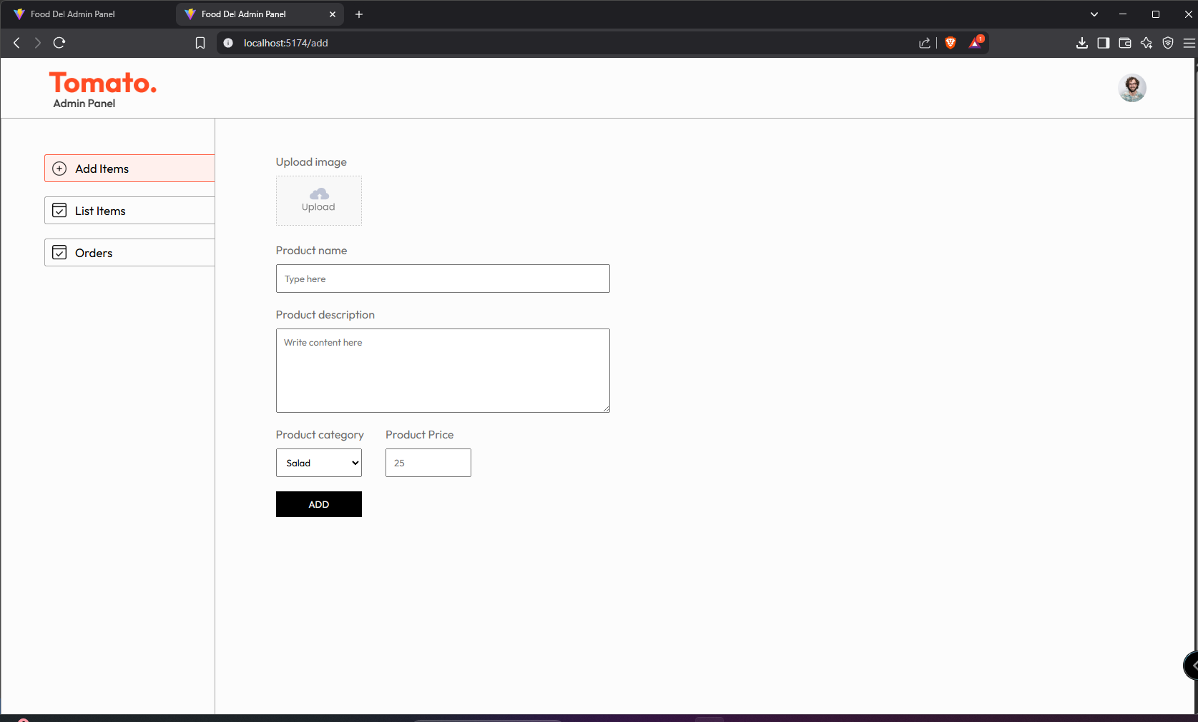Adding new item page

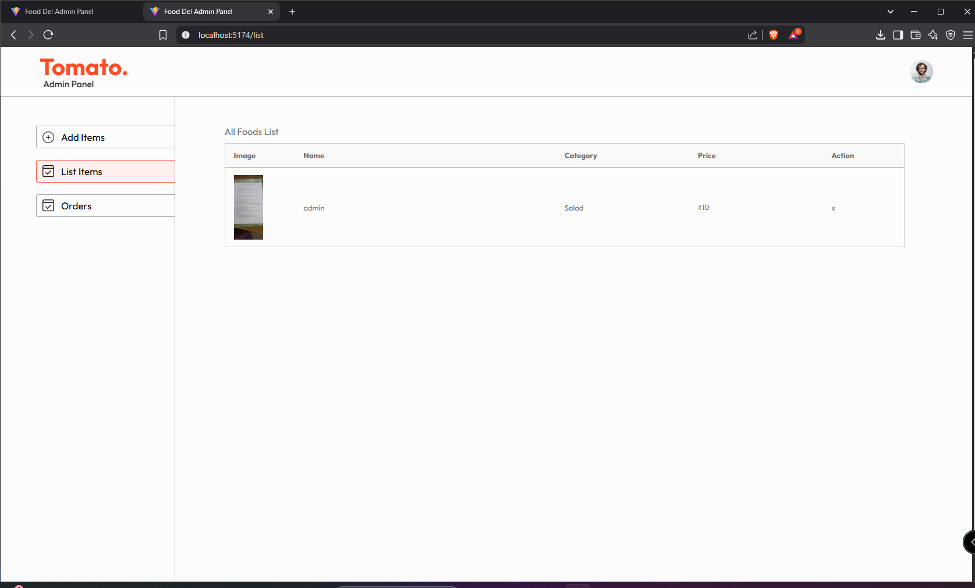List of Items page

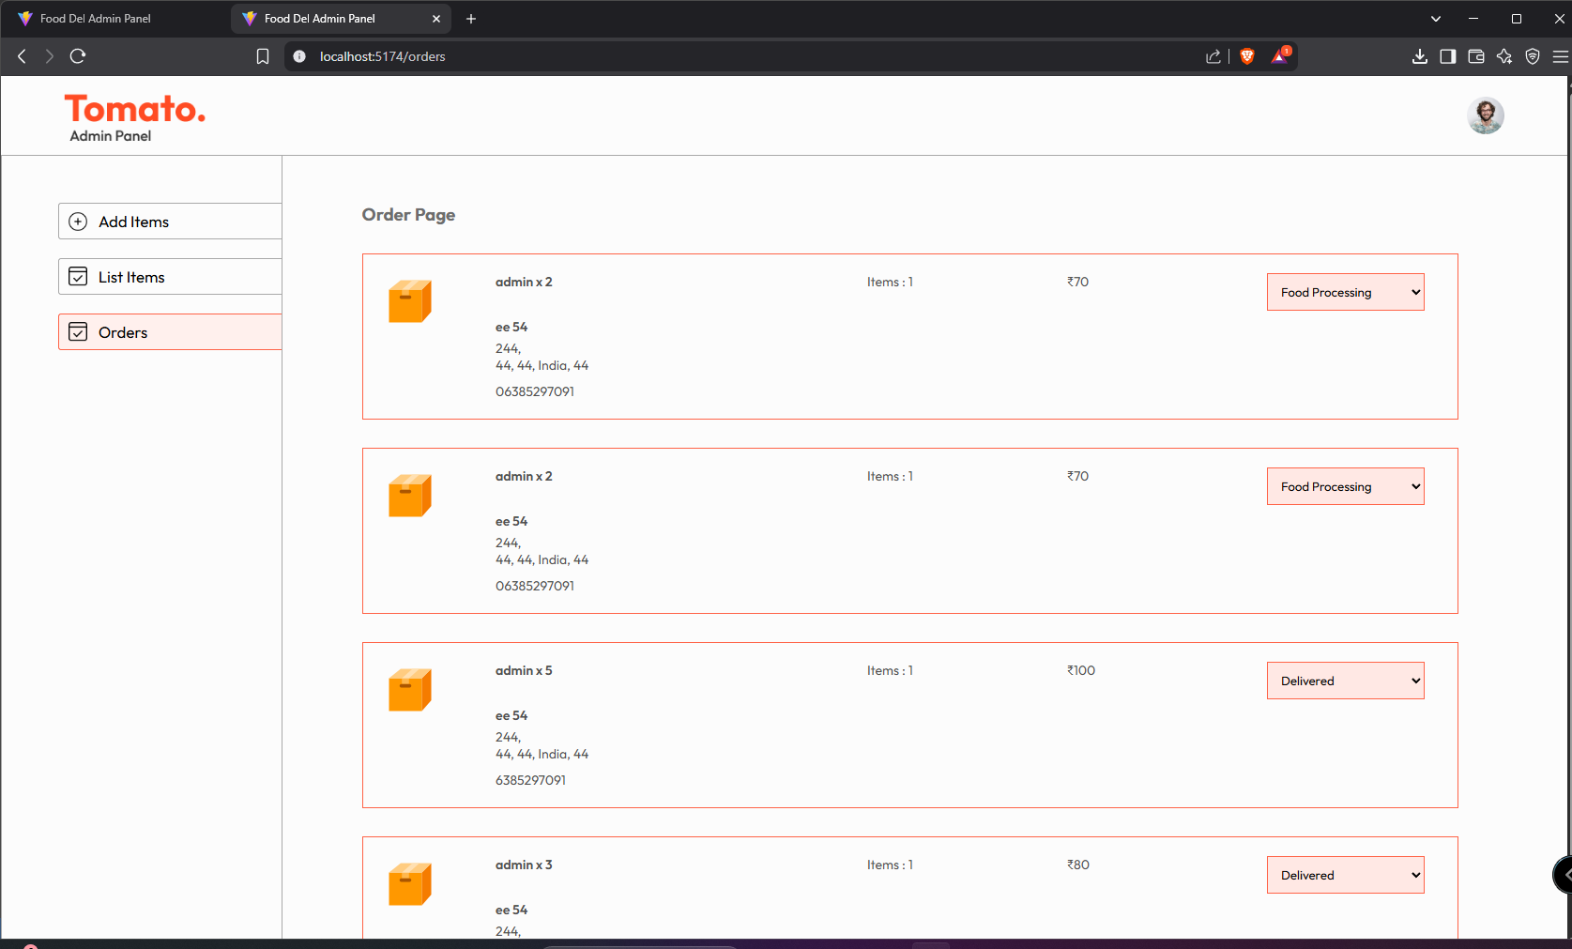order detail page

User Pages

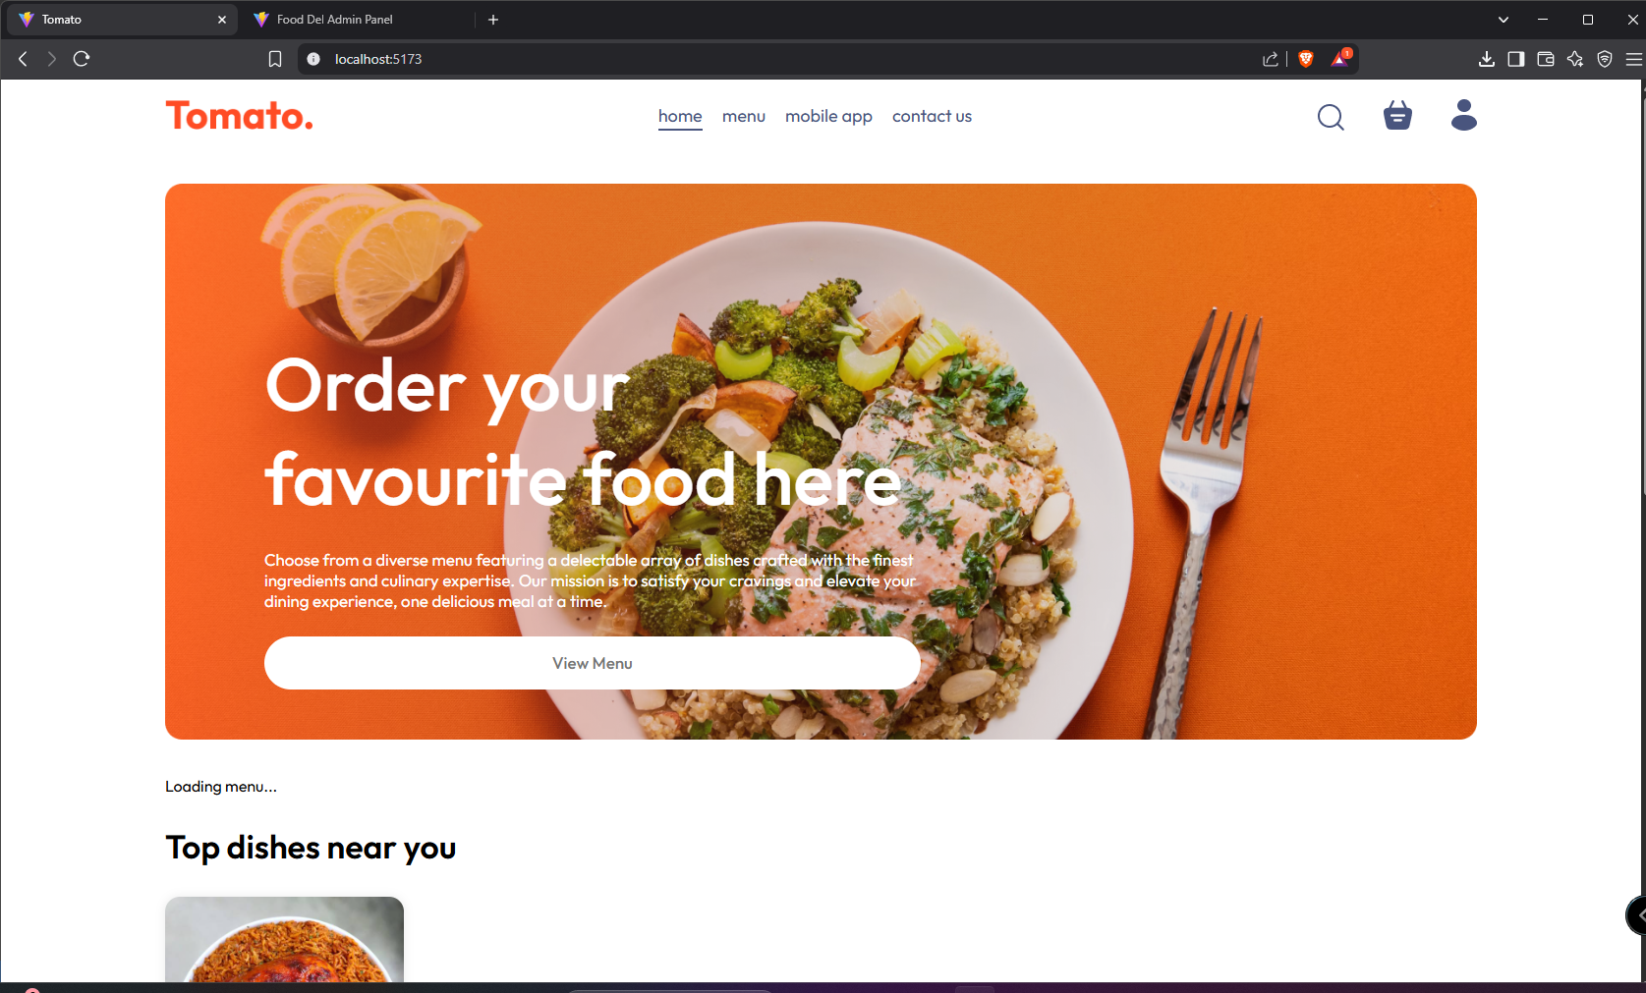Home page

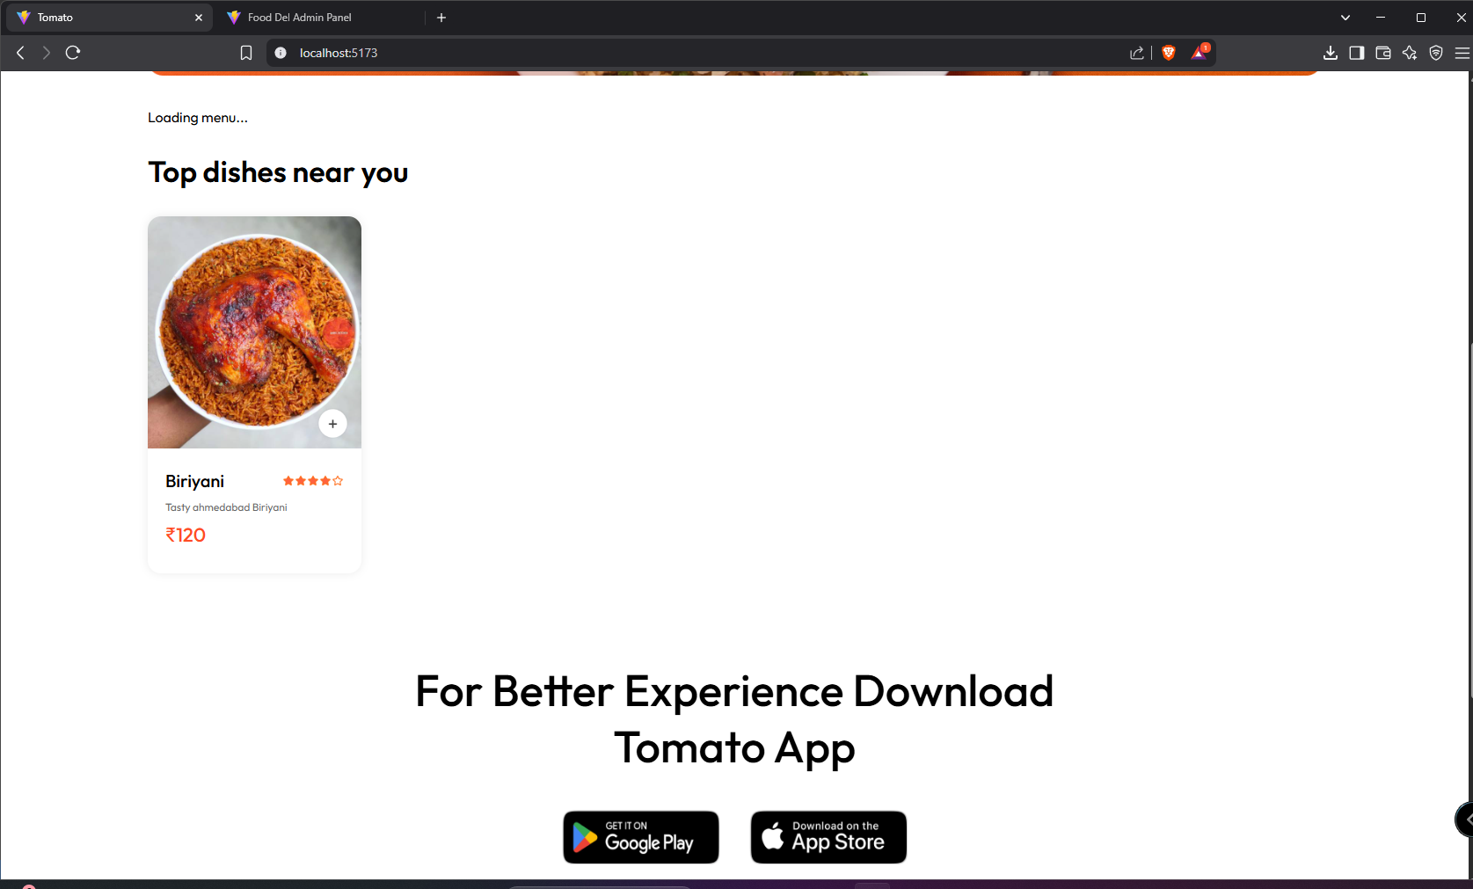Dishes list page

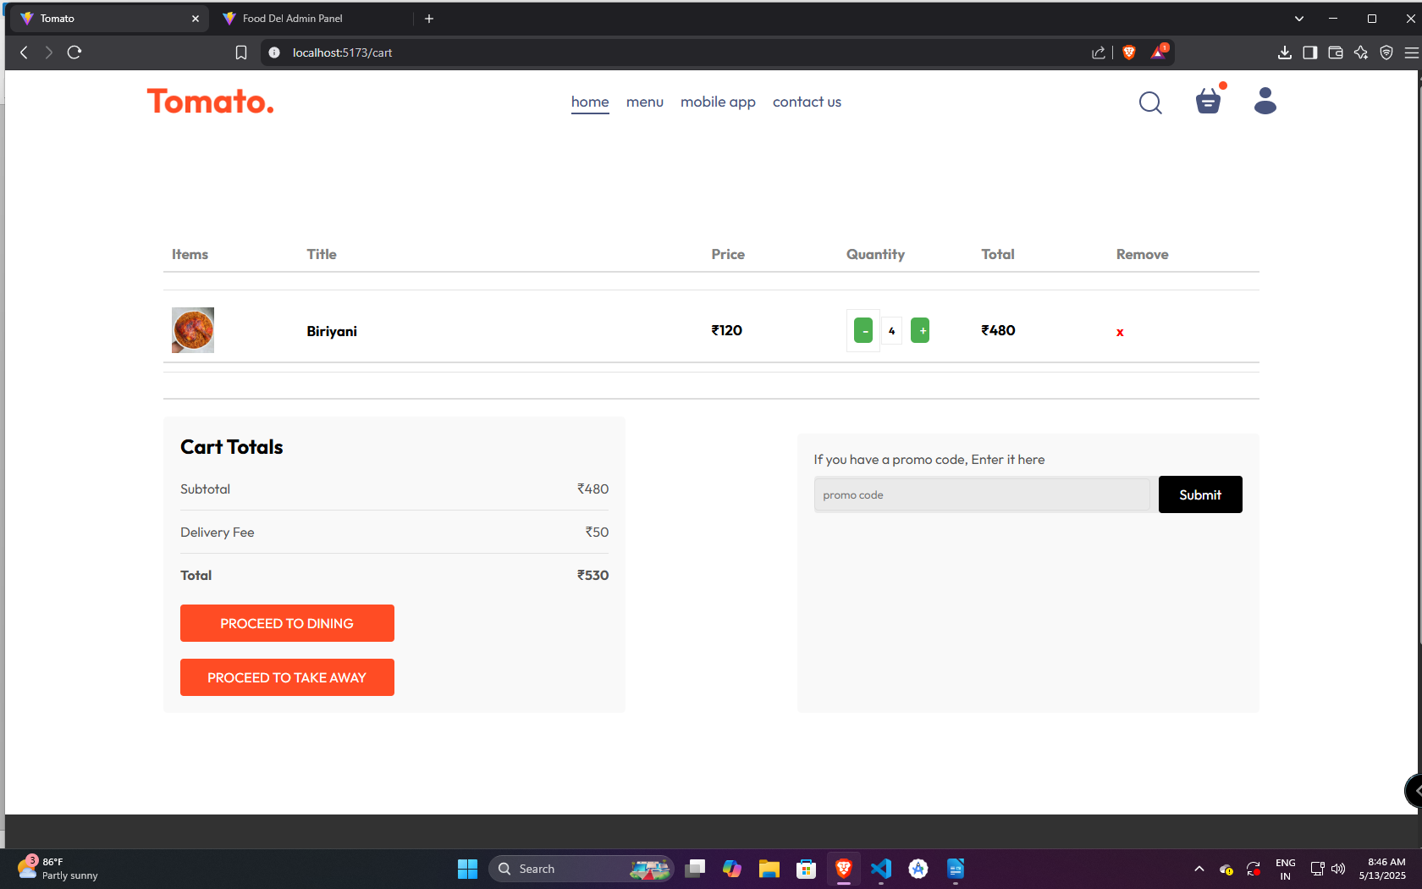Cart Page

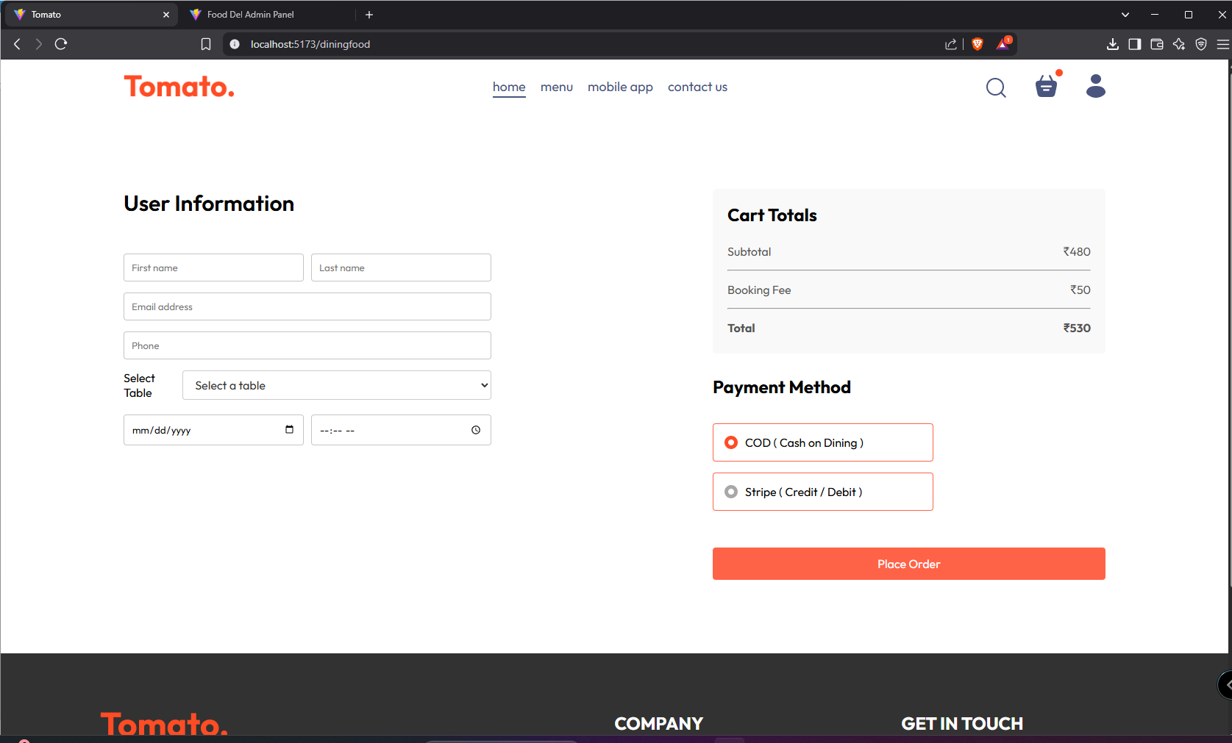Table booking

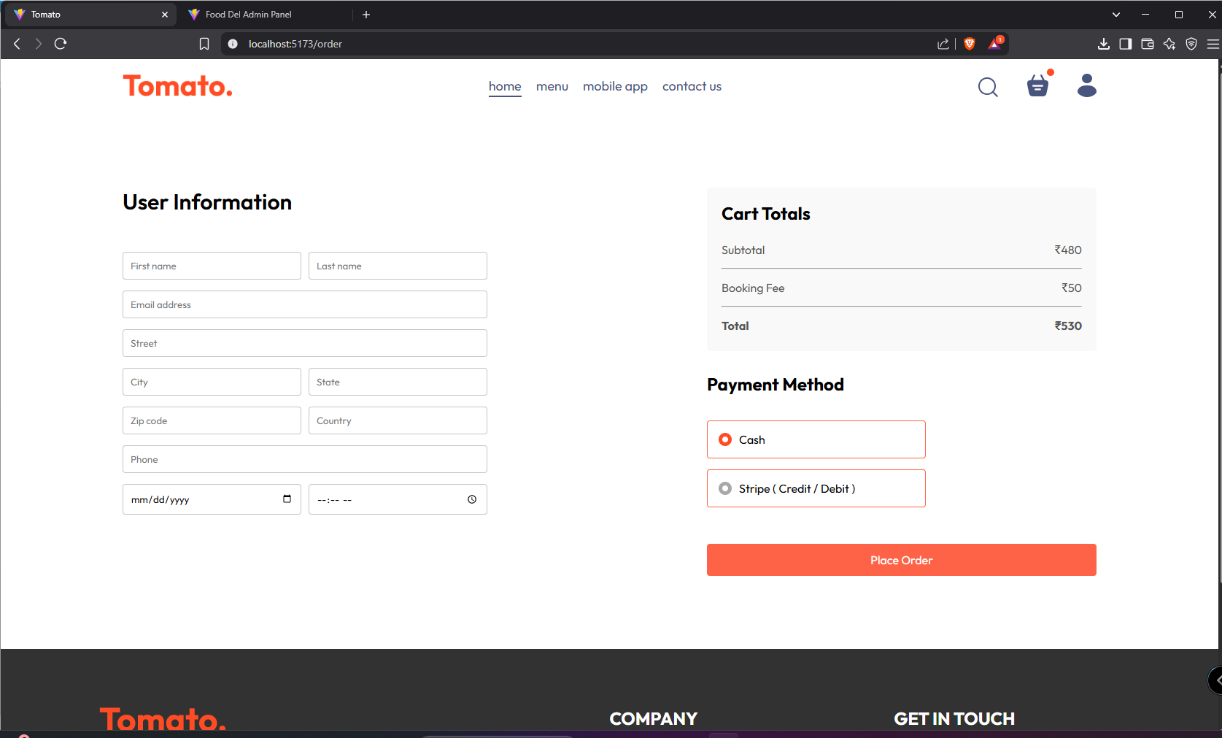TakeAway Booking

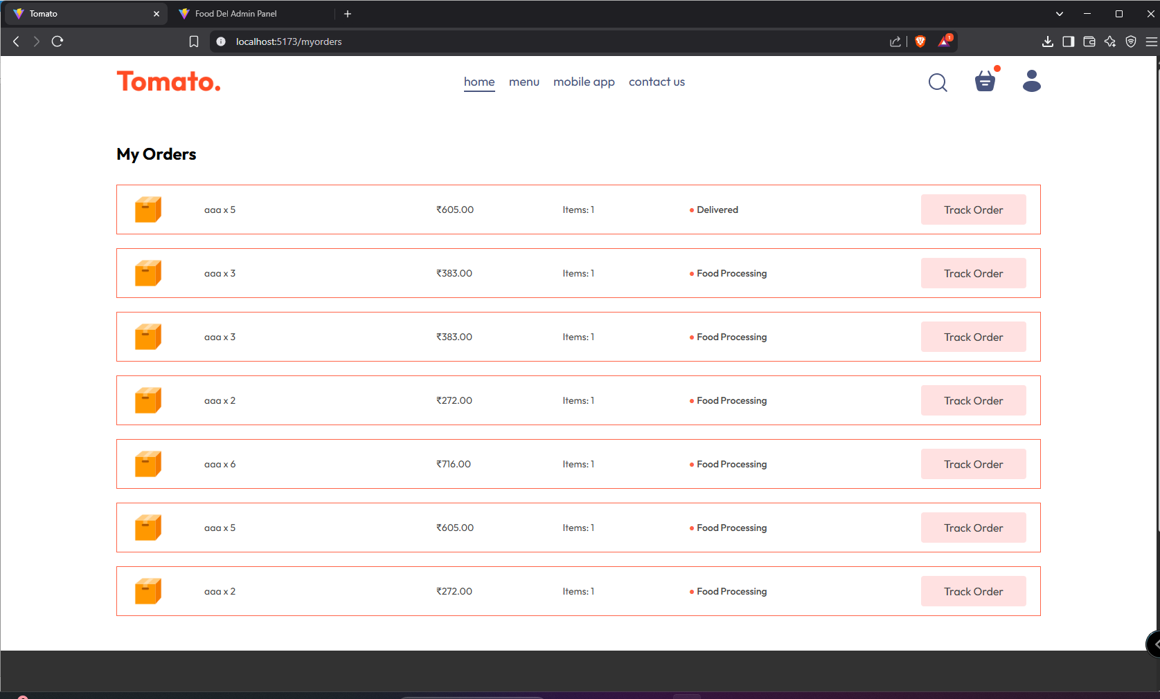Order Tracking page

**APPENDIX 3**

**SOURCE CODE**

import React, { useContext } from 'react';

import './Cart.css';

import { StoreContext } from '../../Context/StoreContext';

import { useNavigate } from 'react-router-dom';

const Cart = () => {

  const { cartItems, food_list, removeFromCart, getTotalCartAmount, url, currency, deliveryCharge, updateCartItemQuantity } = useContext(StoreContext);

  const navigate = useNavigate();

  // Function to handle adding to the quantity

  const handleIncrease = (itemId) => {

    updateCartItemQuantity(itemId, cartItems[itemId] + 1); // Increase the quantity by 1

  };

  // Function to handle decreasing the quantity

  const handleDecrease = (itemId) => {

    if (cartItems[itemId] > 1) {

      updateCartItemQuantity(itemId, cartItems[itemId] - 1); // Decrease the quantity by 1, but not below 1

    }

  };

  return (

    <div className='cart'>

      <div className="cart-items">

        <div className="cart-items-title">

          <p>Items</p> <p>Title</p> <p>Price</p> <p>Quantity</p> <p>Total</p> <p>Remove</p>

        </div>

        <br />

        <hr />

        {food_list.map((item, index) => {

          if (cartItems[item._id] > 0) {

            return (

              <div key={index}>

                <div className="cart-items-title cart-items-item">

                  <img src={url + "/images/" + item.image} alt="" />

                  <p>{item.name}</p>

                  <p>{currency}{item.price}</p>

                  <div className="cart-items-quantity">

                    <button className="quantity-btn" onClick={() => handleDecrease(item._id)}>-</button>

                    <div>{cartItems[item._id]}</div>

                    <button className="quantity-btn" onClick={() => handleIncrease(item._id)}>+</button>

                  </div>

                  <p>{currency}{item.price * cartItems[item._id]}</p>

                  <p className='cart-items-remove-icon' onClick={() => removeFromCart(item._id)}>x</p>

                </div>

                <hr />

              </div>

            );

          }

        })}

      </div>

      <div className="cart-bottom">

        <div className="cart-total">

          <h2>Cart Totals</h2>

          <div>

            <div className="cart-total-details"><p>Subtotal</p><p>{currency}{getTotalCartAmount()}</p></div>

            <hr />

            <div className="cart-total-details"><p>Delivery Fee</p><p>{currency}{getTotalCartAmount() === 0 ? 0 : deliveryCharge}</p></div>

            <hr />

            <div className="cart-total-details"><b>Total</b><b>{currency}{getTotalCartAmount() === 0 ? 0 : getTotalCartAmount() + deliveryCharge}</b></div>

          </div>

          <button onClick={() => navigate('/order')}>PROCEED TO CHECKOUT</button>

        </div>

        <div className="cart-promocode">

          <div>

            <p>If you have a promo code, Enter it here</p>

            <div className='cart-promocode-input'>

              <input type="text" placeholder='promo code'/>

              <button>Submit</button>

            </div>

          </div>

        </div>

      </div>

    </div>

  );

};

export default Cart;

import React, { useEffect, useState } from 'react'

import './List.css'

import { url, currency } from '../../assets/assets'

import axios from 'axios';

import { toast } from 'react-toastify';

const List = () => {

  const [list, setList] = useState([]);

  const fetchList = async () => {

    const response = await axios.get(`${url}/api/food/list`)

    if (response.data.success) {

      setList(response.data.data);

    }

    else {

      toast.error("Error")

    }

  }

  const removeFood = async (foodId) => {

    const response = await axios.post(`${url}/api/food/remove`, {

      id: foodId

    })

    await fetchList();

    if (response.data.success) {

      toast.success(response.data.message);

    }

    else {

      toast.error("Error")

    }

  }

  useEffect(() => {

    fetchList();

  }, [])

  return (

    <div className='list add flex-col'>

      <p>All Foods List</p>

      <div className='list-table'>

        <div className="list-table-format title">

          <b>Image</b>

          <b>Name</b>

          <b>Category</b>

          <b>Price</b>

          <b>Action</b>

        </div>

        {list.map((item, index) => {

          return (

            <div key={index} className='list-table-format'>

              <img src={`${url}/images/` + item.image} alt="" />

              <p>{item.name}</p>

              <p>{item.category}</p>

              <p>{currency}{item.price}</p>

              <p className='cursor' onClick={() => removeFood(item._id)}>x</p>

            </div>

          )

        })}

      </div>

    </div>

  )

}

export default List

import React, { useEffect, useState } from 'react'

import './Orders.css'

import { toast } from 'react-toastify';

import axios from 'axios';

import { assets, url, currency } from '../../assets/assets';

const Order = () => {

  const [orders, setOrders] = useState([]);

  const fetchAllOrders = async () => {

    const response = await axios.get(`${url}/api/order/list`)

    if (response.data.success) {

      setOrders(response.data.data.reverse());

    }

    else {

      toast.error("Error")

    }

  }

  const statusHandler = async (event, orderId) => {

    console.log(event, orderId);

    const response = await axios.post(`${url}/api/order/status`, {

      orderId,

      status: event.target.value

    })

    if (response.data.success) {

      await fetchAllOrders();

    }

  }

  useEffect(() => {

    fetchAllOrders();

  }, [])

  return (

    <div className='order add'>

      <h3>Order Page</h3>

      <div className="order-list">

        {orders.map((order, index) => (

          <div key={index} className='order-item'>

            <img src={assets.parcel_icon} alt="" />

            <div>

              <p className='order-item-food'>

                {order.items.map((item, index) => {

                  if (index === order.items.length - 1) {

                    return item.name + " x " + item.quantity

                  }

                  else {

                    return item.name + " x " + item.quantity + ", "

                  }

                })}

              </p>

              <p className='order-item-name'>{order.address.firstName + " " + order.address.lastName}</p>

              <div className='order-item-address'>

                <p>{order.address.street + ","}</p>

                <p>{order.address.city + ", " + order.address.state + ", " + order.address.country + ", " + order.address.zipcode}</p>

              </div>

              <p className='order-item-phone'>{order.address.phone}</p>

            </div>

            <p>Items : {order.items.length}</p>

            <p>{currency}{order.amount}</p>

            <select onChange={(e) => statusHandler(e, order._id)} value={order.status} name="" id="">

              <option value="Food Processing">Food Processing</option>

              <option value="Out for delivery">Out for delivery</option>

              <option value="Delivered">Delivered</option>

            </select>

          </div>

        ))}

      </div>

    </div>

  )

}

export default Order

index.css

@import url('https://fonts.googleapis.com/css2?family=Outfit:wght@100..900&display=swap');

*{

  padding: 0;

  margin: 0;

  box-sizing: border-box;

  font-family: Outfit;

}

body{

  min-height: 100vh;

  background-color: #FCFCFC;

}

a{

  text-decoration: none;

  color: inherit;

}

hr{

  border: none;

  height: 1px;

  background-color: #A9A9A9;

}

.app-content{

  display: flex;

}

.flex-col{

  display: flex;

  flex-direction: column;

  gap: 10px;

}

.cursor{

  cursor: pointer;

}

main.jsx

{

"name": "food-del-backend",

"version": "1.0.0",

"lockfileVersion": 3,

"requires": true,

"packages": {

"": {

"name": "food-del-backend",

"version": "1.0.0",

"license": "ISC",

"dependencies": {

"bcrypt": "^5.1.1",

"body-parser": "^1.20.2",

"cors": "^2.8.5",

"dotenv": "^16.4.1",

"express": "^4.18.2",

"jsonwebtoken": "^9.0.2",

"mongoose": "^8.1.1",

"multer": "^1.4.5-lts.1",

"nodemailer": "^6.10.0",

"nodemon": "^3.0.3",

"stripe": "^14.17.0",

"validator": "^13.11.0"

}

},

"node_modules/@mapbox/node-pre-gyp": {

"version": "1.0.11",

"resolved": "https://registry.npmjs.org/@mapbox/node-pre-gyp/-/node-pre-gyp-1.0.11.tgz",

"integrity": "sha512-Yhlar6v9WQgUp/He7BdgzOz8lqMQ8sU+jkCq7Wx8Myc5YFJLbEe7lgui/V7G1qB1DJykHSGwreceSaD60Y0PUQ==",

"dependencies": {

"detect-libc": "^2.0.0",

"https-proxy-agent": "^5.0.0",

"make-dir": "^3.1.0",

"node-fetch": "^2.6.7",

"nopt": "^5.0.0",

"npmlog": "^5.0.1",

"rimraf": "^3.0.2",

"semver": "^7.3.5",

"tar": "^6.1.11"

},

"bin": {

"node-pre-gyp": "bin/node-pre-gyp"

}

},

"node_modules/@mapbox/node-pre-gyp/node_modules/nopt": {

"version": "5.0.0",

"resolved": "https://registry.npmjs.org/nopt/-/nopt-5.0.0.tgz",

"integrity": "sha512-Tbj67rffqceeLpcRXrT7vKAN8CwfPeIBgM7E6iBkmKLV7bEMwpGgYLGv0jACUsECaa/vuxP0IjEont6umdMgtQ==",

"dependencies": {

"abbrev": "1"

},

"bin": {

"nopt": "bin/nopt.js"

},

"engines": {

"node": ">=6"

}

},

"node_modules/@mongodb-js/saslprep": {

"version": "1.1.4",

"resolved": "https://registry.npmjs.org/@mongodb-js/saslprep/-/saslprep-1.1.4.tgz",

"integrity": "sha512-8zJ8N1x51xo9hwPh6AWnKdLGEC5N3lDa6kms1YHmFBoRhTpJR6HG8wWk0td1MVCu9cD4YBrvjZEtd5Obw0Fbnw==",

"dependencies": {

"sparse-bitfield": "^3.0.3"

}

},

"node_modules/@types/node": {

"version": "20.11.19",

"resolved": "https://registry.npmjs.org/@types/node/-/node-20.11.19.tgz",

"integrity": "sha512-7xMnVEcZFu0DikYjWOlRq7NTPETrm7teqUT2WkQjrTIkEgUyyGdWsj/Zg8bEJt5TNklzbPD1X3fqfsHw3SpapQ==",

"dependencies": {

"undici-types": "~5.26.4"

}

},

"node_modules/@types/webidl-conversions": {

"version": "7.0.3",

"resolved": "https://registry.npmjs.org/@types/webidl-conversions/-/webidl-conversions-7.0.3.tgz",

"integrity": "sha512-CiJJvcRtIgzadHCYXw7dqEnMNRjhGZlYK05Mj9OyktqV8uVT8fD2BFOB7S1uwBE3Kj2Z+4UyPmFw/Ixgw/LAlA=="

},

"node_modules/@types/whatwg-url": {

"version": "11.0.4",

"resolved": "https://registry.npmjs.org/@types/whatwg-url/-/whatwg-url-11.0.4.tgz",

"integrity": "sha512-lXCmTWSHJvf0TRSO58nm978b8HJ/EdsSsEKLd3ODHFjo+3VGAyyTp4v50nWvwtzBxSMQrVOK7tcuN0zGPLICMw==",

"dependencies": {

"@types/webidl-conversions": "*"

}

},

"node_modules/abbrev": {

"version": "1.1.1",

"resolved": "https://registry.npmjs.org/abbrev/-/abbrev-1.1.1.tgz",

"integrity": "sha512-nne9/IiQ/hzIhY6pdDnbBtz7DjPTKrY00P/zvPSm5pOFkl6xuGrGnXn/VtTNNfNtAfZ9/1RtehkszU9qcTii0Q=="

},

"node_modules/accepts": {

"version": "1.3.8",

"resolved": "https://registry.npmjs.org/accepts/-/accepts-1.3.8.tgz",

"integrity": "sha512-PYAthTa2m2VKxuvSD3DPC/Gy+U+sOA1LAuT8mkmRuvw+NACSaeXEQ+NHcVF7rONl6qcaxV3Uuemwawk+7+SJLw==",

"dependencies": {

"mime-types": "~2.1.34",

"negotiator": "0.6.3"

},

"engines": {

"node": ">= 0.6"

}

},

"node_modules/agent-base": {

"version": "6.0.2",

"resolved": "https://registry.npmjs.org/agent-base/-/agent-base-6.0.2.tgz",

"integrity": "sha512-RZNwNclF7+MS/8bDg70amg32dyeZGZxiDuQmZxKLAlQjr3jGyLx+4Kkk58UO7D2QdgFIQCovuSuZESne6RG6XQ==",

"dependencies": {

"debug": "4"

},

"engines": {

"node": ">= 6.0.0"

}

},

"node_modules/ansi-regex": {

"version": "5.0.1",

"resolved": "https://registry.npmjs.org/ansi-regex/-/ansi-regex-5.0.1.tgz",

"integrity": "sha512-quJQXlTSUGL2LH9SUXo8VwsY4soanhgo6LNSm84E1LBcE8s3O0wpdiRzyR9z/ZZJMlMWv37qOOb9pdJlMUEKFQ==",

"engines": {

"node": ">=8"

}

},

"node_modules/anymatch": {

"version": "3.1.3",

"resolved": "https://registry.npmjs.org/anymatch/-/anymatch-3.1.3.tgz",

"integrity": "sha512-KMReFUr0B4t+D+OBkjR3KYqvocp2XaSzO55UcB6mgQMd3KbcE+mWTyvVV7D/zsdEbNnV6acZUutkiHQXvTr1Rw==",

"dependencies": {

"normalize-path": "^3.0.0",

"picomatch": "^2.0.4"

},

"engines": {

"node": ">= 8"

}

},

"node_modules/append-field": {

"version": "1.0.0",

"resolved": "https://registry.npmjs.org/append-field/-/append-field-1.0.0.tgz",

"integrity": "sha512-klpgFSWLW1ZEs8svjfb7g4qWY0YS5imI82dTg+QahUvJ8YqAY0P10Uk8tTyh9ZGuYEZEMaeJYCF5BFuX552hsw=="

},

"node_modules/aproba": {

"version": "2.0.0",

"resolved": "https://registry.npmjs.org/aproba/-/aproba-2.0.0.tgz",

"integrity": "sha512-lYe4Gx7QT+MKGbDsA+Z+he/Wtef0BiwDOlK/XkBrdfsh9J/jPPXbX0tE9x9cl27Tmu5gg3QUbUrQYa/y+KOHPQ=="

},

"node_modules/are-we-there-yet": {

"version": "2.0.0",

"resolved": "https://registry.npmjs.org/are-we-there-yet/-/are-we-there-yet-2.0.0.tgz",

"integrity": "sha512-Ci/qENmwHnsYo9xKIcUJN5LeDKdJ6R1Z1j9V/J5wyq8nh/mYPEpIKJbBZXtZjG04HiK7zV/p6Vs9952MrMeUIw==",

"dependencies": {

"delegates": "^1.0.0",

"readable-stream": "^3.6.0"

},

"engines": {

"node": ">=10"

}

},

"node_modules/are-we-there-yet/node_modules/readable-stream": {

"version": "3.6.2",

"resolved": "https://registry.npmjs.org/readable-stream/-/readable-stream-3.6.2.tgz",

"integrity": "sha512-9u/sniCrY3D5WdsERHzHE4G2YCXqoG5FTHUiCC4SIbr6XcLZBY05ya9EKjYek9O5xOAwjGq+1JdGBAS7Q9ScoA==",

"dependencies": {

"inherits": "^2.0.3",

"string_decoder": "^1.1.1",

"util-deprecate": "^1.0.1"

},

"engines": {

"node": ">= 6"

}

},

"node_modules/array-flatten": {

"version": "1.1.1",

"resolved": "https://registry.npmjs.org/array-flatten/-/array-flatten-1.1.1.tgz",

"integrity": "sha512-PCVAQswWemu6UdxsDFFX/+gVeYqKAod3D3UVm91jHwynguOwAvYPhx8nNlM++NqRcK6CxxpUafjmhIdKiHibqg=="

},

"node_modules/balanced-match": {

"version": "1.0.2",

"resolved": "https://registry.npmjs.org/balanced-match/-/balanced-match-1.0.2.tgz",

"integrity": "sha512-3oSeUO0TMV67hN1AmbXsK4yaqU7tjiHlbxRDZOpH0KW9+CeX4bRAaX0Anxt0tx2MrpRpWwQaPwIlISEJhYU5Pw=="

},

"node_modules/bcrypt": {

"version": "5.1.1",

"resolved": "https://registry.npmjs.org/bcrypt/-/bcrypt-5.1.1.tgz",

"integrity": "sha512-AGBHOG5hPYZ5Xl9KXzU5iKq9516yEmvCKDg3ecP5kX2aB6UqTeXZxk2ELnDgDm6BQSMlLt9rDB4LoSMx0rYwww==",

"hasInstallScript": true,

"dependencies": {

"@mapbox/node-pre-gyp": "^1.0.11",

"node-addon-api": "^5.0.0"

},

"engines": {

"node": ">= 10.0.0"

}

},

"node_modules/binary-extensions": {

"version": "2.2.0",

"resolved": "https://registry.npmjs.org/binary-extensions/-/binary-extensions-2.2.0.tgz",

"integrity": "sha512-jDctJ/IVQbZoJykoeHbhXpOlNBqGNcwXJKJog42E5HDPUwQTSdjCHdihjj0DlnheQ7blbT6dHOafNAiS8ooQKA==",

"engines": {

"node": ">=8"

}

},

"node_modules/body-parser": {

"version": "1.20.2",

"resolved": "https://registry.npmjs.org/body-parser/-/body-parser-1.20.2.tgz",

"integrity": "sha512-ml9pReCu3M61kGlqoTm2umSXTlRTuGTx0bfYj+uIUKKYycG5NtSbeetV3faSU6R7ajOPw0g/J1PvK4qNy7s5bA==",

"dependencies": {

"bytes": "3.1.2",

"content-type": "~1.0.5",

"debug": "2.6.9",

"depd": "2.0.0",

"destroy": "1.2.0",

"http-errors": "2.0.0",

"iconv-lite": "0.4.24",

"on-finished": "2.4.1",

"qs": "6.11.0",

"raw-body": "2.5.2",

"type-is": "~1.6.18",

"unpipe": "1.0.0"

},

"engines": {

"node": ">= 0.8",

"npm": "1.2.8000 || >= 1.4.16"

}

},

"node_modules/body-parser/node_modules/debug": {

"version": "2.6.9",

"resolved": "https://registry.npmjs.org/debug/-/debug-2.6.9.tgz",

"integrity": "sha512-bC7ElrdJaJnPbAP+1EotYvqZsb3ecl5wi6Bfi6BJTUcNowp6cvspg0jXznRTKDjm/E7AdgFBVeAPVMNcKGsHMA==",

"dependencies": {

"ms": "2.0.0"

}

},

"node_modules/body-parser/node_modules/ms": {

"version": "2.0.0",

"resolved": "https://registry.npmjs.org/ms/-/ms-2.0.0.tgz",

"integrity": "sha512-Tpp60P6IUJDTuOq/5Z8cdskzJujfwqfOTkrwIwj7IRISpnkJnT6SyJ4PCPnGMoFjC9ddhal5KVIYtAt97ix05A=="

},

"node_modules/brace-expansion": {

"version": "1.1.11",

"resolved": "https://registry.npmjs.org/brace-expansion/-/brace-expansion-1.1.11.tgz",

"integrity": "sha512-iCuPHDFgrHX7H2vEI/5xpz07zSHB00TpugqhmYtVmMO6518mCuRMoOYFldEBl0g187ufozdaHgWKcYFb61qGiA==",

"dependencies": {

"balanced-match": "^1.0.0",

"concat-map": "0.0.1"

}

},

"node_modules/braces": {

"version": "3.0.2",

"resolved": "https://registry.npmjs.org/braces/-/braces-3.0.2.tgz",

"integrity": "sha512-b8um+L1RzM3WDSzvhm6gIz1yfTbBt6YTlcEKAvsmqCZZFw46z626lVj9j1yEPW33H5H+lBQpZMP1k8l+78Ha0A==",

"dependencies": {

"fill-range": "^7.0.1"

},

"engines": {

"node": ">=8"

}

},

"node_modules/bson": {

"version": "6.3.0",

"resolved": "https://registry.npmjs.org/bson/-/bson-6.3.0.tgz",

"integrity": "sha512-balJfqwwTBddxfnidJZagCBPP/f48zj9Sdp3OJswREOgsJzHiQSaOIAtApSgDQFYgHqAvFkp53AFSqjMDZoTFw==",

"engines": {

"node": ">=16.20.1"

}

},

"node_modules/buffer-equal-constant-time": {

"version": "1.0.1",

"resolved": "https://registry.npmjs.org/buffer-equal-constant-time/-/buffer-equal-constant-time-1.0.1.tgz",

"integrity": "sha512-zRpUiDwd/xk6ADqPMATG8vc9VPrkck7T07OIx0gnjmJAnHnTVXNQG3vfvWNuiZIkwu9KrKdA1iJKfsfTVxE6NA=="

},

"node_modules/buffer-from": {

"version": "1.1.2",

"resolved": "https://registry.npmjs.org/buffer-from/-/buffer-from-1.1.2.tgz",

"integrity": "sha512-E+XQCRwSbaaiChtv6k6Dwgc+bx+Bs6vuKJHHl5kox/BaKbhiXzqQOwK4cO22yElGp2OCmjwVhT3HmxgyPGnJfQ=="

},

"node_modules/busboy": {

"version": "1.6.0",

"resolved": "https://registry.npmjs.org/busboy/-/busboy-1.6.0.tgz",

"integrity": "sha512-8SFQbg/0hQ9xy3UNTB0YEnsNBbWfhf7RtnzpL7TkBiTBRfrQ9Fxcnz7VJsleJpyp6rVLvXiuORqjlHi5q+PYuA==",

"dependencies": {

"streamsearch": "^1.1.0"

},

"engines": {

"node": ">=10.16.0"

}

},

"node_modules/bytes": {

"version": "3.1.2",

"resolved": "https://registry.npmjs.org/bytes/-/bytes-3.1.2.tgz",

"integrity": "sha512-/Nf7TyzTx6S3yRJObOAV7956r8cr2+Oj8AC5dt8wSP3BQAoeX58NoHyCU8P8zGkNXStjTSi6fzO6F0pBdcYbEg==",

"engines": {

"node": ">= 0.8"

}

},

"node_modules/call-bind": {

"version": "1.0.6",

"resolved": "https://registry.npmjs.org/call-bind/-/call-bind-1.0.6.tgz",

"integrity": "sha512-Mj50FLHtlsoVfRfnHaZvyrooHcrlceNZdL/QBvJJVd9Ta55qCQK0gs4ss2oZDeV9zFCs6ewzYgVE5yfVmfFpVg==",

"dependencies": {

"es-errors": "^1.3.0",

"function-bind": "^1.1.2",

"get-intrinsic": "^1.2.3",

"set-function-length": "^1.2.0"

},

"engines": {

"node": ">= 0.4"

},

"funding": {

"url": "https://github.com/sponsors/ljharb"

}

},

"node_modules/chokidar": {

"version": "3.6.0",

"resolved": "https://registry.npmjs.org/chokidar/-/chokidar-3.6.0.tgz",

"integrity": "sha512-7VT13fmjotKpGipCW9JEQAusEPE+Ei8nl6/g4FBAmIm0GOOLMua9NDDo/DWp0ZAxCr3cPq5ZpBqmPAQgDda2Pw==",

"dependencies": {

"anymatch": "~3.1.2",

"braces": "~3.0.2",

"glob-parent": "~5.1.2",

"is-binary-path": "~2.1.0",

"is-glob": "~4.0.1",

"normalize-path": "~3.0.0",

"readdirp": "~3.6.0"

},

"engines": {

"node": ">= 8.10.0"

},

"funding": {

"url": "https://paulmillr.com/funding/"

},

"optionalDependencies": {

"fsevents": "~2.3.2"

}

},

"node_modules/chownr": {

"version": "2.0.0",

"resolved": "https://registry.npmjs.org/chownr/-/chownr-2.0.0.tgz",

"integrity": "sha512-bIomtDF5KGpdogkLd9VspvFzk9KfpyyGlS8YFVZl7TGPBHL5snIOnxeshwVgPteQ9b4Eydl+pVbIyE1DcvCWgQ==",

"engines": {

"node": ">=10"

}

},

"node_modules/color-support": {

"version": "1.1.3",

"resolved": "https://registry.npmjs.org/color-support/-/color-support-1.1.3.tgz",

"integrity": "sha512-qiBjkpbMLO/HL68y+lh4q0/O1MZFj2RX6X/KmMa3+gJD3z+WwI1ZzDHysvqHGS3mP6mznPckpXmw1nI9cJjyRg==",

"bin": {

"color-support": "bin.js"

}

},

"node_modules/concat-map": {

"version": "0.0.1",

"resolved": "https://registry.npmjs.org/concat-map/-/concat-map-0.0.1.tgz",

"integrity": "sha512-/Srv4dswyQNBfohGpz9o6Yb3Gz3SrUDqBH5rTuhGR7ahtlbYKnVxw2bCFMRljaA7EXHaXZ8wsHdodFvbkhKmqg=="

},

"node_modules/concat-stream": {

"version": "1.6.2",

"resolved": "https://registry.npmjs.org/concat-stream/-/concat-stream-1.6.2.tgz",

"integrity": "sha512-27HBghJxjiZtIk3Ycvn/4kbJk/1uZuJFfuPEns6LaEvpvG1f0hTea8lilrouyo9mVc2GWdcEZ8OLoGmSADlrCw==",

"engines": [

"node >= 0.8"

],

"dependencies": {

"buffer-from": "^1.0.0",

"inherits": "^2.0.3",

"readable-stream": "^2.2.2",

"typedarray": "^0.0.6"

}

},

"node_modules/console-control-strings": {

"version": "1.1.0",

"resolved": "https://registry.npmjs.org/console-control-strings/-/console-control-strings-1.1.0.tgz",

"integrity": "sha512-ty/fTekppD2fIwRvnZAVdeOiGd1c7YXEixbgJTNzqcxJWKQnjJ/V1bNEEE6hygpM3WjwHFUVK6HTjWSzV4a8sQ=="

},

"node_modules/content-disposition": {

"version": "0.5.4",

"resolved": "https://registry.npmjs.org/content-disposition/-/content-disposition-0.5.4.tgz",

"integrity": "sha512-FveZTNuGw04cxlAiWbzi6zTAL/lhehaWbTtgluJh4/E95DqMwTmha3KZN1aAWA8cFIhHzMZUvLevkw5Rqk+tSQ==",

"dependencies": {

"safe-buffer": "5.2.1"

},

"engines": {

"node": ">= 0.6"

}

},

"node_modules/content-type": {

"version": "1.0.5",

"resolved": "https://registry.npmjs.org/content-type/-/content-type-1.0.5.tgz",

"integrity": "sha512-nTjqfcBFEipKdXCv4YDQWCfmcLZKm81ldF0pAopTvyrFGVbcR6P/VAAd5G7N+0tTr8QqiU0tFadD6FK4NtJwOA==",

"engines": {

"node": ">= 0.6"

}

},

"node_modules/cookie": {

"version": "0.5.0",

"resolved": "https://registry.npmjs.org/cookie/-/cookie-0.5.0.tgz",

"integrity": "sha512-YZ3GUyn/o8gfKJlnlX7g7xq4gyO6OSuhGPKaaGssGB2qgDUS0gPgtTvoyZLTt9Ab6dC4hfc9dV5arkvc/OCmrw==",

"engines": {

"node": ">= 0.6"

}

},

"node_modules/cookie-signature": {

"version": "1.0.6",

"resolved": "https://registry.npmjs.org/cookie-signature/-/cookie-signature-1.0.6.tgz",

"integrity": "sha512-QADzlaHc8icV8I7vbaJXJwod9HWYp8uCqf1xa4OfNu1T7JVxQIrUgOWtHdNDtPiywmFbiS12VjotIXLrKM3orQ=="

},

"node_modules/core-util-is": {

"version": "1.0.3",

"resolved": "https://registry.npmjs.org/core-util-is/-/core-util-is-1.0.3.tgz",

"integrity": "sha512-ZQBvi1DcpJ4GDqanjucZ2Hj3wEO5pZDS89BWbkcrvdxksJorwUDDZamX9ldFkp9aw2lmBDLgkObEA4DWNJ9FYQ=="

},

"node_modules/cors": {

"version": "2.8.5",

"resolved": "https://registry.npmjs.org/cors/-/cors-2.8.5.tgz",

"integrity": "sha512-KIHbLJqu73RGr/hnbrO9uBeixNGuvSQjul/jdFvS/KFSIH1hWVd1ng7zOHx+YrEfInLG7q4n6GHQ9cDtxv/P6g==",

"dependencies": {

"object-assign": "^4",

"vary": "^1"

},

"engines": {

"node": ">= 0.10"

}

},

"node_modules/debug": {

"version": "4.3.4",

"resolved": "https://registry.npmjs.org/debug/-/debug-4.3.4.tgz",

"integrity": "sha512-PRWFHuSU3eDtQJPvnNY7Jcket1j0t5OuOsFzPPzsekD52Zl8qUfFIPEiswXqIvHWGVHOgX+7G/vCNNhehwxfkQ==",

"dependencies": {

"ms": "2.1.2"

},

"engines": {

"node": ">=6.0"

},

"peerDependenciesMeta": {

"supports-color": {

"optional": true

}

}

},

"node_modules/define-data-property": {

"version": "1.1.2",

"resolved": "https://registry.npmjs.org/define-data-property/-/define-data-property-1.1.2.tgz",

"integrity": "sha512-SRtsSqsDbgpJBbW3pABMCOt6rQyeM8s8RiyeSN8jYG8sYmt/kGJejbydttUsnDs1tadr19tvhT4ShwMyoqAm4g==",

"dependencies": {

"es-errors": "^1.3.0",

"get-intrinsic": "^1.2.2",

"gopd": "^1.0.1",

"has-property-descriptors": "^1.0.1"

},

"engines": {

"node": ">= 0.4"

}

},

"node_modules/delegates": {

"version": "1.0.0",

"resolved": "https://registry.npmjs.org/delegates/-/delegates-1.0.0.tgz",

"integrity": "sha512-bd2L678uiWATM6m5Z1VzNCErI3jiGzt6HGY8OVICs40JQq/HALfbyNJmp0UDakEY4pMMaN0Ly5om/B1VI/+xfQ=="

},

"node_modules/depd": {

"version": "2.0.0",

"resolved": "https://registry.npmjs.org/depd/-/depd-2.0.0.tgz",

"integrity": "sha512-g7nH6P6dyDioJogAAGprGpCtVImJhpPk/roCzdb3fIh61/s/nPsfR6onyMwkCAR/OlC3yBC0lESvUoQEAssIrw==",

"engines": {

"node": ">= 0.8"

}

},

"node_modules/destroy": {

"version": "1.2.0",

"resolved": "https://registry.npmjs.org/destroy/-/destroy-1.2.0.tgz",

"integrity": "sha512-2sJGJTaXIIaR1w4iJSNoN0hnMY7Gpc/n8D4qSCJw8QqFWXf7cuAgnEHxBpweaVcPevC2l3KpjYCx3NypQQgaJg==",

"engines": {

"node": ">= 0.8",

"npm": "1.2.8000 || >= 1.4.16"

}

},

"node_modules/detect-libc": {

"version": "2.0.2",

"resolved": "https://registry.npmjs.org/detect-libc/-/detect-libc-2.0.2.tgz",

"integrity": "sha512-UX6sGumvvqSaXgdKGUsgZWqcUyIXZ/vZTrlRT/iobiKhGL0zL4d3osHj3uqllWJK+i+sixDS/3COVEOFbupFyw==",

"engines": {

"node": ">=8"

}

},

"node_modules/dotenv": {

"version": "16.4.1",

"resolved": "https://registry.npmjs.org/dotenv/-/dotenv-16.4.1.tgz",

"integrity": "sha512-CjA3y+Dr3FyFDOAMnxZEGtnW9KBR2M0JvvUtXNW+dYJL5ROWxP9DUHCwgFqpMk0OXCc0ljhaNTr2w/kutYIcHQ==",

"engines": {

"node": ">=12"

},

"funding": {

"url": "https://github.com/motdotla/dotenv?sponsor=1"

}

},

"node_modules/ecdsa-sig-formatter": {

"version": "1.0.11",

"resolved": "https://registry.npmjs.org/ecdsa-sig-formatter/-/ecdsa-sig-formatter-1.0.11.tgz",

"integrity": "sha512-nagl3RYrbNv6kQkeJIpt6NJZy8twLB/2vtz6yN9Z4vRKHN4/QZJIEbqohALSgwKdnksuY3k5Addp5lg8sVoVcQ==",

"dependencies": {

"safe-buffer": "^5.0.1"

}

},

"node_modules/ee-first": {

"version": "1.1.1",

"resolved": "https://registry.npmjs.org/ee-first/-/ee-first-1.1.1.tgz",

"integrity": "sha512-WMwm9LhRUo+WUaRN+vRuETqG89IgZphVSNkdFgeb6sS/E4OrDIN7t48CAewSHXc6C8lefD8KKfr5vY61brQlow=="

},

"node_modules/emoji-regex": {

"version": "8.0.0",

"resolved": "https://registry.npmjs.org/emoji-regex/-/emoji-regex-8.0.0.tgz",

"integrity": "sha512-MSjYzcWNOA0ewAHpz0MxpYFvwg6yjy1NG3xteoqz644VCo/RPgnr1/GGt+ic3iJTzQ8Eu3TdM14SawnVUmGE6A=="

},

"node_modules/encodeurl": {

"version": "1.0.2",

"resolved": "https://registry.npmjs.org/encodeurl/-/encodeurl-1.0.2.tgz",

"integrity": "sha512-TPJXq8JqFaVYm2CWmPvnP2Iyo4ZSM7/QKcSmuMLDObfpH5fi7RUGmd/rTDf+rut/saiDiQEeVTNgAmJEdAOx0w==",

"engines": {

"node": ">= 0.8"

}

},

"node_modules/es-errors": {

"version": "1.3.0",

"resolved": "https://registry.npmjs.org/es-errors/-/es-errors-1.3.0.tgz",

"integrity": "sha512-Zf5H2Kxt2xjTvbJvP2ZWLEICxA6j+hAmMzIlypy4xcBg1vKVnx89Wy0GbS+kf5cwCVFFzdCFh2XSCFNULS6csw==",

"engines": {

"node": ">= 0.4"

}

},

"node_modules/escape-html": {

"version": "1.0.3",

"resolved": "https://registry.npmjs.org/escape-html/-/escape-html-1.0.3.tgz",

"integrity": "sha512-NiSupZ4OeuGwr68lGIeym/ksIZMJodUGOSCZ/FSnTxcrekbvqrgdUxlJOMpijaKZVjAJrWrGs/6Jy8OMuyj9ow=="

},

"node_modules/etag": {

"version": "1.8.1",

"resolved": "https://registry.npmjs.org/etag/-/etag-1.8.1.tgz",

"integrity": "sha512-aIL5Fx7mawVa300al2BnEE4iNvo1qETxLrPI/o05L7z6go7fCw1J6EQmbK4FmJ2AS7kgVF/KEZWufBfdClMcPg==",

"engines": {

"node": ">= 0.6"

}

},

"node_modules/express": {

"version": "4.18.2",

"resolved": "https://registry.npmjs.org/express/-/express-4.18.2.tgz",

"integrity": "sha512-5/PsL6iGPdfQ/lKM1UuielYgv3BUoJfz1aUwU9vHZ+J7gyvwdQXFEBIEIaxeGf0GIcreATNyBExtalisDbuMqQ==",

"dependencies": {

"accepts": "~1.3.8",

"array-flatten": "1.1.1",

"body-parser": "1.20.1",

"content-disposition": "0.5.4",

"content-type": "~1.0.4",

"cookie": "0.5.0",

"cookie-signature": "1.0.6",

"debug": "2.6.9",

"depd": "2.0.0",

"encodeurl": "~1.0.2",

"escape-html": "~1.0.3",

"etag": "~1.8.1",

"finalhandler": "1.2.0",

"fresh": "0.5.2",

"http-errors": "2.0.0",

"merge-descriptors": "1.0.1",

"methods": "~1.1.2",

"on-finished": "2.4.1",

"parseurl": "~1.3.3",

"path-to-regexp": "0.1.7",

"proxy-addr": "~2.0.7",

"qs": "6.11.0",

"range-parser": "~1.2.1",

"safe-buffer": "5.2.1",

"send": "0.18.0",

"serve-static": "1.15.0",

"setprototypeof": "1.2.0",

"statuses": "2.0.1",

"type-is": "~1.6.18",

"utils-merge": "1.0.1",

"vary": "~1.1.2"

},

"engines": {

"node": ">= 0.10.0"

}

},

"node_modules/express/node_modules/body-parser": {

"version": "1.20.1",

"resolved": "https://registry.npmjs.org/body-parser/-/body-parser-1.20.1.tgz",

"integrity": "sha512-jWi7abTbYwajOytWCQc37VulmWiRae5RyTpaCyDcS5/lMdtwSz5lOpDE67srw/HYe35f1z3fDQw+3txg7gNtWw==",

"dependencies": {

"bytes": "3.1.2",

"content-type": "~1.0.4",

"debug": "2.6.9",

"depd": "2.0.0",

"destroy": "1.2.0",

"http-errors": "2.0.0",

"iconv-lite": "0.4.24",

"on-finished": "2.4.1",

"qs": "6.11.0",

"raw-body": "2.5.1",

"type-is": "~1.6.18",

"unpipe": "1.0.0"

},

"engines": {

"node": ">= 0.8",

"npm": "1.2.8000 || >= 1.4.16"

}

},

"node_modules/express/node_modules/debug": {

"version": "2.6.9",

"resolved": "https://registry.npmjs.org/debug/-/debug-2.6.9.tgz",

"integrity": "sha512-bC7ElrdJaJnPbAP+1EotYvqZsb3ecl5wi6Bfi6BJTUcNowp6cvspg0jXznRTKDjm/E7AdgFBVeAPVMNcKGsHMA==",

"dependencies": {

"ms": "2.0.0"

}

},

"node_modules/express/node_modules/ms": {

"version": "2.0.0",

"resolved": "https://registry.npmjs.org/ms/-/ms-2.0.0.tgz",

"integrity": "sha512-Tpp60P6IUJDTuOq/5Z8cdskzJujfwqfOTkrwIwj7IRISpnkJnT6SyJ4PCPnGMoFjC9ddhal5KVIYtAt97ix05A=="

},

"node_modules/express/node_modules/raw-body": {

"version": "2.5.1",

"resolved": "https://registry.npmjs.org/raw-body/-/raw-body-2.5.1.tgz",

"integrity": "sha512-qqJBtEyVgS0ZmPGdCFPWJ3FreoqvG4MVQln/kCgF7Olq95IbOp0/BWyMwbdtn4VTvkM8Y7khCQ2Xgk/tcrCXig==",

"dependencies": {

"bytes": "3.1.2",

"http-errors": "2.0.0",

"iconv-lite": "0.4.24",

"unpipe": "1.0.0"

},

"engines": {

"node": ">= 0.8"

}

},

"node_modules/fill-range": {

"version": "7.0.1",

"resolved": "https://registry.npmjs.org/fill-range/-/fill-range-7.0.1.tgz",

"integrity": "sha512-qOo9F+dMUmC2Lcb4BbVvnKJxTPjCm+RRpe4gDuGrzkL7mEVl/djYSu2OdQ2Pa302N4oqkSg9ir6jaLWJ2USVpQ==",

"dependencies": {

"to-regex-range": "^5.0.1"

},

"engines": {

"node": ">=8"

}

},

"node_modules/finalhandler": {

"version": "1.2.0",

"resolved": "https://registry.npmjs.org/finalhandler/-/finalhandler-1.2.0.tgz",

"integrity": "sha512-5uXcUVftlQMFnWC9qu/svkWv3GTd2PfUhK/3PLkYNAe7FbqJMt3515HaxE6eRL74GdsriiwujiawdaB1BpEISg==",

"dependencies": {

"debug": "2.6.9",

"encodeurl": "~1.0.2",

"escape-html": "~1.0.3",

"on-finished": "2.4.1",

"parseurl": "~1.3.3",

"statuses": "2.0.1",

"unpipe": "~1.0.0"

},

"engines": {

"node": ">= 0.8"

}

},

"node_modules/finalhandler/node_modules/debug": {

"version": "2.6.9",

"resolved": "https://registry.npmjs.org/debug/-/debug-2.6.9.tgz",

"integrity": "sha512-bC7ElrdJaJnPbAP+1EotYvqZsb3ecl5wi6Bfi6BJTUcNowp6cvspg0jXznRTKDjm/E7AdgFBVeAPVMNcKGsHMA==",

"dependencies": {

"ms": "2.0.0"

}

},

"node_modules/finalhandler/node_modules/ms": {

"version": "2.0.0",

"resolved": "https://registry.npmjs.org/ms/-/ms-2.0.0.tgz",

"integrity": "sha512-Tpp60P6IUJDTuOq/5Z8cdskzJujfwqfOTkrwIwj7IRISpnkJnT6SyJ4PCPnGMoFjC9ddhal5KVIYtAt97ix05A=="

},

"node_modules/forwarded": {

"version": "0.2.0",

"resolved": "https://registry.npmjs.org/forwarded/-/forwarded-0.2.0.tgz",

"integrity": "sha512-buRG0fpBtRHSTCOASe6hD258tEubFoRLb4ZNA6NxMVHNw2gOcwHo9wyablzMzOA5z9xA9L1KNjk/Nt6MT9aYow==",

"engines": {

"node": ">= 0.6"

}

},

"node_modules/fresh": {

"version": "0.5.2",

"resolved": "https://registry.npmjs.org/fresh/-/fresh-0.5.2.tgz",

"integrity": "sha512-zJ2mQYM18rEFOudeV4GShTGIQ7RbzA7ozbU9I/XBpm7kqgMywgmylMwXHxZJmkVoYkna9d2pVXVXPdYTP9ej8Q==",

"engines": {

"node": ">= 0.6"

}

},

"node_modules/fs-minipass": {

"version": "2.1.0",

"resolved": "https://registry.npmjs.org/fs-minipass/-/fs-minipass-2.1.0.tgz",

"integrity": "sha512-V/JgOLFCS+R6Vcq0slCuaeWEdNC3ouDlJMNIsacH2VtALiu9mV4LPrHc5cDl8k5aw6J8jwgWWpiTo5RYhmIzvg==",

"dependencies": {

"minipass": "^3.0.0"

},

"engines": {

"node": ">= 8"

}

},

"node_modules/fs-minipass/node_modules/minipass": {

"version": "3.3.6",

"resolved": "https://registry.npmjs.org/minipass/-/minipass-3.3.6.tgz",

"integrity": "sha512-DxiNidxSEK+tHG6zOIklvNOwm3hvCrbUrdtzY74U6HKTJxvIDfOUL5W5P2Ghd3DTkhhKPYGqeNUIh5qcM4YBfw==",

"dependencies": {

"yallist": "^4.0.0"

},

"engines": {

"node": ">=8"

}

},

"node_modules/fs.realpath": {

"version": "1.0.0",

"resolved": "https://registry.npmjs.org/fs.realpath/-/fs.realpath-1.0.0.tgz",

"integrity": "sha512-OO0pH2lK6a0hZnAdau5ItzHPI6pUlvI7jMVnxUQRtw4owF2wk8lOSabtGDCTP4Ggrg2MbGnWO9X8K1t4+fGMDw=="

},

"node_modules/fsevents": {

"version": "2.3.3",

"resolved": "https://registry.npmjs.org/fsevents/-/fsevents-2.3.3.tgz",

"integrity": "sha512-5xoDfX+fL7faATnagmWPpbFtwh/R77WmMMqqHGS65C3vvB0YHrgF+B1YmZ3441tMj5n63k0212XNoJwzlhffQw==",

"hasInstallScript": true,

"optional": true,

"os": [

"darwin"

],

"engines": {

"node": "^8.16.0 || ^10.6.0 || >=11.0.0"

}

},

"node_modules/function-bind": {

"version": "1.1.2",

"resolved": "https://registry.npmjs.org/function-bind/-/function-bind-1.1.2.tgz",

"integrity": "sha512-7XHNxH7qX9xG5mIwxkhumTox/MIRNcOgDrxWsMt2pAr23WHp6MrRlN7FBSFpCpr+oVO0F744iUgR82nJMfG2SA==",

"funding": {

"url": "https://github.com/sponsors/ljharb"

}

},

"node_modules/gauge": {

"version": "3.0.2",

"resolved": "https://registry.npmjs.org/gauge/-/gauge-3.0.2.tgz",

"integrity": "sha512-+5J6MS/5XksCuXq++uFRsnUd7Ovu1XenbeuIuNRJxYWjgQbPuFhT14lAvsWfqfAmnwluf1OwMjz39HjfLPci0Q==",

"dependencies": {

"aproba": "^1.0.3 || ^2.0.0",

"color-support": "^1.1.2",

"console-control-strings": "^1.0.0",

"has-unicode": "^2.0.1",

"object-assign": "^4.1.1",

"signal-exit": "^3.0.0",

"string-width": "^4.2.3",

"strip-ansi": "^6.0.1",

"wide-align": "^1.1.2"

},

"engines": {

"node": ">=10"

}

},

"node_modules/get-intrinsic": {

"version": "1.2.4",

"resolved": "https://registry.npmjs.org/get-intrinsic/-/get-intrinsic-1.2.4.tgz",

"integrity": "sha512-5uYhsJH8VJBTv7oslg4BznJYhDoRI6waYCxMmCdnTrcCrHA/fCFKoTFz2JKKE0HdDFUF7/oQuhzumXJK7paBRQ==",

"dependencies": {

"es-errors": "^1.3.0",

"function-bind": "^1.1.2",

"has-proto": "^1.0.1",

"has-symbols": "^1.0.3",

"hasown": "^2.0.0"

},

"engines": {

"node": ">= 0.4"

},

"funding": {

"url": "https://github.com/sponsors/ljharb"

}

},

"node_modules/glob": {

"version": "7.2.3",

"resolved": "https://registry.npmjs.org/glob/-/glob-7.2.3.tgz",

"integrity": "sha512-nFR0zLpU2YCaRxwoCJvL6UvCH2JFyFVIvwTLsIf21AuHlMskA1hhTdk+LlYJtOlYt9v6dvszD2BGRqBL+iQK9Q==",

"dependencies": {

"fs.realpath": "^1.0.0",

"inflight": "^1.0.4",

"inherits": "2",

"minimatch": "^3.1.1",

"once": "^1.3.0",

"path-is-absolute": "^1.0.0"

},

"engines": {

"node": "*"

},

"funding": {

"url": "https://github.com/sponsors/isaacs"

}

},

"node_modules/glob-parent": {

"version": "5.1.2",

"resolved": "https://registry.npmjs.org/glob-parent/-/glob-parent-5.1.2.tgz",

"integrity": "sha512-AOIgSQCepiJYwP3ARnGx+5VnTu2HBYdzbGP45eLw1vr3zB3vZLeyed1sC9hnbcOc9/SrMyM5RPQrkGz4aS9Zow==",

"dependencies": {

"is-glob": "^4.0.1"

},

"engines": {

"node": ">= 6"

}

},

"node_modules/gopd": {

"version": "1.0.1",

"resolved": "https://registry.npmjs.org/gopd/-/gopd-1.0.1.tgz",

"integrity": "sha512-d65bNlIadxvpb/A2abVdlqKqV563juRnZ1Wtk6s1sIR8uNsXR70xqIzVqxVf1eTqDunwT2MkczEeaezCKTZhwA==",

"dependencies": {

"get-intrinsic": "^1.1.3"

},

"funding": {

"url": "https://github.com/sponsors/ljharb"

}

},

"node_modules/has-flag": {

"version": "3.0.0",

"resolved": "https://registry.npmjs.org/has-flag/-/has-flag-3.0.0.tgz",

"integrity": "sha512-sKJf1+ceQBr4SMkvQnBDNDtf4TXpVhVGateu0t918bl30FnbE2m4vNLX+VWe/dpjlb+HugGYzW7uQXH98HPEYw==",

"engines": {

"node": ">=4"

}

},

"node_modules/has-property-descriptors": {

"version": "1.0.1",

"resolved": "https://registry.npmjs.org/has-property-descriptors/-/has-property-descriptors-1.0.1.tgz",

"integrity": "sha512-VsX8eaIewvas0xnvinAe9bw4WfIeODpGYikiWYLH+dma0Jw6KHYqWiWfhQlgOVK8D6PvjubK5Uc4P0iIhIcNVg==",

"dependencies": {

"get-intrinsic": "^1.2.2"

},

"funding": {

"url": "https://github.com/sponsors/ljharb"

}

},

"node_modules/has-proto": {

"version": "1.0.1",

"resolved": "https://registry.npmjs.org/has-proto/-/has-proto-1.0.1.tgz",

"integrity": "sha512-7qE+iP+O+bgF9clE5+UoBFzE65mlBiVj3tKCrlNQ0Ogwm0BjpT/gK4SlLYDMybDh5I3TCTKnPPa0oMG7JDYrhg==",

"engines": {

"node": ">= 0.4"

},

"funding": {

"url": "https://github.com/sponsors/ljharb"

}

},

"node_modules/has-symbols": {

"version": "1.0.3",

"resolved": "https://registry.npmjs.org/has-symbols/-/has-symbols-1.0.3.tgz",

"integrity": "sha512-l3LCuF6MgDNwTDKkdYGEihYjt5pRPbEg46rtlmnSPlUbgmB8LOIrKJbYYFBSbnPaJexMKtiPO8hmeRjRz2Td+A==",

"engines": {

"node": ">= 0.4"

},

"funding": {

"url": "https://github.com/sponsors/ljharb"

}

},

"node_modules/has-unicode": {

"version": "2.0.1",

"resolved": "https://registry.npmjs.org/has-unicode/-/has-unicode-2.0.1.tgz",

"integrity": "sha512-8Rf9Y83NBReMnx0gFzA8JImQACstCYWUplepDa9xprwwtmgEZUF0h/i5xSA625zB/I37EtrswSST6OXxwaaIJQ=="

},

"node_modules/hasown": {

"version": "2.0.0",

"resolved": "https://registry.npmjs.org/hasown/-/hasown-2.0.0.tgz",

"integrity": "sha512-vUptKVTpIJhcczKBbgnS+RtcuYMB8+oNzPK2/Hp3hanz8JmpATdmmgLgSaadVREkDm+e2giHwY3ZRkyjSIDDFA==",

"dependencies": {

"function-bind": "^1.1.2"

},

"engines": {

"node": ">= 0.4"

}

},

"node_modules/http-errors": {

"version": "2.0.0",

"resolved": "https://registry.npmjs.org/http-errors/-/http-errors-2.0.0.tgz",

"integrity": "sha512-FtwrG/euBzaEjYeRqOgly7G0qviiXoJWnvEH2Z1plBdXgbyjv34pHTSb9zoeHMyDy33+DWy5Wt9Wo+TURtOYSQ==",

"dependencies": {

"depd": "2.0.0",

"inherits": "2.0.4",

"setprototypeof": "1.2.0",

"statuses": "2.0.1",

"toidentifier": "1.0.1"

},

"engines": {

"node": ">= 0.8"

}

},

"node_modules/https-proxy-agent": {

"version": "5.0.1",

"resolved": "https://registry.npmjs.org/https-proxy-agent/-/https-proxy-agent-5.0.1.tgz",

"integrity": "sha512-dFcAjpTQFgoLMzC2VwU+C/CbS7uRL0lWmxDITmqm7C+7F0Odmj6s9l6alZc6AELXhrnggM2CeWSXHGOdX2YtwA==",

"dependencies": {

"agent-base": "6",

"debug": "4"

},

"engines": {

"node": ">= 6"

}

},

"node_modules/iconv-lite": {

"version": "0.4.24",

"resolved": "https://registry.npmjs.org/iconv-lite/-/iconv-lite-0.4.24.tgz",

"integrity": "sha512-v3MXnZAcvnywkTUEZomIActle7RXXeedOR31wwl7VlyoXO4Qi9arvSenNQWne1TcRwhCL1HwLI21bEqdpj8/rA==",

"dependencies": {

"safer-buffer": ">= 2.1.2 < 3"

},

"engines": {

"node": ">=0.10.0"

}

},

"node_modules/ignore-by-default": {

"version": "1.0.1",

"resolved": "https://registry.npmjs.org/ignore-by-default/-/ignore-by-default-1.0.1.tgz",

"integrity": "sha512-Ius2VYcGNk7T90CppJqcIkS5ooHUZyIQK+ClZfMfMNFEF9VSE73Fq+906u/CWu92x4gzZMWOwfFYckPObzdEbA=="

},

"node_modules/inflight": {

"version": "1.0.6",

"resolved": "https://registry.npmjs.org/inflight/-/inflight-1.0.6.tgz",

"integrity": "sha512-k92I/b08q4wvFscXCLvqfsHCrjrF7yiXsQuIVvVE7N82W3+aqpzuUdBbfhWcy/FZR3/4IgflMgKLOsvPDrGCJA==",

"dependencies": {

"once": "^1.3.0",

"wrappy": "1"

}

},

"node_modules/inherits": {

"version": "2.0.4",

"resolved": "https://registry.npmjs.org/inherits/-/inherits-2.0.4.tgz",

"integrity": "sha512-k/vGaX4/Yla3WzyMCvTQOXYeIHvqOKtnqBduzTHpzpQZzAskKMhZ2K+EnBiSM9zGSoIFeMpXKxa4dYeZIQqewQ=="

},

"node_modules/ipaddr.js": {

"version": "1.9.1",

"resolved": "https://registry.npmjs.org/ipaddr.js/-/ipaddr.js-1.9.1.tgz",

"integrity": "sha512-0KI/607xoxSToH7GjN1FfSbLoU0+btTicjsQSWQlh/hZykN8KpmMf7uYwPW3R+akZ6R/w18ZlXSHBYXiYUPO3g==",

"engines": {

"node": ">= 0.10"

}

},

"node_modules/is-binary-path": {

"version": "2.1.0",

"resolved": "https://registry.npmjs.org/is-binary-path/-/is-binary-path-2.1.0.tgz",

"integrity": "sha512-ZMERYes6pDydyuGidse7OsHxtbI7WVeUEozgR/g7rd0xUimYNlvZRE/K2MgZTjWy725IfelLeVcEM97mmtRGXw==",

"dependencies": {

"binary-extensions": "^2.0.0"

},

"engines": {

"node": ">=8"

}

},

"node_modules/is-extglob": {

"version": "2.1.1",

"resolved": "https://registry.npmjs.org/is-extglob/-/is-extglob-2.1.1.tgz",

"integrity": "sha512-SbKbANkN603Vi4jEZv49LeVJMn4yGwsbzZworEoyEiutsN3nJYdbO36zfhGJ6QEDpOZIFkDtnq5JRxmvl3jsoQ==",

"engines": {

"node": ">=0.10.0"

}

},

"node_modules/is-fullwidth-code-point": {

"version": "3.0.0",

"resolved": "https://registry.npmjs.org/is-fullwidth-code-point/-/is-fullwidth-code-point-3.0.0.tgz",

"integrity": "sha512-zymm5+u+sCsSWyD9qNaejV3DFvhCKclKdizYaJUuHA83RLjb7nSuGnddCHGv0hk+KY7BMAlsWeK4Ueg6EV6XQg==",

"engines": {

"node": ">=8"

}

},

"node_modules/is-glob": {

"version": "4.0.3",

"resolved": "https://registry.npmjs.org/is-glob/-/is-glob-4.0.3.tgz",

"integrity": "sha512-xelSayHH36ZgE7ZWhli7pW34hNbNl8Ojv5KVmkJD4hBdD3th8Tfk9vYasLM+mXWOZhFkgZfxhLSnrwRr4elSSg==",

"dependencies": {

"is-extglob": "^2.1.1"

},

"engines": {

"node": ">=0.10.0"

}

},

"node_modules/is-number": {

"version": "7.0.0",

"resolved": "https://registry.npmjs.org/is-number/-/is-number-7.0.0.tgz",

"integrity": "sha512-41Cifkg6e8TylSpdtTpeLVMqvSBEVzTttHvERD741+pnZ8ANv0004MRL43QKPDlK9cGvNp6NZWZUBlbGXYxxng==",

"engines": {

"node": ">=0.12.0"

}

},

"node_modules/isarray": {

"version": "1.0.0",

"resolved": "https://registry.npmjs.org/isarray/-/isarray-1.0.0.tgz",

"integrity": "sha512-VLghIWNM6ELQzo7zwmcg0NmTVyWKYjvIeM83yjp0wRDTmUnrM678fQbcKBo6n2CJEF0szoG//ytg+TKla89ALQ=="

},

"node_modules/jsonwebtoken": {

"version": "9.0.2",

"resolved": "https://registry.npmjs.org/jsonwebtoken/-/jsonwebtoken-9.0.2.tgz",

"integrity": "sha512-PRp66vJ865SSqOlgqS8hujT5U4AOgMfhrwYIuIhfKaoSCZcirrmASQr8CX7cUg+RMih+hgznrjp99o+W4pJLHQ==",

"dependencies": {

"jws": "^3.2.2",

"lodash.includes": "^4.3.0",

"lodash.isboolean": "^3.0.3",

"lodash.isinteger": "^4.0.4",

"lodash.isnumber": "^3.0.3",

"lodash.isplainobject": "^4.0.6",

"lodash.isstring": "^4.0.1",

"lodash.once": "^4.0.0",

"ms": "^2.1.1",

"semver": "^7.5.4"

},

"engines": {

"node": ">=12",

"npm": ">=6"

}

},

"node_modules/jwa": {

"version": "1.4.1",

"resolved": "https://registry.npmjs.org/jwa/-/jwa-1.4.1.tgz",

"integrity": "sha512-qiLX/xhEEFKUAJ6FiBMbes3w9ATzyk5W7Hvzpa/SLYdxNtng+gcurvrI7TbACjIXlsJyr05/S1oUhZrc63evQA==",

"dependencies": {

"buffer-equal-constant-time": "1.0.1",

"ecdsa-sig-formatter": "1.0.11",

"safe-buffer": "^5.0.1"

}

},

"node_modules/jws": {

"version": "3.2.2",

"resolved": "https://registry.npmjs.org/jws/-/jws-3.2.2.tgz",

"integrity": "sha512-YHlZCB6lMTllWDtSPHz/ZXTsi8S00usEV6v1tjq8tOUZzw7DpSDWVXjXDre6ed1w/pd495ODpHZYSdkRTsa0HA==",

"dependencies": {

"jwa": "^1.4.1",

"safe-buffer": "^5.0.1"

}

},

"node_modules/kareem": {

"version": "2.5.1",

"resolved": "https://registry.npmjs.org/kareem/-/kareem-2.5.1.tgz",

"integrity": "sha512-7jFxRVm+jD+rkq3kY0iZDJfsO2/t4BBPeEb2qKn2lR/9KhuksYk5hxzfRYWMPV8P/x2d0kHD306YyWLzjjH+uA==",

"engines": {

"node": ">=12.0.0"

}

},

"node_modules/lodash.includes": {

"version": "4.3.0",

"resolved": "https://registry.npmjs.org/lodash.includes/-/lodash.includes-4.3.0.tgz",

"integrity": "sha512-W3Bx6mdkRTGtlJISOvVD/lbqjTlPPUDTMnlXZFnVwi9NKJ6tiAk6LVdlhZMm17VZisqhKcgzpO5Wz91PCt5b0w=="

},

"node_modules/lodash.isboolean": {

"version": "3.0.3",

"resolved": "https://registry.npmjs.org/lodash.isboolean/-/lodash.isboolean-3.0.3.tgz",

"integrity": "sha512-Bz5mupy2SVbPHURB98VAcw+aHh4vRV5IPNhILUCsOzRmsTmSQ17jIuqopAentWoehktxGd9e/hbIXq980/1QJg=="

},

"node_modules/lodash.isinteger": {

"version": "4.0.4",

"resolved": "https://registry.npmjs.org/lodash.isinteger/-/lodash.isinteger-4.0.4.tgz",

"integrity": "sha512-DBwtEWN2caHQ9/imiNeEA5ys1JoRtRfY3d7V9wkqtbycnAmTvRRmbHKDV4a0EYc678/dia0jrte4tjYwVBaZUA=="

},

"node_modules/lodash.isnumber": {

"version": "3.0.3",

"resolved": "https://registry.npmjs.org/lodash.isnumber/-/lodash.isnumber-3.0.3.tgz",

"integrity": "sha512-QYqzpfwO3/CWf3XP+Z+tkQsfaLL/EnUlXWVkIk5FUPc4sBdTehEqZONuyRt2P67PXAk+NXmTBcc97zw9t1FQrw=="

},

"node_modules/lodash.isplainobject": {

"version": "4.0.6",

"resolved": "https://registry.npmjs.org/lodash.isplainobject/-/lodash.isplainobject-4.0.6.tgz",

"integrity": "sha512-oSXzaWypCMHkPC3NvBEaPHf0KsA5mvPrOPgQWDsbg8n7orZ290M0BmC/jgRZ4vcJ6DTAhjrsSYgdsW/F+MFOBA=="

},

"node_modules/lodash.isstring": {

"version": "4.0.1",

"resolved": "https://registry.npmjs.org/lodash.isstring/-/lodash.isstring-4.0.1.tgz",

"integrity": "sha512-0wJxfxH1wgO3GrbuP+dTTk7op+6L41QCXbGINEmD+ny/G/eCqGzxyCsh7159S+mgDDcoarnBw6PC1PS5+wUGgw=="

},

"node_modules/lodash.once": {

"version": "4.1.1",

"resolved": "https://registry.npmjs.org/lodash.once/-/lodash.once-4.1.1.tgz",

"integrity": "sha512-Sb487aTOCr9drQVL8pIxOzVhafOjZN9UU54hiN8PU3uAiSV7lx1yYNpbNmex2PK6dSJoNTSJUUswT651yww3Mg=="

},

"node_modules/lru-cache": {

"version": "6.0.0",

"resolved": "https://registry.npmjs.org/lru-cache/-/lru-cache-6.0.0.tgz",

"integrity": "sha512-Jo6dJ04CmSjuznwJSS3pUeWmd/H0ffTlkXXgwZi+eq1UCmqQwCh+eLsYOYCwY991i2Fah4h1BEMCx4qThGbsiA==",

"dependencies": {

"yallist": "^4.0.0"

},

"engines": {

"node": ">=10"

}

},

"node_modules/make-dir": {

"version": "3.1.0",

"resolved": "https://registry.npmjs.org/make-dir/-/make-dir-3.1.0.tgz",

"integrity": "sha512-g3FeP20LNwhALb/6Cz6Dd4F2ngze0jz7tbzrD2wAV+o9FeNHe4rL+yK2md0J/fiSf1sa1ADhXqi5+oVwOM/eGw==",

"dependencies": {

"semver": "^6.0.0"

},

"engines": {

"node": ">=8"

},

"funding": {

"url": "https://github.com/sponsors/sindresorhus"

}

},

"node_modules/make-dir/node_modules/semver": {

"version": "6.3.1",

"resolved": "https://registry.npmjs.org/semver/-/semver-6.3.1.tgz",

"integrity": "sha512-BR7VvDCVHO+q2xBEWskxS6DJE1qRnb7DxzUrogb71CWoSficBxYsiAGd+Kl0mmq/MprG9yArRkyrQxTO6XjMzA==",

"bin": {

"semver": "bin/semver.js"

}

},

"node_modules/media-typer": {

"version": "0.3.0",

"resolved": "https://registry.npmjs.org/media-typer/-/media-typer-0.3.0.tgz",

"integrity": "sha512-dq+qelQ9akHpcOl/gUVRTxVIOkAJ1wR3QAvb4RsVjS8oVoFjDGTc679wJYmUmknUF5HwMLOgb5O+a3KxfWapPQ==",

"engines": {

"node": ">= 0.6"

}

},

"node_modules/memory-pager": {

"version": "1.5.0",

"resolved": "https://registry.npmjs.org/memory-pager/-/memory-pager-1.5.0.tgz",

"integrity": "sha512-ZS4Bp4r/Zoeq6+NLJpP+0Zzm0pR8whtGPf1XExKLJBAczGMnSi3It14OiNCStjQjM6NU1okjQGSxgEZN8eBYKg=="

},

"node_modules/merge-descriptors": {

"version": "1.0.1",

"resolved": "https://registry.npmjs.org/merge-descriptors/-/merge-descriptors-1.0.1.tgz",

"integrity": "sha512-cCi6g3/Zr1iqQi6ySbseM1Xvooa98N0w31jzUYrXPX2xqObmFGHJ0tQ5u74H3mVh7wLouTseZyYIq39g8cNp1w=="

},

"node_modules/methods": {

"version": "1.1.2",

"resolved": "https://registry.npmjs.org/methods/-/methods-1.1.2.tgz",

"integrity": "sha512-iclAHeNqNm68zFtnZ0e+1L2yUIdvzNoauKU4WBA3VvH/vPFieF7qfRlwUZU+DA9P9bPXIS90ulxoUoCH23sV2w==",

"engines": {

"node": ">= 0.6"

}

},

"node_modules/mime": {

"version": "1.6.0",

"resolved": "https://registry.npmjs.org/mime/-/mime-1.6.0.tgz",

"integrity": "sha512-x0Vn8spI+wuJ1O6S7gnbaQg8Pxh4NNHb7KSINmEWKiPE4RKOplvijn+NkmYmmRgP68mc70j2EbeTFRsrswaQeg==",

"bin": {

"mime": "cli.js"

},

"engines": {

"node": ">=4"

}

},

"node_modules/mime-db": {

"version": "1.52.0",

"resolved": "https://registry.npmjs.org/mime-db/-/mime-db-1.52.0.tgz",

"integrity": "sha512-sPU4uV7dYlvtWJxwwxHD0PuihVNiE7TyAbQ5SWxDCB9mUYvOgroQOwYQQOKPJ8CIbE+1ETVlOoK1UC2nU3gYvg==",

"engines": {

"node": ">= 0.6"

}

},

"node_modules/mime-types": {

"version": "2.1.35",

"resolved": "https://registry.npmjs.org/mime-types/-/mime-types-2.1.35.tgz",

"integrity": "sha512-ZDY+bPm5zTTF+YpCrAU9nK0UgICYPT0QtT1NZWFv4s++TNkcgVaT0g6+4R2uI4MjQjzysHB1zxuWL50hzaeXiw==",

"dependencies": {

"mime-db": "1.52.0"

},

"engines": {

"node": ">= 0.6"

}

},

"node_modules/minimatch": {

"version": "3.1.2",

"resolved": "https://registry.npmjs.org/minimatch/-/minimatch-3.1.2.tgz",

"integrity": "sha512-J7p63hRiAjw1NDEww1W7i37+ByIrOWO5XQQAzZ3VOcL0PNybwpfmV/N05zFAzwQ9USyEcX6t3UO+K5aqBQOIHw==",

"dependencies": {

"brace-expansion": "^1.1.7"

},

"engines": {

"node": "*"

}

},

"node_modules/minimist": {

"version": "1.2.8",

"resolved": "https://registry.npmjs.org/minimist/-/minimist-1.2.8.tgz",

"integrity": "sha512-2yyAR8qBkN3YuheJanUpWC5U3bb5osDywNB8RzDVlDwDHbocAJveqqj1u8+SVD7jkWT4yvsHCpWqqWqAxb0zCA==",

"funding": {

"url": "https://github.com/sponsors/ljharb"

}

},

"node_modules/minipass": {

"version": "5.0.0",

"resolved": "https://registry.npmjs.org/minipass/-/minipass-5.0.0.tgz",

"integrity": "sha512-3FnjYuehv9k6ovOEbyOswadCDPX1piCfhV8ncmYtHOjuPwylVWsghTLo7rabjC3Rx5xD4HDx8Wm1xnMF7S5qFQ==",

"engines": {

"node": ">=8"

}

},

"node_modules/minizlib": {

"version": "2.1.2",

"resolved": "https://registry.npmjs.org/minizlib/-/minizlib-2.1.2.tgz",

"integrity": "sha512-bAxsR8BVfj60DWXHE3u30oHzfl4G7khkSuPW+qvpd7jFRHm7dLxOjUk1EHACJ/hxLY8phGJ0YhYHZo7jil7Qdg==",

"dependencies": {

"minipass": "^3.0.0",

"yallist": "^4.0.0"

},

"engines": {

"node": ">= 8"

}

},

"node_modules/minizlib/node_modules/minipass": {

"version": "3.3.6",

"resolved": "https://registry.npmjs.org/minipass/-/minipass-3.3.6.tgz",

"integrity": "sha512-DxiNidxSEK+tHG6zOIklvNOwm3hvCrbUrdtzY74U6HKTJxvIDfOUL5W5P2Ghd3DTkhhKPYGqeNUIh5qcM4YBfw==",

"dependencies": {

"yallist": "^4.0.0"

},

"engines": {

"node": ">=8"

}

},

"node_modules/mkdirp": {

"version": "0.5.6",

"resolved": "https://registry.npmjs.org/mkdirp/-/mkdirp-0.5.6.tgz",

"integrity": "sha512-FP+p8RB8OWpF3YZBCrP5gtADmtXApB5AMLn+vdyA+PyxCjrCs00mjyUozssO33cwDeT3wNGdLxJ5M//YqtHAJw==",

"dependencies": {

"minimist": "^1.2.6"

},

"bin": {

"mkdirp": "bin/cmd.js"

}

},

"node_modules/mongodb": {

"version": "6.3.0",

"resolved": "https://registry.npmjs.org/mongodb/-/mongodb-6.3.0.tgz",

"integrity": "sha512-tt0KuGjGtLUhLoU263+xvQmPHEGTw5LbcNC73EoFRYgSHwZt5tsoJC110hDyO1kjQzpgNrpdcSza9PknWN4LrA==",

"dependencies": {

"@mongodb-js/saslprep": "^1.1.0",

"bson": "^6.2.0",

"mongodb-connection-string-url": "^3.0.0"

},

"engines": {

"node": ">=16.20.1"

},

"peerDependencies": {

"@aws-sdk/credential-providers": "^3.188.0",

"@mongodb-js/zstd": "^1.1.0",

"gcp-metadata": "^5.2.0",

"kerberos": "^2.0.1",

"mongodb-client-encryption": ">=6.0.0 <7",

"snappy": "^7.2.2",

"socks": "^2.7.1"

},

"peerDependenciesMeta": {

"@aws-sdk/credential-providers": {

"optional": true

},

"@mongodb-js/zstd": {

"optional": true

},

"gcp-metadata": {

"optional": true

},

"kerberos": {

"optional": true

},

"mongodb-client-encryption": {

"optional": true

},

"snappy": {

"optional": true

},

"socks": {

"optional": true

}

}

},

"node_modules/mongodb-connection-string-url": {

"version": "3.0.0",

"resolved": "https://registry.npmjs.org/mongodb-connection-string-url/-/mongodb-connection-string-url-3.0.0.tgz",

"integrity": "sha512-t1Vf+m1I5hC2M5RJx/7AtxgABy1cZmIPQRMXw+gEIPn/cZNF3Oiy+l0UIypUwVB5trcWHq3crg2g3uAR9aAwsQ==",

"dependencies": {

"@types/whatwg-url": "^11.0.2",

"whatwg-url": "^13.0.0"

}

},

"node_modules/mongoose": {

"version": "8.1.1",

"resolved": "https://registry.npmjs.org/mongoose/-/mongoose-8.1.1.tgz",

"integrity": "sha512-DbLb0NsiEXmaqLOpEz+AtAsgwhRw6f25gwa1dF5R7jj6lS1D8X6uTdhBSC8GDVtOwe5Tfw2EL7nTn6hiJT3Bgg==",

"dependencies": {

"bson": "^6.2.0",

"kareem": "2.5.1",

"mongodb": "6.3.0",

"mpath": "0.9.0",

"mquery": "5.0.0",

"ms": "2.1.3",

"sift": "16.0.1"

},

"engines": {

"node": ">=16.20.1"

},

"funding": {

"type": "opencollective",

"url": "https://opencollective.com/mongoose"

}

},

"node_modules/mongoose/node_modules/ms": {

"version": "2.1.3",

"resolved": "https://registry.npmjs.org/ms/-/ms-2.1.3.tgz",

"integrity": "sha512-6FlzubTLZG3J2a/NVCAleEhjzq5oxgHyaCU9yYXvcLsvoVaHJq/s5xXI6/XXP6tz7R9xAOtHnSO/tXtF3WRTlA=="

},

"node_modules/mpath": {

"version": "0.9.0",

"resolved": "https://registry.npmjs.org/mpath/-/mpath-0.9.0.tgz",

"integrity": "sha512-ikJRQTk8hw5DEoFVxHG1Gn9T/xcjtdnOKIU1JTmGjZZlg9LST2mBLmcX3/ICIbgJydT2GOc15RnNy5mHmzfSew==",

"engines": {

"node": ">=4.0.0"

}

},

"node_modules/mquery": {

"version": "5.0.0",

"resolved": "https://registry.npmjs.org/mquery/-/mquery-5.0.0.tgz",

"integrity": "sha512-iQMncpmEK8R8ncT8HJGsGc9Dsp8xcgYMVSbs5jgnm1lFHTZqMJTUWTDx1LBO8+mK3tPNZWFLBghQEIOULSTHZg==",

"dependencies": {

"debug": "4.x"

},

"engines": {

"node": ">=14.0.0"

}

},

"node_modules/ms": {

"version": "2.1.2",

"resolved": "https://registry.npmjs.org/ms/-/ms-2.1.2.tgz",

"integrity": "sha512-sGkPx+VjMtmA6MX27oA4FBFELFCZZ4S4XqeGOXCv68tT+jb3vk/RyaKWP0PTKyWtmLSM0b+adUTEvbs1PEaH2w=="

},

"node_modules/multer": {

"version": "1.4.5-lts.1",

"resolved": "https://registry.npmjs.org/multer/-/multer-1.4.5-lts.1.tgz",

"integrity": "sha512-ywPWvcDMeH+z9gQq5qYHCCy+ethsk4goepZ45GLD63fOu0YcNecQxi64nDs3qluZB+murG3/D4dJ7+dGctcCQQ==",

"dependencies": {

"append-field": "^1.0.0",

"busboy": "^1.0.0",

"concat-stream": "^1.5.2",

"mkdirp": "^0.5.4",

"object-assign": "^4.1.1",

"type-is": "^1.6.4",

"xtend": "^4.0.0"

},

"engines": {

"node": ">= 6.0.0"

}

},

"node_modules/negotiator": {

"version": "0.6.3",

"resolved": "https://registry.npmjs.org/negotiator/-/negotiator-0.6.3.tgz",

"integrity": "sha512-+EUsqGPLsM+j/zdChZjsnX51g4XrHFOIXwfnCVPGlQk/k5giakcKsuxCObBRu6DSm9opw/O6slWbJdghQM4bBg==",

"engines": {

"node": ">= 0.6"

}

},

"node_modules/node-addon-api": {

"version": "5.1.0",

"resolved": "https://registry.npmjs.org/node-addon-api/-/node-addon-api-5.1.0.tgz",

"integrity": "sha512-eh0GgfEkpnoWDq+VY8OyvYhFEzBk6jIYbRKdIlyTiAXIVJ8PyBaKb0rp7oDtoddbdoHWhq8wwr+XZ81F1rpNdA=="

},

"node_modules/node-fetch": {

"version": "2.7.0",

"resolved": "https://registry.npmjs.org/node-fetch/-/node-fetch-2.7.0.tgz",

"integrity": "sha512-c4FRfUm/dbcWZ7U+1Wq0AwCyFL+3nt2bEw05wfxSz+DWpWsitgmSgYmy2dQdWyKC1694ELPqMs/YzUSNozLt8A==",

"dependencies": {

"whatwg-url": "^5.0.0"

},

"engines": {

"node": "4.x || >=6.0.0"

},

"peerDependencies": {

"encoding": "^0.1.0"

},

"peerDependenciesMeta": {

"encoding": {

"optional": true

}

}

},

"node_modules/node-fetch/node_modules/tr46": {

"version": "0.0.3",

"resolved": "https://registry.npmjs.org/tr46/-/tr46-0.0.3.tgz",

"integrity": "sha512-N3WMsuqV66lT30CrXNbEjx4GEwlow3v6rr4mCcv6prnfwhS01rkgyFdjPNBYd9br7LpXV1+Emh01fHnq2Gdgrw=="

},

"node_modules/node-fetch/node_modules/webidl-conversions": {

"version": "3.0.1",

"resolved": "https://registry.npmjs.org/webidl-conversions/-/webidl-conversions-3.0.1.tgz",

"integrity": "sha512-2JAn3z8AR6rjK8Sm8orRC0h/bcl/DqL7tRPdGZ4I1CjdF+EaMLmYxBHyXuKL849eucPFhvBoxMsflfOb8kxaeQ=="

},

"node_modules/node-fetch/node_modules/whatwg-url": {

"version": "5.0.0",

"resolved": "https://registry.npmjs.org/whatwg-url/-/whatwg-url-5.0.0.tgz",

"integrity": "sha512-saE57nupxk6v3HY35+jzBwYa0rKSy0XR8JSxZPwgLr7ys0IBzhGviA1/TUGJLmSVqs8pb9AnvICXEuOHLprYTw==",

"dependencies": {

"tr46": "~0.0.3",

"webidl-conversions": "^3.0.0"

}

},

"node_modules/nodemailer": {

"version": "6.10.0",

"resolved": "https://registry.npmjs.org/nodemailer/-/nodemailer-6.10.0.tgz",

"integrity": "sha512-SQ3wZCExjeSatLE/HBaXS5vqUOQk6GtBdIIKxiFdmm01mOQZX/POJkO3SUX1wDiYcwUOJwT23scFSC9fY2H8IA==",

"license": "MIT-0",

"engines": {

"node": ">=6.0.0"

}

},

"node_modules/nodemon": {

"version": "3.0.3",

"resolved": "https://registry.npmjs.org/nodemon/-/nodemon-3.0.3.tgz",

"integrity": "sha512-7jH/NXbFPxVaMwmBCC2B9F/V6X1VkEdNgx3iu9jji8WxWcvhMWkmhNWhI5077zknOnZnBzba9hZP6bCPJLSReQ==",

"dependencies": {

"chokidar": "^3.5.2",

"debug": "^4",

"ignore-by-default": "^1.0.1",

"minimatch": "^3.1.2",

"pstree.remy": "^1.1.8",

"semver": "^7.5.3",

"simple-update-notifier": "^2.0.0",

"supports-color": "^5.5.0",

"touch": "^3.1.0",

"undefsafe": "^2.0.5"

},

"bin": {

"nodemon": "bin/nodemon.js"

},

"engines": {

"node": ">=10"

},

"funding": {

"type": "opencollective",

"url": "https://opencollective.com/nodemon"

}

},

"node_modules/nopt": {

"version": "1.0.10",

"resolved": "https://registry.npmjs.org/nopt/-/nopt-1.0.10.tgz",

"integrity": "sha512-NWmpvLSqUrgrAC9HCuxEvb+PSloHpqVu+FqcO4eeF2h5qYRhA7ev6KvelyQAKtegUbC6RypJnlEOhd8vloNKYg==",

"dependencies": {

"abbrev": "1"

},

"bin": {

"nopt": "bin/nopt.js"

},

"engines": {

"node": "*"

}

},

"node_modules/normalize-path": {

"version": "3.0.0",

"resolved": "https://registry.npmjs.org/normalize-path/-/normalize-path-3.0.0.tgz",

"integrity": "sha512-6eZs5Ls3WtCisHWp9S2GUy8dqkpGi4BVSz3GaqiE6ezub0512ESztXUwUB6C6IKbQkY2Pnb/mD4WYojCRwcwLA==",

"engines": {

"node": ">=0.10.0"

}

},

"node_modules/npmlog": {

"version": "5.0.1",

"resolved": "https://registry.npmjs.org/npmlog/-/npmlog-5.0.1.tgz",

"integrity": "sha512-AqZtDUWOMKs1G/8lwylVjrdYgqA4d9nu8hc+0gzRxlDb1I10+FHBGMXs6aiQHFdCUUlqH99MUMuLfzWDNDtfxw==",

"dependencies": {

"are-we-there-yet": "^2.0.0",

"console-control-strings": "^1.1.0",

"gauge": "^3.0.0",

"set-blocking": "^2.0.0"

}

},

"node_modules/object-assign": {

"version": "4.1.1",

"resolved": "https://registry.npmjs.org/object-assign/-/object-assign-4.1.1.tgz",

"integrity": "sha512-rJgTQnkUnH1sFw8yT6VSU3zD3sWmu6sZhIseY8VX+GRu3P6F7Fu+JNDoXfklElbLJSnc3FUQHVe4cU5hj+BcUg==",

"engines": {

"node": ">=0.10.0"

}

},

"node_modules/object-inspect": {

"version": "1.13.1",

"resolved": "https://registry.npmjs.org/object-inspect/-/object-inspect-1.13.1.tgz",

"integrity": "sha512-5qoj1RUiKOMsCCNLV1CBiPYE10sziTsnmNxkAI/rZhiD63CF7IqdFGC/XzjWjpSgLf0LxXX3bDFIh0E18f6UhQ==",

"funding": {

"url": "https://github.com/sponsors/ljharb"

}

},

"node_modules/on-finished": {

"version": "2.4.1",

"resolved": "https://registry.npmjs.org/on-finished/-/on-finished-2.4.1.tgz",

"integrity": "sha512-oVlzkg3ENAhCk2zdv7IJwd/QUD4z2RxRwpkcGY8psCVcCYZNq4wYnVWALHM+brtuJjePWiYF/ClmuDr8Ch5+kg==",

"dependencies": {

"ee-first": "1.1.1"

},

"engines": {

"node": ">= 0.8"

}

},

"node_modules/once": {

"version": "1.4.0",

"resolved": "https://registry.npmjs.org/once/-/once-1.4.0.tgz",

"integrity": "sha512-lNaJgI+2Q5URQBkccEKHTQOPaXdUxnZZElQTZY0MFUAuaEqe1E+Nyvgdz/aIyNi6Z9MzO5dv1H8n58/GELp3+w==",

"dependencies": {

"wrappy": "1"

}

},

"node_modules/parseurl": {

"version": "1.3.3",

"resolved": "https://registry.npmjs.org/parseurl/-/parseurl-1.3.3.tgz",

"integrity": "sha512-CiyeOxFT/JZyN5m0z9PfXw4SCBJ6Sygz1Dpl0wqjlhDEGGBP1GnsUVEL0p63hoG1fcj3fHynXi9NYO4nWOL+qQ==",

"engines": {

"node": ">= 0.8"

}

},

"node_modules/path-is-absolute": {

"version": "1.0.1",

"resolved": "https://registry.npmjs.org/path-is-absolute/-/path-is-absolute-1.0.1.tgz",

"integrity": "sha512-AVbw3UJ2e9bq64vSaS9Am0fje1Pa8pbGqTTsmXfaIiMpnr5DlDhfJOuLj9Sf95ZPVDAUerDfEk88MPmPe7UCQg==",

"engines": {

"node": ">=0.10.0"

}

},

"node_modules/path-to-regexp": {

"version": "0.1.7",

"resolved": "https://registry.npmjs.org/path-to-regexp/-/path-to-regexp-0.1.7.tgz",

"integrity": "sha512-5DFkuoqlv1uYQKxy8omFBeJPQcdoE07Kv2sferDCrAq1ohOU+MSDswDIbnx3YAM60qIOnYa53wBhXW0EbMonrQ=="

},

"node_modules/picomatch": {

"version": "2.3.1",

"resolved": "https://registry.npmjs.org/picomatch/-/picomatch-2.3.1.tgz",

"integrity": "sha512-JU3teHTNjmE2VCGFzuY8EXzCDVwEqB2a8fsIvwaStHhAWJEeVd1o1QD80CU6+ZdEXXSLbSsuLwJjkCBWqRQUVA==",

"engines": {

"node": ">=8.6"

},

"funding": {

"url": "https://github.com/sponsors/jonschlinkert"

}

},

"node_modules/process-nextick-args": {

"version": "2.0.1",

"resolved": "https://registry.npmjs.org/process-nextick-args/-/process-nextick-args-2.0.1.tgz",

"integrity": "sha512-3ouUOpQhtgrbOa17J7+uxOTpITYWaGP7/AhoR3+A+/1e9skrzelGi/dXzEYyvbxubEF6Wn2ypscTKiKJFFn1ag=="

},

"node_modules/proxy-addr": {

"version": "2.0.7",

"resolved": "https://registry.npmjs.org/proxy-addr/-/proxy-addr-2.0.7.tgz",

"integrity": "sha512-llQsMLSUDUPT44jdrU/O37qlnifitDP+ZwrmmZcoSKyLKvtZxpyV0n2/bD/N4tBAAZ/gJEdZU7KMraoK1+XYAg==",

"dependencies": {

"forwarded": "0.2.0",

"ipaddr.js": "1.9.1"

},

"engines": {

"node": ">= 0.10"

}

},

"node_modules/pstree.remy": {

"version": "1.1.8",

"resolved": "https://registry.npmjs.org/pstree.remy/-/pstree.remy-1.1.8.tgz",

"integrity": "sha512-77DZwxQmxKnu3aR542U+X8FypNzbfJ+C5XQDk3uWjWxn6151aIMGthWYRXTqT1E5oJvg+ljaa2OJi+VfvCOQ8w=="

},

"node_modules/punycode": {

"version": "2.3.1",

"resolved": "https://registry.npmjs.org/punycode/-/punycode-2.3.1.tgz",

"integrity": "sha512-vYt7UD1U9Wg6138shLtLOvdAu+8DsC/ilFtEVHcH+wydcSpNE20AfSOduf6MkRFahL5FY7X1oU7nKVZFtfq8Fg==",

"engines": {

"node": ">=6"

}

},

"node_modules/qs": {

"version": "6.11.0",

"resolved": "https://registry.npmjs.org/qs/-/qs-6.11.0.tgz",

"integrity": "sha512-MvjoMCJwEarSbUYk5O+nmoSzSutSsTwF85zcHPQ9OrlFoZOYIjaqBAJIqIXjptyD5vThxGq52Xu/MaJzRkIk4Q==",

"dependencies": {

"side-channel": "^1.0.4"

},

"engines": {

"node": ">=0.6"

},

"funding": {

"url": "https://github.com/sponsors/ljharb"

}

},

"node_modules/range-parser": {

"version": "1.2.1",

"resolved": "https://registry.npmjs.org/range-parser/-/range-parser-1.2.1.tgz",

"integrity": "sha512-Hrgsx+orqoygnmhFbKaHE6c296J+HTAQXoxEF6gNupROmmGJRoyzfG3ccAveqCBrwr/2yxQ5BVd/GTl5agOwSg==",

"engines": {

"node": ">= 0.6"

}

},

"node_modules/raw-body": {

"version": "2.5.2",

"resolved": "https://registry.npmjs.org/raw-body/-/raw-body-2.5.2.tgz",

"integrity": "sha512-8zGqypfENjCIqGhgXToC8aB2r7YrBX+AQAfIPs/Mlk+BtPTztOvTS01NRW/3Eh60J+a48lt8qsCzirQ6loCVfA==",

"dependencies": {

"bytes": "3.1.2",

"http-errors": "2.0.0",

"iconv-lite": "0.4.24",

"unpipe": "1.0.0"

},

"engines": {

"node": ">= 0.8"

}

},

"node_modules/readable-stream": {

"version": "2.3.8",

"resolved": "https://registry.npmjs.org/readable-stream/-/readable-stream-2.3.8.tgz",

"integrity": "sha512-8p0AUk4XODgIewSi0l8Epjs+EVnWiK7NoDIEGU0HhE7+ZyY8D1IMY7odu5lRrFXGg71L15KG8QrPmum45RTtdA==",

"dependencies": {

"core-util-is": "~1.0.0",

"inherits": "~2.0.3",

"isarray": "~1.0.0",

"process-nextick-args": "~2.0.0",

"safe-buffer": "~5.1.1",

"string_decoder": "~1.1.1",

"util-deprecate": "~1.0.1"

}

},

"node_modules/readable-stream/node_modules/safe-buffer": {

"version": "5.1.2",

"resolved": "https://registry.npmjs.org/safe-buffer/-/safe-buffer-5.1.2.tgz",

"integrity": "sha512-Gd2UZBJDkXlY7GbJxfsE8/nvKkUEU1G38c1siN6QP6a9PT9MmHB8GnpscSmMJSoF8LOIrt8ud/wPtojys4G6+g=="

},

"node_modules/readdirp": {

"version": "3.6.0",

"resolved": "https://registry.npmjs.org/readdirp/-/readdirp-3.6.0.tgz",

"integrity": "sha512-hOS089on8RduqdbhvQ5Z37A0ESjsqz6qnRcffsMU3495FuTdqSm+7bhJ29JvIOsBDEEnan5DPu9t3To9VRlMzA==",

"dependencies": {

"picomatch": "^2.2.1"

},

"engines": {

"node": ">=8.10.0"

}

},

"node_modules/rimraf": {

"version": "3.0.2",

"resolved": "https://registry.npmjs.org/rimraf/-/rimraf-3.0.2.tgz",

"integrity": "sha512-JZkJMZkAGFFPP2YqXZXPbMlMBgsxzE8ILs4lMIX/2o0L9UBw9O/Y3o6wFw/i9YLapcUJWwqbi3kdxIPdC62TIA==",

"dependencies": {

"glob": "^7.1.3"

},

"bin": {

"rimraf": "bin.js"

},

"funding": {

"url": "https://github.com/sponsors/isaacs"

}

},

"node_modules/safe-buffer": {

"version": "5.2.1",

"resolved": "https://registry.npmjs.org/safe-buffer/-/safe-buffer-5.2.1.tgz",

"integrity": "sha512-rp3So07KcdmmKbGvgaNxQSJr7bGVSVk5S9Eq1F+ppbRo70+YeaDxkw5Dd8NPN+GD6bjnYm2VuPuCXmpuYvmCXQ==",

"funding": [

{

"type": "github",

"url": "https://github.com/sponsors/feross"

},

{

"type": "patreon",

"url": "https://www.patreon.com/feross"

},

{

"type": "consulting",

"url": "https://feross.org/support"

}

]

},

"node_modules/safer-buffer": {

"version": "2.1.2",

"resolved": "https://registry.npmjs.org/safer-buffer/-/safer-buffer-2.1.2.tgz",

"integrity": "sha512-YZo3K82SD7Riyi0E1EQPojLz7kpepnSQI9IyPbHHg1XXXevb5dJI7tpyN2ADxGcQbHG7vcyRHk0cbwqcQriUtg=="

},

"node_modules/semver": {

"version": "7.6.0",

"resolved": "https://registry.npmjs.org/semver/-/semver-7.6.0.tgz",

"integrity": "sha512-EnwXhrlwXMk9gKu5/flx5sv/an57AkRplG3hTK68W7FRDN+k+OWBj65M7719OkA82XLBxrcX0KSHj+X5COhOVg==",

"dependencies": {

"lru-cache": "^6.0.0"

},

"bin": {

"semver": "bin/semver.js"

},

"engines": {

"node": ">=10"

}

},

"node_modules/send": {

"version": "0.18.0",

"resolved": "https://registry.npmjs.org/send/-/send-0.18.0.tgz",

"integrity": "sha512-qqWzuOjSFOuqPjFe4NOsMLafToQQwBSOEpS+FwEt3A2V3vKubTquT3vmLTQpFgMXp8AlFWFuP1qKaJZOtPpVXg==",

"dependencies": {

"debug": "2.6.9",

"depd": "2.0.0",

"destroy": "1.2.0",

"encodeurl": "~1.0.2",

"escape-html": "~1.0.3",

"etag": "~1.8.1",

"fresh": "0.5.2",

"http-errors": "2.0.0",

"mime": "1.6.0",

"ms": "2.1.3",

"on-finished": "2.4.1",

"range-parser": "~1.2.1",

"statuses": "2.0.1"

},

"engines": {

"node": ">= 0.8.0"

}

},

"node_modules/send/node_modules/debug": {

"version": "2.6.9",

"resolved": "https://registry.npmjs.org/debug/-/debug-2.6.9.tgz",

"integrity": "sha512-bC7ElrdJaJnPbAP+1EotYvqZsb3ecl5wi6Bfi6BJTUcNowp6cvspg0jXznRTKDjm/E7AdgFBVeAPVMNcKGsHMA==",

"dependencies": {

"ms": "2.0.0"

}

},

"node_modules/send/node_modules/debug/node_modules/ms": {

"version": "2.0.0",

"resolved": "https://registry.npmjs.org/ms/-/ms-2.0.0.tgz",

"integrity": "sha512-Tpp60P6IUJDTuOq/5Z8cdskzJujfwqfOTkrwIwj7IRISpnkJnT6SyJ4PCPnGMoFjC9ddhal5KVIYtAt97ix05A=="

},

"node_modules/send/node_modules/ms": {

"version": "2.1.3",

"resolved": "https://registry.npmjs.org/ms/-/ms-2.1.3.tgz",

"integrity": "sha512-6FlzubTLZG3J2a/NVCAleEhjzq5oxgHyaCU9yYXvcLsvoVaHJq/s5xXI6/XXP6tz7R9xAOtHnSO/tXtF3WRTlA=="

},

"node_modules/serve-static": {

"version": "1.15.0",

"resolved": "https://registry.npmjs.org/serve-static/-/serve-static-1.15.0.tgz",

"integrity": "sha512-XGuRDNjXUijsUL0vl6nSD7cwURuzEgglbOaFuZM9g3kwDXOWVTck0jLzjPzGD+TazWbboZYu52/9/XPdUgne9g==",

"dependencies": {

"encodeurl": "~1.0.2",

"escape-html": "~1.0.3",

"parseurl": "~1.3.3",

"send": "0.18.0"

},

"engines": {

"node": ">= 0.8.0"

}

},

"node_modules/set-blocking": {

"version": "2.0.0",

"resolved": "https://registry.npmjs.org/set-blocking/-/set-blocking-2.0.0.tgz",

"integrity": "sha512-KiKBS8AnWGEyLzofFfmvKwpdPzqiy16LvQfK3yv/fVH7Bj13/wl3JSR1J+rfgRE9q7xUJK4qvgS8raSOeLUehw=="

},

"node_modules/set-function-length": {

"version": "1.2.1",

"resolved": "https://registry.npmjs.org/set-function-length/-/set-function-length-1.2.1.tgz",

"integrity": "sha512-j4t6ccc+VsKwYHso+kElc5neZpjtq9EnRICFZtWyBsLojhmeF/ZBd/elqm22WJh/BziDe/SBiOeAt0m2mfLD0g==",

"dependencies": {

"define-data-property": "^1.1.2",

"es-errors": "^1.3.0",

"function-bind": "^1.1.2",

"get-intrinsic": "^1.2.3",

"gopd": "^1.0.1",

"has-property-descriptors": "^1.0.1"

},

"engines": {

"node": ">= 0.4"

}

},

"node_modules/setprototypeof": {

"version": "1.2.0",

"resolved": "https://registry.npmjs.org/setprototypeof/-/setprototypeof-1.2.0.tgz",

"integrity": "sha512-E5LDX7Wrp85Kil5bhZv46j8jOeboKq5JMmYM3gVGdGH8xFpPWXUMsNrlODCrkoxMEeNi/XZIwuRvY4XNwYMJpw=="

},

"node_modules/side-channel": {

"version": "1.0.5",

"resolved": "https://registry.npmjs.org/side-channel/-/side-channel-1.0.5.tgz",

"integrity": "sha512-QcgiIWV4WV7qWExbN5llt6frQB/lBven9pqliLXfGPB+K9ZYXxDozp0wLkHS24kWCm+6YXH/f0HhnObZnZOBnQ==",

"dependencies": {

"call-bind": "^1.0.6",

"es-errors": "^1.3.0",

"get-intrinsic": "^1.2.4",

"object-inspect": "^1.13.1"

},

"engines": {

"node": ">= 0.4"

},

"funding": {

"url": "https://github.com/sponsors/ljharb"

}

},

"node_modules/sift": {

"version": "16.0.1",

"resolved": "https://registry.npmjs.org/sift/-/sift-16.0.1.tgz",

"integrity": "sha512-Wv6BjQ5zbhW7VFefWusVP33T/EM0vYikCaQ2qR8yULbsilAT8/wQaXvuQ3ptGLpoKx+lihJE3y2UTgKDyyNHZQ=="

},

"node_modules/signal-exit": {

"version": "3.0.7",

"resolved": "https://registry.npmjs.org/signal-exit/-/signal-exit-3.0.7.tgz",

"integrity": "sha512-wnD2ZE+l+SPC/uoS0vXeE9L1+0wuaMqKlfz9AMUo38JsyLSBWSFcHR1Rri62LZc12vLr1gb3jl7iwQhgwpAbGQ=="

},

"node_modules/simple-update-notifier": {

"version": "2.0.0",

"resolved": "https://registry.npmjs.org/simple-update-notifier/-/simple-update-notifier-2.0.0.tgz",

"integrity": "sha512-a2B9Y0KlNXl9u/vsW6sTIu9vGEpfKu2wRV6l1H3XEas/0gUIzGzBoP/IouTcUQbm9JWZLH3COxyn03TYlFax6w==",

"dependencies": {

"semver": "^7.5.3"

},

"engines": {

"node": ">=10"

}

},

"node_modules/sparse-bitfield": {

"version": "3.0.3",

"resolved": "https://registry.npmjs.org/sparse-bitfield/-/sparse-bitfield-3.0.3.tgz",

"integrity": "sha512-kvzhi7vqKTfkh0PZU+2D2PIllw2ymqJKujUcyPMd9Y75Nv4nPbGJZXNhxsgdQab2BmlDct1YnfQCguEvHr7VsQ==",

"dependencies": {

"memory-pager": "^1.0.2"

}

},

"node_modules/statuses": {

"version": "2.0.1",

"resolved": "https://registry.npmjs.org/statuses/-/statuses-2.0.1.tgz",

"integrity": "sha512-RwNA9Z/7PrK06rYLIzFMlaF+l73iwpzsqRIFgbMLbTcLD6cOao82TaWefPXQvB2fOC4AjuYSEndS7N/mTCbkdQ==",

"engines": {

"node": ">= 0.8"

}

},

"node_modules/streamsearch": {

"version": "1.1.0",

"resolved": "https://registry.npmjs.org/streamsearch/-/streamsearch-1.1.0.tgz",

"integrity": "sha512-Mcc5wHehp9aXz1ax6bZUyY5afg9u2rv5cqQI3mRrYkGC8rW2hM02jWuwjtL++LS5qinSyhj2QfLyNsuc+VsExg==",

"engines": {

"node": ">=10.0.0"

}

},

"node_modules/string_decoder": {

"version": "1.1.1",

"resolved": "https://registry.npmjs.org/string_decoder/-/string_decoder-1.1.1.tgz",

"integrity": "sha512-n/ShnvDi6FHbbVfviro+WojiFzv+s8MPMHBczVePfUpDJLwoLT0ht1l4YwBCbi8pJAveEEdnkHyPyTP/mzRfwg==",

"dependencies": {

"safe-buffer": "~5.1.0"

}

},

"node_modules/string_decoder/node_modules/safe-buffer": {

"version": "5.1.2",

"resolved": "https://registry.npmjs.org/safe-buffer/-/safe-buffer-5.1.2.tgz",

"integrity": "sha512-Gd2UZBJDkXlY7GbJxfsE8/nvKkUEU1G38c1siN6QP6a9PT9MmHB8GnpscSmMJSoF8LOIrt8ud/wPtojys4G6+g=="

},

"node_modules/string-width": {

"version": "4.2.3",

"resolved": "https://registry.npmjs.org/string-width/-/string-width-4.2.3.tgz",

"integrity": "sha512-wKyQRQpjJ0sIp62ErSZdGsjMJWsap5oRNihHhu6G7JVO/9jIB6UyevL+tXuOqrng8j/cxKTWyWUwvSTriiZz/g==",

"dependencies": {

"emoji-regex": "^8.0.0",

"is-fullwidth-code-point": "^3.0.0",

"strip-ansi": "^6.0.1"

},

"engines": {

"node": ">=8"

}

},

"node_modules/strip-ansi": {

"version": "6.0.1",

"resolved": "https://registry.npmjs.org/strip-ansi/-/strip-ansi-6.0.1.tgz",

"integrity": "sha512-Y38VPSHcqkFrCpFnQ9vuSXmquuv5oXOKpGeT6aGrr3o3Gc9AlVa6JBfUSOCnbxGGZF+/0ooI7KrPuUSztUdU5A==",

"dependencies": {

"ansi-regex": "^5.0.1"

},

"engines": {

"node": ">=8"

}

},

"node_modules/stripe": {

"version": "14.17.0",

"resolved": "https://registry.npmjs.org/stripe/-/stripe-14.17.0.tgz",

"integrity": "sha512-iwV5SKoXuRIQFne4twGwiiczOkVW73eE2CKn6ltUKCacDy4SGHBX6kj1/xCV2bzzzQjcVtsh5F1aAbJTmf3tLw==",

"dependencies": {

"@types/node": ">=8.1.0",

"qs": "^6.11.0"

},

"engines": {

"node": ">=12.*"

}

},

"node_modules/supports-color": {

"version": "5.5.0",

"resolved": "https://registry.npmjs.org/supports-color/-/supports-color-5.5.0.tgz",

"integrity": "sha512-QjVjwdXIt408MIiAqCX4oUKsgU2EqAGzs2Ppkm4aQYbjm+ZEWEcW4SfFNTr4uMNZma0ey4f5lgLrkB0aX0QMow==",

"dependencies": {

"has-flag": "^3.0.0"

},

"engines": {

"node": ">=4"

}

},

"node_modules/tar": {

"version": "6.2.0",

"resolved": "https://registry.npmjs.org/tar/-/tar-6.2.0.tgz",

"integrity": "sha512-/Wo7DcT0u5HUV486xg675HtjNd3BXZ6xDbzsCUZPt5iw8bTQ63bP0Raut3mvro9u+CUyq7YQd8Cx55fsZXxqLQ==",

"dependencies": {

"chownr": "^2.0.0",

"fs-minipass": "^2.0.0",

"minipass": "^5.0.0",

"minizlib": "^2.1.1",

"mkdirp": "^1.0.3",

"yallist": "^4.0.0"

},

"engines": {

"node": ">=10"

}

},

"node_modules/tar/node_modules/mkdirp": {

"version": "1.0.4",

"resolved": "https://registry.npmjs.org/mkdirp/-/mkdirp-1.0.4.tgz",

"integrity": "sha512-vVqVZQyf3WLx2Shd0qJ9xuvqgAyKPLAiqITEtqW0oIUjzo3PePDd6fW9iFz30ef7Ysp/oiWqbhszeGWW2T6Gzw==",

"bin": {

"mkdirp": "bin/cmd.js"

},

"engines": {

"node": ">=10"

}

},

"node_modules/to-regex-range": {

"version": "5.0.1",

"resolved": "https://registry.npmjs.org/to-regex-range/-/to-regex-range-5.0.1.tgz",

"integrity": "sha512-65P7iz6X5yEr1cwcgvQxbbIw7Uk3gOy5dIdtZ4rDveLqhrdJP+Li/Hx6tyK0NEb+2GCyneCMJiGqrADCSNk8sQ==",

"dependencies": {

"is-number": "^7.0.0"

},

"engines": {

"node": ">=8.0"

}

},

"node_modules/toidentifier": {

"version": "1.0.1",

"resolved": "https://registry.npmjs.org/toidentifier/-/toidentifier-1.0.1.tgz",

"integrity": "sha512-o5sSPKEkg/DIQNmH43V0/uerLrpzVedkUh8tGNvaeXpfpuwjKenlSox/2O/BTlZUtEe+JG7s5YhEz608PlAHRA==",

"engines": {

"node": ">=0.6"

}

},

"node_modules/touch": {

"version": "3.1.0",

"resolved": "https://registry.npmjs.org/touch/-/touch-3.1.0.tgz",

"integrity": "sha512-WBx8Uy5TLtOSRtIq+M03/sKDrXCLHxwDcquSP2c43Le03/9serjQBIztjRz6FkJez9D/hleyAXTBGLwwZUw9lA==",

"dependencies": {

"nopt": "~1.0.10"

},

"bin": {

"nodetouch": "bin/nodetouch.js"

}

},

"node_modules/tr46": {

"version": "4.1.1",

"resolved": "https://registry.npmjs.org/tr46/-/tr46-4.1.1.tgz",

"integrity": "sha512-2lv/66T7e5yNyhAAC4NaKe5nVavzuGJQVVtRYLyQ2OI8tsJ61PMLlelehb0wi2Hx6+hT/OJUWZcw8MjlSRnxvw==",

"dependencies": {

"punycode": "^2.3.0"

},

"engines": {

"node": ">=14"

}

},

"node_modules/type-is": {

"version": "1.6.18",

"resolved": "https://registry.npmjs.org/type-is/-/type-is-1.6.18.tgz",

"integrity": "sha512-TkRKr9sUTxEH8MdfuCSP7VizJyzRNMjj2J2do2Jr3Kym598JVdEksuzPQCnlFPW4ky9Q+iA+ma9BGm06XQBy8g==",

"dependencies": {

"media-typer": "0.3.0",

"mime-types": "~2.1.24"

},

"engines": {

"node": ">= 0.6"

}

},

"node_modules/typedarray": {

"version": "0.0.6",

"resolved": "https://registry.npmjs.org/typedarray/-/typedarray-0.0.6.tgz",

"integrity": "sha512-/aCDEGatGvZ2BIk+HmLf4ifCJFwvKFNb9/JeZPMulfgFracn9QFcAf5GO8B/mweUjSoblS5In0cWhqpfs/5PQA=="

},

"node_modules/undefsafe": {

"version": "2.0.5",

"resolved": "https://registry.npmjs.org/undefsafe/-/undefsafe-2.0.5.tgz",

"integrity": "sha512-WxONCrssBM8TSPRqN5EmsjVrsv4A8X12J4ArBiiayv3DyyG3ZlIg6yysuuSYdZsVz3TKcTg2fd//Ujd4CHV1iA=="

},

"node_modules/undici-types": {

"version": "5.26.5",

"resolved": "https://registry.npmjs.org/undici-types/-/undici-types-5.26.5.tgz",

"integrity": "sha512-JlCMO+ehdEIKqlFxk6IfVoAUVmgz7cU7zD/h9XZ0qzeosSHmUJVOzSQvvYSYWXkFXC+IfLKSIffhv0sVZup6pA=="

},

"node_modules/unpipe": {

"version": "1.0.0",

"resolved": "https://registry.npmjs.org/unpipe/-/unpipe-1.0.0.tgz",

"integrity": "sha512-pjy2bYhSsufwWlKwPc+l3cN7+wuJlK6uz0YdJEOlQDbl6jo/YlPi4mb8agUkVC8BF7V8NuzeyPNqRksA3hztKQ==",

"engines": {

"node": ">= 0.8"

}

},

"node_modules/util-deprecate": {

"version": "1.0.2",

"resolved": "https://registry.npmjs.org/util-deprecate/-/util-deprecate-1.0.2.tgz",

"integrity": "sha512-EPD5q1uXyFxJpCrLnCc1nHnq3gOa6DZBocAIiI2TaSCA7VCJ1UJDMagCzIkXNsUYfD1daK//LTEQ8xiIbrHtcw=="

},

"node_modules/utils-merge": {

"version": "1.0.1",

"resolved": "https://registry.npmjs.org/utils-merge/-/utils-merge-1.0.1.tgz",

"integrity": "sha512-pMZTvIkT1d+TFGvDOqodOclx0QWkkgi6Tdoa8gC8ffGAAqz9pzPTZWAybbsHHoED/ztMtkv/VoYTYyShUn81hA==",

"engines": {

"node": ">= 0.4.0"

}

},

"node_modules/validator": {

"version": "13.11.0",

"resolved": "https://registry.npmjs.org/validator/-/validator-13.11.0.tgz",

"integrity": "sha512-Ii+sehpSfZy+At5nPdnyMhx78fEoPDkR2XW/zimHEL3MyGJQOCQ7WeP20jPYRz7ZCpcKLB21NxuXHF3bxjStBQ==",

"engines": {

"node": ">= 0.10"

}

},

"node_modules/vary": {

"version": "1.1.2",

"resolved": "https://registry.npmjs.org/vary/-/vary-1.1.2.tgz",

"integrity": "sha512-BNGbWLfd0eUPabhkXUVm0j8uuvREyTh5ovRa/dyow/BqAbZJyC+5fU+IzQOzmAKzYqYRAISoRhdQr3eIZ/PXqg==",

"engines": {

"node": ">= 0.8"

}

},

"node_modules/webidl-conversions": {

"version": "7.0.0",

"resolved": "https://registry.npmjs.org/webidl-conversions/-/webidl-conversions-7.0.0.tgz",

"integrity": "sha512-VwddBukDzu71offAQR975unBIGqfKZpM+8ZX6ySk8nYhVoo5CYaZyzt3YBvYtRtO+aoGlqxPg/B87NGVZ/fu6g==",

"engines": {

"node": ">=12"

}

},

"node_modules/whatwg-url": {

"version": "13.0.0",

"resolved": "https://registry.npmjs.org/whatwg-url/-/whatwg-url-13.0.0.tgz",

"integrity": "sha512-9WWbymnqj57+XEuqADHrCJ2eSXzn8WXIW/YSGaZtb2WKAInQ6CHfaUUcTyyver0p8BDg5StLQq8h1vtZuwmOig==",

"dependencies": {

"tr46": "^4.1.1",

"webidl-conversions": "^7.0.0"

},

"engines": {

"node": ">=16"

}

},

"node_modules/wide-align": {

"version": "1.1.5",

"resolved": "https://registry.npmjs.org/wide-align/-/wide-align-1.1.5.tgz",

"integrity": "sha512-eDMORYaPNZ4sQIuuYPDHdQvf4gyCF9rEEV/yPxGfwPkRodwEgiMUUXTx/dex+Me0wxx53S+NgUHaP7y3MGlDmg==",

"dependencies": {

"string-width": "^1.0.2 || 2 || 3 || 4"

}

},

"node_modules/wrappy": {

"version": "1.0.2",

"resolved": "https://registry.npmjs.org/wrappy/-/wrappy-1.0.2.tgz",

"integrity": "sha512-l4Sp/DRseor9wL6EvV2+TuQn63dMkPjZ/sp9XkghTEbV9KlPS1xUsZ3u7/IQO4wxtcFB4bgpQPRcR3QCvezPcQ=="

},

"node_modules/xtend": {

"version": "4.0.2",

"resolved": "https://registry.npmjs.org/xtend/-/xtend-4.0.2.tgz",

"integrity": "sha512-LKYU1iAXJXUgAXn9URjiu+MWhyUXHsvfp7mcuYm9dSUKK0/CjtrUwFAxD82/mCWbtLsGjFIad0wIsod4zrTAEQ==",

"engines": {

"node": ">=0.4"

}

},

"node_modules/yallist": {

"version": "4.0.0",

"resolved": "https://registry.npmjs.org/yallist/-/yallist-4.0.0.tgz",

"integrity": "sha512-3wdGidZyq5PB084XLES5TpOSRA3wjXAlIWMhum2kRcv/41Sn2emQ0dycQW4uZXLejwKvg6EsvbdlVL+FYEct7A=="

}

}

}